Modelling Guidelines
FpML Architecture Working Group
Editor: Andrew Jacobs (chair)
2008-05-15

Introduction
The aim of this paper is to document some of the principles used in the design of FpML and supported through its architecture. These principles should be used both in the design of new products and messages for the standard itself and in proprietary extension schemas developed by institutions for their own or shared use.
The development of FpML to date has been an evolutionary process involving many people of different backgrounds. As a result there are variations in the modelling style used across the model and especially in some of the earlier work. There are parts of the FpML schema that we probably design differently today to bring better consistency and make the model easier to understand.

What is FpML?
Before looking at the design principles we need first of all to define what FpML really is as this affects how and what we design.
Fundamentally FpML is an XML representation for transferring information between computer systems located either within the same enterprise or two different enterprises. As the sender and receiver operate independently and may be managing many financial transactions simultaneously each FpML document must contain sufficient data that the receiver can clearly tell why the sender sent it and to which business ‘objects’ it pertains so it can initiate the correct processing.
FpML was NOT designed to be the underlying data structure used by an application to record the information it is processing. It is highly likely that there will be similarities between an application’s view of some piece of business data (e.g. financial product descriptions) and the same information when represented in FpML but at the same time their may be considerable differences.
- There may be more information in FpML than is actually required for the receiving application to perform its task.
- The FpML document many be capable of representing more (or indeed fewer) business object variants (e.g. types of options, hybrid products, etc.) than the processing application can handle
- The application may need to hold additional information to manage the ‘state’ (i.e. what processing has already been done) or ‘enterprise view’ (e.g. local aliases, internal management data, etc.) of the business data as it sees it.
If the same FpML document is delivered to more than one computer system each system may choose to extract different portions of the message for its own purposes to suit its responsibilities. A typical example would be a trade execution notification being delivered to both a middle office risk management system and a back office settlement system.
In software terms the data content of an FpML document performs the same role as the formal arguments to a method rather than the object model manipulated by the method to record or update the application state.
interface ConfirmationService {
public boolean requestTradeConfirmation (Trade trade, Party [] parties);
// etc.
};
interface TradeListener {
public void tradeCreated (Trade trade, Party [] parties);
// etc.
};

Modeling
So how can FpML ensure than each document contains the right amount of information to describe the action?
The structure of business ‘objects’ in FpML is defined primarily using XML schema complex types containing elements that describe the properties of the ‘object’.
- If a property may only take a single value then an XML schema simple type would typically be used to define the type of value expected (e.g. integer, decimal, date, normalizedString, etc).
By using facets on the element definition (or on derived custom simple types) the range of ranges accepted by an element can be further constrained (e.g. minimum length of a string, range of acceptable numeric values, etc.).
- If a property is multi-valued then a complex type containing further element definitions can be used to describe the sub-properties.
By setting the ‘minOccurs’ and ‘maxOccurs’ facets on the element definition the optionality and/or number of times that a property can appear can be controlled.

Use of Grammar
XML schema gives us additional control over the content model for complex types by allowing the order of the contained elements to be defined in terms of sequences and choices. Often a simple grammar combining sequence, choices and some optional elements can use used to capture a dependency between elements.
For example in the Foreign Exchange product model a set of elements are provided to hold the rate of exchange, spot rate and forward points as shown in the following schema diagram. The ‘forwardPoints’ element should imply the presence of the ‘spotRate’ element but the current FpML model cannot enforce this.
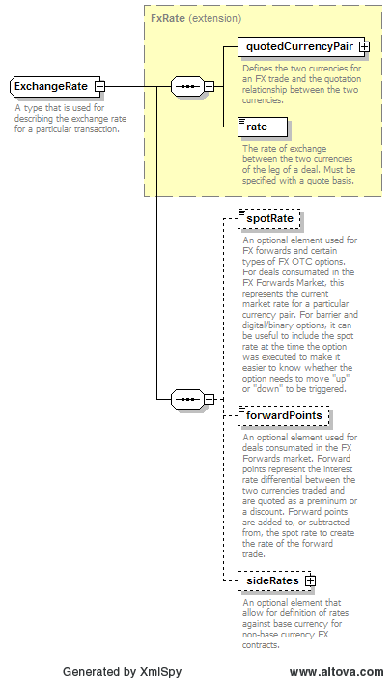
As this model currently stands it provides little control over content and it is quite possible for the ‘forwardPoints’ element to appear by itself. Without modifying the schema to only way to enforce the relationship between the elements is with a business rule that would have to be implemented in application code or as a script and checked against FpML documents after XML parsing has been completed but some applications may not implement the rule or may interpret the rule differently (or incorrectly).
If the design is adjusted to make greater use of the grammatical features of schema then simple relationships like this can be expressed in a form that the XML parser can test against document during the parsing process. For example defining the ‘ExchangeRate’ type so that it looks like following diagram achieves this for the example. In the revised schema ‘spotRate’ and ‘forwardPoints’ have been moved into an option sequence and ‘spotRate’ has been made mandatory. As the sequence is optional both elements can be omitted. The ‘spotRate’ element can appear on its own or followed by ‘forwardPoints’ but it is now impossible for ‘forwardPoints’ to appear on its own.
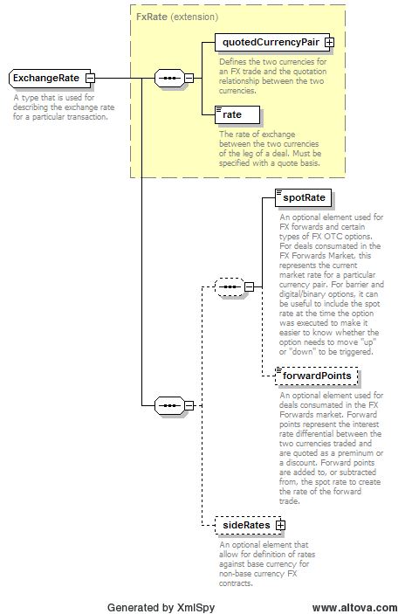
A commonly occurring pattern is the selection of one two elements or both (e.g. ‘X or Y or X and Y’). The following diagram shows the use of this pattern in the definition of stub calculations. In order to meet the XML parsers requirement that the grammar is deterministic (i.e. when the grammar contains a choice between multiple element sequences it must be able to figure out which has been use by looking at a single element in the document) the ‘finalStub’ element appears twice in the structure although it can only ever appear once in a document instance.
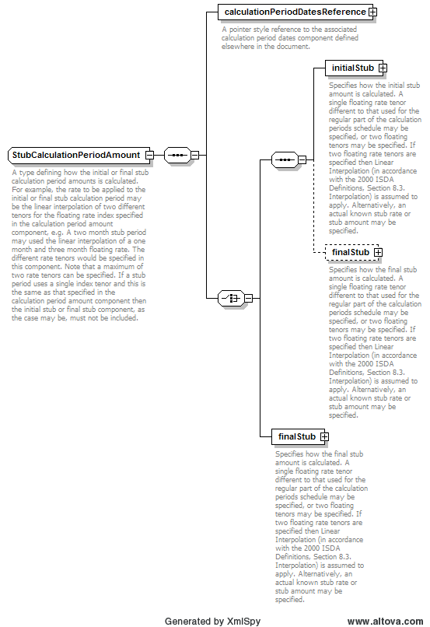
Many software developers use schema based code generators to create binding libraries to map between the XML representation and the applications data structure view of the world but the structures created when grammar is used to constrain content do not directly map to Java or C# classes.
A simple conversion of such structures could result in invalid class structures with repeated member definitions (e.g. for ‘finalStub’). A good binding tool will convert the grammatical structure of the schema into equivalent model that can be more easily represented in the target programming language, but which may be more general than the original and capable of holding combinations of elements that are invalid in the schema definition. For example in the case of the ‘StubCalculationPeriodAmount’ a binding tool would probably produce a class in which both the ‘initialStub’ and ‘finalStub’ are optional. This would allow the state where neither is defined to exist within the application although it is not permitted in an XML instance, never the less it is a useful state from the point of view of a program that is incrementally constructing a document image in memory.
It should be clear from theses examples that grammatical control over content is only possible when the elements to be controlled are situated together, as siblings in the same complex type. We cannot directly use the presence or absence in one sub-part of the XML document to control the state of related elements situated remotely. The schema designer needs to consider co-locating related data properties to allow full use of grammar constraints.

Over Generalisation
When designing complex structures it is often tempting to combine a number of variants of the same basic business ‘object’ within the same complex type but doing so reduces our control over the structure as a whole and may make it more difficult to understand, especially for someone new to the specification.
An example of this can be seen in the ‘InterestRateStream’ type used within swaps (see following diagram). This structure is used to describe both fixed and floating payment streams within interest rate and inflation swaps.
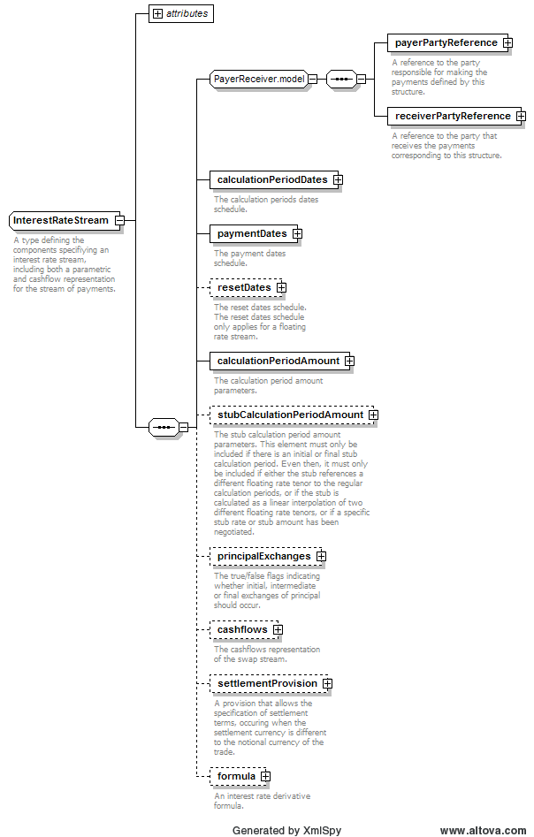
When a stream is configured to use a fixed rate the ‘resetDates’ and ‘formula’ elements of the stream become irrelevant and should not appear in a document. When the stream has a floating rate the presence of ‘resetDates’ becomes mandatory and the appearance of ‘formula’ is optional.
If we were designing an object oriented application we would probably use class inheritance to differentiate between fixed and floating payment streams, both derived from an abstract class containing the common properties of both. The same approach can and should be applied in XML schema.
A balance needs to be struck between having a single structure that can describe multiple variants and a number of specific structures that each describe a single variant. The key is to determine the ‘principal’ or ‘major’ variants (e.g. fixed vs. float payments, interest vs. inflation vs. index rates, American vs. European vs. Bermudan exercise, etc.) from the more ‘minor’ ones that can be managed thru the grammar (e.g. spot vs. forward, deliverable vs. non-deliverable, long form vs. short form, etc.).

The Neutral View Concept
One of the very first decisions made about FpML was to represent contracts from a neutral point of view. In other standards transactions often express the details from a single point of view (e.g. ‘I bought this from you’ or ‘I sold this to you’). In an exchange of messages between trading partners the details of the trade must be reversed in any response message (e.g. buy become sell, sell becomes buy) and an third party must match a buy with a sell to determine a match.
In FpML the representation of a transaction will have basically the same structure (although the order of some repeating information could be different, like the legs of a swap) regardless of which party generates the message, even if it is a third party. FpML product designs use references to a party (directly or indirectly) to indicate for each obligation who is the payer and receiver or the buyer and seller.
All new product descriptions with FpML or in proprietary extensions should continue this approach.

Business Object vs. Business Event Properties
Not all data properties belong to business ‘objects’, some are actually properties of the business ‘event’ that is occurring on the business ‘object’. Take for example the action of novating a transation between parties X and Y, in whole or in part, to another party Z.
At the start of the event there is a single transaction between X & Y. At the end there will either be a single contract between Y & Z or two smaller contracts (X & Y and Y & Z). The details of how much of the original contract to novate, when the novation will occur will be used to derive the business values in the revised contracts but is not part of them. These ‘parameters’ to the notation process are properties of the ‘event’ itself and should be described in the messages exchanged between the parties as the business process is carried out.
Other examples of business event properties could include the roles that participants take on with respect to transactions but which are not actually recorded in the transactions themselves, such as the broker or custodian.

Instances and Associations
An FpML document typically contains descriptions of several distinct business ‘objects’ (e.g. the transaction, parties, etc.). Each unique business object represented in an FpML document should appear only once to avoid ambiguity.
This means that the schema design for the main business objects in a document should not be nested inside each other and their definitions will reside in disjoint sections of the XML document.
Associations between business ‘objects’ should be represented using ID and IDREF based attributes, and the name of the referencing element should clearly indicate the role the referenced object takes in relation to the referencing one (e.g. ‘buyerPartyReference’, etc.).

Components and Reusability
The FpML schema contains a large number of complex types that can and should be reused in new models when appropriate. Reuse increases consistency across the model as a whole and make knowledge gained in one product area reusable when working with others.
The majority of the components we expect people to reuse have been placed in the ‘shared’ sub-schema. If you design a FpML new product and reuse a component defined in a product sub-schema then it may be better to relocate its definition (and anything it needs to define itself) into the shared sub-schema otherwise the dependencies between the sub-schema files themselves can become too complex and standard XML processing tools start to fail.

Refactoring
Sometimes an existing component is almost but not quite exactly what we need to design a new business object or message. There are three strategies we can adopt, although some will only apply when editing the FpML schema itself.
- If an existing component has an initial sequence of elements that matches our requirement but the end of the component is unsuitable then consider splitting the complex type into two and making the part containing the common sequence the base type of both the original type (to maintain its content model) and a new type used by our model addition.
- If an existing component contains a sequence of elements that match our requirement but they are located somewhere in the middle of the structure then consider moving them into a new model group and then using group references to restore the original type and to construct the new one.
- If neither of the first two strategies will work then you may be forced to duplicate the declaration of the elements you need within the new model components.
Refactoring using the first two options is only possible if the grammatical constraints present in the original type are maintained by the changes.
The last option often applies to extensions made outside of the FpML schema. If you find yourself having to do this then it may be worth appealing to the FpML coordination committee to have some changes performed within the schema on your behalf but even if the changes are accepted they may not be available until the next minor release so in the short term you will probably have to duplicate the elements you need.

Names and Homographs
The ‘X’ in XML is taken from the word ‘eXtensible’ and refers to the fact that the element names use in document instances can be defined by the schema design to reflect the terminology used in the solutions domain.
In the case of FpML much of the terminology used throughout our documents is based on the legal terms defined in the ISDA master agreements, contractual supplements that create the framework for derivatives trading.
When designing new model element or extensions you aim to remain consistent with this approach and in particular you should try not to create any ‘homographs’ (i.e. words with more than one definition) unnecessarily. Sometimes this is not easy, one financial market may use the same term but with a different interpretation (e.g. a basis point in interest rate markets is 1/100 of 1% = 0.01, in the FX market it is 0.0001).
In general we try not to use prefixes on elements like ‘paymentAmount’ or ‘paymentCurrency’. It is usually better to group related values within an element representing the group as a whole (e.g. ‘payment’, ‘bribe’ or ‘dowry’) and then using simpler (and more reusable) names within it (e.g. ‘currency’, ‘amount’).

Ordering of Repeating Elements
FpML does not require that properties that repeat, either single or multi-valued, are represented within a document in any particular order.
Normally such repeating information will contain a property, such as a date, that can be used to sort the information into order within an application if necessary. In cases where there is no easily identifiable ordering criteria (e.g. ‘swapStream’ element within a ‘Swap’) more elaborate matching algorithms may be needed.

In Summary
There are a great number of similarities between modeling information for use in XML and as ‘classes and objects’ for use in an object orient application, but as the preceding examples show there are also some subtle differences.
When you are designing you need think beyond just listing the properties of a business ‘object’. If there are clear dependencies between the elements then use schemas grammar feature to capture them as part of the grammar.
As the ‘ExchangeRate’ and ‘InterestRateStream’ examples show there are some parts of FpML that we might model differently today to make them easier to understand and use. We can change the FpML models over time using deprecation and periodic major releases but it is often better to spend more time reviewing and considering alternatives to be sure that model additions are the very best they can be in the first place.
It is essential to use the correct market or legal terminology for element names. Try not to reuse a name incorrectly or have unnecessary prefixes.
Care must also be taken in deciding when properties are intrinsic to a business objects definition or actually relate to the context in which the object is being used and hence are more likely to be message properties.

