

FpML Version 2.0
Trial Recommendation 13 December 2002

This version:
http://www.fpml.org/spec/2002/tr-fpml-2-0-2002-12-13
Latest version:
http://www.fpml.org/spec/fpml-2-0
Previous versions:
http://www.fpml.org/spec/2002/tr-fpml-2-0-2002-08-30
http://www.fpml.org/spec/2002/tr-fpml-2-0-2002-05-01
http://www.fpml.org/spec/2002/tr-fpml-2-0-2002-01-14
Errata for this version:
http://www.fpml.org/spec/errata/tr-fpml-2-0-2002-12-13-errata.html

Copyright © 1999 - 2002. All rights reserved.

Financial Products Markup Language is subject to the FpML Public License.

A copy of this license is available at http://www.fpml.org/documents/license.
Status of this Document:

This is the Trial Recommendation of the FpML Version 2.0 specification. This specification is considered stable by the Interest Rate Derivative Product Working Group and has been reviewed by the FpML Standards Committee which has agreed to its publication as a Trial Recommendation.

It is available for review during the Trial Recommendation period. The period of review ends on 31st January 2003 after which the FpML Standards Committee will consider moving this to a Recommendation. The FpML Standards Committee invites implementation feedback, both in the form of comments on the standard and confirmation of its successful implementation. Comments on this document and reports of successful implementations should be sent via http://www.fpml.org/issues/. An archive of the comments is available at http://www.fpml.org/issues/archive.asp.

Public discussion of FpML takes place on the FpML Discussion List at discuss@fpml.org (subscribe at http://www.fpml.org/mailing-lists/join-discuss.asp )

A list of current FpML Recommendations and other technical documents can be found at http://www.fpml.org/spec.

While implementation experience reports are welcomed, the FpML Consortium will not allow early implementation to constrain its ability to make changes to this specification prior to final release.

This document has been produced as part of the FpML Version 2.0 activity and is part of the Standards Approval Process. This Activity was initiated by the FpML Board of Directors in October 2000 to extend the FpML Version 1.0 product definitions, which covered interest rate swaps and FRAs, to include further interest rate derivatives products and features.

Working Group Members and Acknowledgements:

This document was produced in the IRD Products Working Group, which comprises of the following members:

- Steven Lord (UBS Warburg), chair
- Guy Gurden (SwapsWire), previous chair
- Andrew Addison (Merrill Lynch)
- Ariane Athalie (BNP Paribas)
- Owen Bugge (Blackbird)
- Marisol Collazo (Mizuho Capital Markets)
- Marie-Paule Dumont (S.W.I.F.T.)
- Alexander Ernst (RiskTrak Financial)
- Tom Fahy (Goldman Sachs)
- Doug Gallager (Reval.com)
- Mark Golding (JPMorgan)
- David Gorans (BNP Paribas)
- Paul Hoskins (Barclays Capital)
- Saleem Huda (Algorithmics)
- Vlad Iordanov (FinTrack Systems)
- Keri Jackson (Cygnifi)
- Sathy Kovvali (Citigroup)
- Philippe Negri (SunGard Trading & Risk Systems)
- Michael North (Reuters)
- Henry Teng (UBS Warburg)
- Ian Thomas (Credit Suisse First Boston)
- Patrick Treanor (Wall Street Systems)
- Olga Urrutia (S.W.I.F.T.)
- James Williams (Deutsche Bank)
- Barry Witkow (Treasury Connect)
- Chuck Witter (Bank of America)

Working Group Guests

- Nicholas Davies (Cygnifi)

Editor
- Steven Lord (UBS Warburg)

TABLE OF CONTENTS

1 Introduction 8
2 Scope 9
2.1 Scope 9
2.2 Architecture Framework 9
2.3 DTD Structure 10
3 Product Architecture Overview 11
3.1 Introduction 11
3.2 Component Framework 11
3.3 Overview of Core Trade Components 12
3.3.1 The Trade Component 12
3.3.2 The Product Component 13
3.4 Coding Schemes 14
4 Interest Rate Derivative Product Architecture 15
4.1 Interest Rate Swap 15
4.1.1 Swap Stream Diagrams 19
4.2 Forward Rate Agreement 28
4.3 Option Components 30
4.3.1 European Exercise 30
4.3.2 American Exercise 32
4.3.3 Bermuda Exercise 33
4.3.4 Early Termination Provision 33
4.3.5 Cancelable Provision 34
4.3.6 Extendible Provision 35
4.3.7 Swaption 36
4.3.8 Cap / Floor 38
4.4 Cash Settlement 38
5 Component Definitions 40
5.1 Interpreting the Diagrams 40
5.2 Root Element Definition 41
5.3 Entity Definitions 42
6 Document TYPE Definition (DTD) 178
6.1 fpml-dtd-2-0 178
7 dATA dICTIONARY 195
7.1 Element Definitions 195
8 Character encoding and character repertoire 249
8.1 Character Encoding 249
8.2 Character Repertoire 249
9 dATATYPES and coding schemes 250
9.1 Datatypes 250
9.1.1 date 250
9.1.2 time 250
9.2 Coding Schemes 251
9.2.1 Introduction 251
9.2.2 Averaging Method Scheme (averagingMethodScheme) 252
9.2.3 Business Center Scheme (businessCenterScheme) 252
9.2.4 Business Day Convention Scheme (businessDayConventionScheme) 254
9.2.5 Calculation Agent Party Scheme (calculationAgentPartyScheme) 255
9.2.6 Compounding Method Scheme (compoundingMethodScheme) 256
9.2.7 Currency Scheme (currencyScheme) 256
9.2.8 Date Relative To Scheme (dateRelativeToScheme) 256
9.2.9 Day Count Fraction Scheme (dayCountFractionScheme) 257
9.2.10 Day Type Scheme (dayTypeScheme) 258
9.2.11 Discounting Type Scheme (discountingTypeScheme) 259
9.2.12 Floating Rate Index Scheme (floatingRateIndexScheme) 259
9.2.13 Information Provider Scheme (informationProviderScheme) 260
9.2.14 Negative Interest Rate Treatment Scheme (negativeInterestRateTreatmentScheme) 260
9.2.15 Party Identifier Scheme (partyIdScheme) 261
9.2.16 Payer Receiver Scheme (payerReceiverScheme) 261
9.2.17 Pay Relative To Scheme (payRelativeToScheme) 261
9.2.18 Period Scheme (periodScheme) 262
9.2.19 Quotation Rate Type Scheme (quotationRateTypeScheme) 262
9.2.20 Rate Treatment Scheme (rateTreatmentScheme) 262
9.2.21 Reference Bank Identifier Scheme (referenceBankIdScheme) 263
9.2.22 Reset Relative To Scheme (resetRelativeToScheme) 263
9.2.23 Roll Convention Scheme (rollConventionScheme) 263
9.2.24 Rounding Direction Scheme (roundingDirectionScheme) 265
9.2.25 Step Relative To Scheme (stepRelativeToScheme) 265
9.2.26 Weekly Roll Convention Scheme (weeklyRollConventionScheme) 267
10 Sample fPml 268
10.1 Introduction 268
10.2 Example 1 - Fixed/Floating Single Currency Interest Rate Swap 270
10.3 Example 2 - Fixed/Floating Single Currency Interest Rate Swap with Initial Stub Period and Notional Amortization 271
10.4 Example 3 - Fixed/Floating Single Currency Interest Rate Swap with Compounding, Payment Delay and Final Rate Rounding 272
10.5 Example 4 - Fixed/Floating Single Currency Interest Rate Swap with Arrears Reset, Step-Up Coupon and Upfront Fee 273
10.6 Example 5 - Fixed/Floating Single Currency Interest Rate Swap with Long Initial Stub and Short Final Stub 274
10.7 Example 6 - Fixed/Floating Cross Currency Interest Rate Swap 275
10.8 Example 7 – Fixed/Floating Overnight Interest Rate Swap (OIS) 276
10.9 Example 8 - Forward Rate Agreement 277
10.10 Example 9 – European Swaption, Physical Settlement, Explicit Underlying Effective Date 278
10.11 Example 10 – European Swaption, Physical Settlement, Relative Underlying Effective Date 279
10.12 Example 11 – European Swaption, Physical Settlement, Partial Exercise, Automatic Exercise 280
10.13 Example 12 – European Swaption, Cash Settlement, Swaption Straddle 281
10.14 Example 13 – European Swaption, Cash Settled, cashflows included 282
10.15 Example 14 – Bermuda Swaption, Physical Settlement. 283
10.16 Example 15 – American Swaption, Physical Settlement. 284
10.17 Example 16 – Fixed/Floating Single Currency IRS With Mandatory Early Termination. 285
10.18 Example 17 – Fixed/Floating Single Currency IRS With European Style Optional Early Termination. 286
10.19 Example 18 – Fixed/Floating Single Currency IRS With Bermuda Style Optional Early Termination, Cashflows + optionalEarlyTerminationAdjustedDates. 287
10.20 Example 19 – Fixed/Floating Single Currency IRS With American Style Optional Early Termination. 288
10.21 Example 20 – Fixed/Floating Single Currency IRS With European Cancelable Provision. 289
10.22 Example 21 – Fixed/Floating Single Currency IRS With European Extendible Provision. 290
10.23 Example 22 – Interest Rate Cap 291
10.24 Example 23 – Interest Rate Floor 292
10.25 Example 24 – Interest Rate Collar 293
10.26 Example 25 – Fixed/Floating IRS Where The Floating Stream Notional Is Reset Based On Prevailing Spot Exchange Rate. 294
10.27 Example 26 – Example 25 – Fixed/Floating IRS Where The Floating Stream Notional Is Reset Based On Prevailing Spot Exchange Rate - Cashflows. 295
10.28 Example 27 – Inverse Floater 296
10.29 Example 28 - BulletPayments 297
11 Appendix I – iNcompatible changes from Fpml 1.0 298
11.1 Removal of ‘product’ element 298
11.2 Change in position of paymentType 298
11.3 CapRate and floorRate changed to complex types 298
11.4 Href attribute of businessCentersReference changed to #REQUIRED 298
12 Appendix II – Changes to FpML 2.0 Trial Recommendation Aug 30, 2002 299
12.1 FpML_CalculationPeriod 299
12.2 FpML_PaymentCalculationPeriod 299
12.3 FpML_PrincipalExchange 299
12.4 FpML_RateObservation 299
12.5 FpML_FxLinkedNotionalAmount 299
12.6 FpML_FxLinkedNotionalSchedule 300
12.7 Element Description Updates 300
13 Appendix iii – Incorporation of product Strategies 301

Introduction

The Financial Products Markup Language (FpML) is a protocol enabling e-commerce activities in the field of financial derivatives. The development of the standard, controlled by ISDA, will ultimately allow the electronic integration of a range of services, from electronic trading and confirmations to portfolio specification for risk analysis. All types of over-the-counter (OTC) derivatives will, over time, be incorporated into the standard, although the current focus of FpML Version 2.0 is interest rate derivatives.

FpML is an application of XML, an internet standard language for describing data shared between computer applications.

Scope

Scope

The scope of the IRD Products Working Group, with respect to extending the FpML 1.0 product definitions, is to complete definitions for the following new products and features:

- Interest Rate Cap
- Interest Rate Floor
- Interest Rate Swaption (European, Bermuda and American Styles; Cash and Physical Settlement)
- Extendible and Cancelable Interest Rate Swap Provisions
- Mandatory and Optional Early Termination Provisions for Interest Rate Swaps
- FX Resetable Cross-Currency Swap

Current capabilities of the FpML Version 1.0 specification to support Basis Swaps will also be reviewed.

Outside the scope of the Working Group are the following:

- Definition of business processes that might result in the trade content defined here being transmitted between parties. The definition of these processes and resulting messages is expected to be covered by the work of other FpML Working Groups.
- Definition of reference data related to the counterparty such as settlement instructions, location and contact details. It was agreed that this static data did not belong in each instance of an FpML document and would most likely be stored in central or distributed repositories and referenced from within the document. Specification or design of such repositories is also beyond the scope of the Working Group. Since identification of parties is an essential requirement of a trade content definition, the FpML Consortium has decided, to continue in this release, to identify parties using the ISO standard bank identifier code (BIC). S.W.I.F.T. is the designated registration authority for the assignment of BIC codes. Although this is the recommended identification scheme for parties wishing to use FpML for inter-firm communication , the FpML architecture supports the use and identification of alternative coding schemes through the Schemes mechanism.

Architecture Framework

The Products Working Group has developed FpML 2.0 within the FpML Architecture Version 1.0 framework defined by the Architecture Working Group. Their recommendations covered:

- XML tools for editing and parsing
- XML namespace usage within FpML
- FpML versioning methodology
- FpML content model - a new style for representing the FpML Document Type Definition (DTD)
- FpML referencing methodology, including guidelines for referencing coding schemes.

DTD Structure

The FpML 2.0 Trial Recommendation, following the approach used with FpML 1.0, utilises a single DTD. However, with the expected addition of other asset classes (FX and Equities) in FpML 3.0 it is intended at that time to separate the DTD into multiple parts:

- A shared components DTD
- Several asset class specific DTDs
- A main DTD which links the other DTDs to form the FpML standard.

Product Architecture Overview

Introduction

FpML incorporates a significant level of structure, rather than being a ‘flat’ representation of data. This structuring is achieved through the grouping of related elements describing particular features of a trade into components. Components can both contain, and be contained by, other components.

An alternative approach would have been to collect all the required elements in a single large component representing a product or trade. A flat structure of this kind would capture all the relevant information concisely but would also constrain the model in two important respects, namely, ease of implementation and extensibility.

Grouping related elements into components makes it easier to validate that the model is correct, that it is complete and that it doesn’t contain redundancy. This is true, both from the perspective of readability to the human eye, and also from the perspective of processing services. Processing services that do not need all the information in a trade definition can isolate components and be sure that the complete set of elements required, and only the elements required, is available for the particular process in hand.

Components additionally serve as the building blocks for a flexible and extensible model. Generally speaking, the complexity of financial products is a result of combining a few simple ideas in a variety of different ways. The component structure supports a trade content definition that is flexible enough to represent the wide variation of features found in traded financial instruments.

It should be noted that the application of the guiding principles of extensibility and ease of use has resulted in a different approach with regard to the forward rate agreement. Because this product is straightforward, commoditized and unlikely to develop further, the advantage to be gained from the extensive use of components is outweighed by the concision of a single component.

Component Framework

The optimum level of granularity is important to FpML. FpML separates the elements which collectively describe a feature of a product or trade into a separate component with each component serving a particular semantic purpose. Every grouping of elements in FpML is regarded as a component and each component is regarded as a container for the elements that describe that component. In the majority of cases each component will contain a mixture of other components and primitive elements, e.g. a date or string, that collectively describe the features of the component. Components are typically represented in the FpML Document Type Definition (DTD) as XML entities.

Generally speaking, the lower level a component is, the more re-usable it will be. FpML makes use of a number of primitive entity components that describe the basic building blocks of financial products, for example, FpML_Money, FpML_AdjustableDate, FpML_BusinessCenters, FpML_Interval, FpML_BusinessDayAdjustments etc. These primitive components are re-used in different business contexts.

Primitive components are contained in higher level components that describe the features of particular products. For this reason these higher level components will tend not to be re-usable to the same extent. Examples within the definition of swapStream are the components required to construct schedules of dates such as calculationPeriodDates, resetDates and paymentDates. However, it should not be inferred from this that any fundamental distinction is drawn between components in usage or structure.

Overview of Core Trade Components

The Trade Component

The trade is the top-level component within the root element FpML. A trade is an agreement between two parties to enter into a financial contract and the trade component in FpML contains the economic information necessary to execute and confirm that trade. A trade contains four components: tradeHeader, product (an abstract concept) , party (two or more instances) and otherPartyPayment (zero or more instances).

(See Section 5.1, Interpreting the Diagrams, for an explanation of the graphical DTD representation shown in the following schematics)

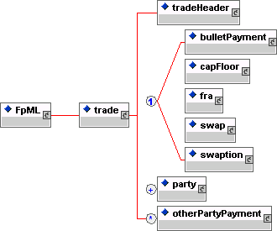

- tradeHeader - The information within tradeHeader will be common across all types of trade regardless of product. In FpML 2.0 this contains the trade date, party trade identifiers and any calculation agent references.
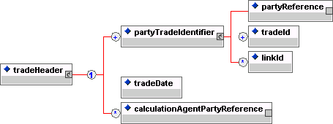

- product – Product is an abstract concept in fpml and an actual product element is not used. Instead, one of the FpML products (bulletPayment, capFloor, fra, swap or swaption) will appear directly under trade.

- party - The party component holds information about a party involved in the trade. The parties involved will be the principals to the trade and potentially additional third parties such as a broker. For this release, this component is restricted to party identification.

It should be noted that an FpML document is not 'written' from the perspective of one particular party, i.e. it is symmetrical with respect to the principal parties. The particular role that a party plays in the trade, e.g. buyer, seller, stream payer/receiver, fee payer/receiver, is modeled via the use of references from the component where the role is identified to the party component.

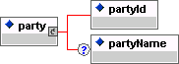

- otherPartyPayment – This component contains additional payments such as brokerage paid to third parties which are not part of the economics of a trade itself.

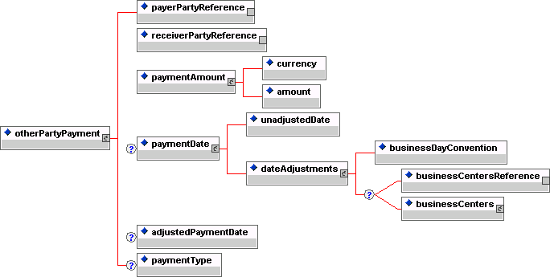

The Product Component

The product component specifies the financial instrument being traded. This component captures the economic details of the trade. Because of the complexity of the OTC Interest Rate Derivatives domain that FpML 2.0 covers, composing these products from various building blocks is a key aspect of the design approach.

FpML 1.0 focused on the instrument definitions for interest rate swaps (including cross currency swaps) and forward rate agreements. For that initial release, a trade was restricted to containing only a single product definition. In FpML 2.0 the instrument definition has been extended to include options.

Coding Schemes

A necessary feature of a portable data standard is both an agreed set of elements and an agreed set of permissible values (the value domain) for those elements. An FpML document exchanged between two parties would not be mutually understandable if either or both of the parties used internal or proprietary coding schemes to populate elements.

Reference data can originate from various sources and the range of permitted values may be more or less extensive. The dayCountFraction is an example of an element with a limited set of permissible values with well-defined meanings. The range of permitted values comes from several sources including ISDA and AFB definitions. However, the currency element is an example of where the list of permitted values is more extensive and the coding scheme reference is to a well-known standard, in this case ISO 4217.

In FpML the recommended domain for party identification is a valid bank identifier code (BIC). The BIC is an ISO standard, ISO 9362. S.W.I.F.T. is the designated registration authority for the assignment of BIC codes.

One possible means of identifying value domains would have been to include the domain of permitted values within the DTD. This solution has been rejected for two reasons. Firstly, in many cases the scope of permitted values is extensive, most obviously with party identifiers, and this would make the standard unnecessarily bulky. Secondly, although there are varying degrees of stability, all value domains are subject to change and including them in the DTD would have necessitated a new version of FpML each time a value domain changed.

For these reasons, FpML uses Schemes to identify the permitted values for an element. In each case, the reference Scheme will be identified by a URI. The URI will either identify a well-known external standard such as ISO 4217, or where no well-established standard exists, an FpML standard. FpML includes provision for a default Scheme and the facility to override the default Scheme at an element level. In both cases, no values are included for the URI in the DTD in order to avoid coding either particular Schemes, or particular versions of Schemes, into FpML. For the same reason, the URI quoted in an FpML document for a Scheme that is FpML controlled will include a date and version in order to identify the particular version referenced.

It should be noted that the Scheme approach adopted by FpML does not allow validation of the values within the DTD. It will be the responsibility of the applications that implement FpML to validate that the contents of an element conform to the specified Scheme.

For further details on the architectural framework behind Schemes, refer to the FpML Architecture Version 1.0 document.

Interest Rate Derivative Product Architecture

Interest Rate Swap

A swap component contains one or more instances of the swapStream component, zero or more instances of the additionalPayment component together with an optional cancelableProvision component, an optional extendibleProvision component and an optional earlyTerminationProvision component. A swapStream contains the elements required to define an individual swap leg.

Within an FpML swap there is no concept of a swap header. Details of payment flows are defined within swapStreams which each contain their own independent parameters. There can also be additionalPayment elements that contain fees. The additionalPayment component is identical to the otherPartyPayment component shown earlier.

FpML 2.0 adds option related features. These include cancelable, extendible swaps and early termination provisions. Combining these together with swaptions into a single component was considered but rejected in favour of identifying the different option types with their own components. This provided more clarity and allowed for easier combination of the different options into a single trade. As such a swap can contain a cancelableProvision, extendibleProvision and an earlyTerminationProvision. These components are all very similar (and similar to the swaption component), achieving re-use by using shared entities within each of the components.

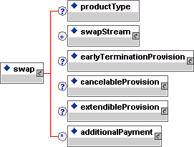

FpML supports two representations of a swap stream; a parametric representation, and a cashflows representation. The parametric representation is designed to capture all the economic information required regarding dates, amounts and rates to allow trade execution and confirmation. The parametric representation is mandatory. The cashflows representation specifies an optional additional description of the same stream. The main purpose of this is to allow the inclusion of adjusted dates within an FpML representation of a trade. It can also be used to represent adhoc trades not achievable by easy manipulation of the parameters of a stream (i.e. by changing the adjusted dates). This would lead to the cashflows not matching those generated by the parameters (see more discussion later) and would also render the representation of the trade unsuitable for a confirmation. The designers of FpML intended that such manipulation of cashflows would be achieved by splitting a single stream into a number of streams though it is recognized that this may be impractical in some systems.

The cashflows representation is not self contained as it relies on certain information contained within the stream's parametric definition. The elements required from the parametric definition to complete the cashflows representation are:

- The following elements and their sub-elements within the calculationPeriodAmount element:
- floatingRateIndex
- indexTenor
- rateTreatment
- finalRateRounding
- averagingMethod
- negativeInterestRateTreatment
- dayCountFraction
- discounting
- compoundingMethod.

- The following elements and their sub-elements within the stubCalculationPeriodAmount element:
- floatingRateIndex
- indexTenor.

The inclusion of the cashflows representation is intended to support application integration. For example, a financial institution may have one application that captures trade parameters and constructs the trade schedules and then publishes the result for use by other applications. In this case it may be either undesirable, or impossible, for each of the subscribing applications to store and calculate schedules.

The flexibility of the cashflows representation also allows payment and calculation schedules which can not be fully represented by the parametric description. If this situation arises, the mandatory parametric data should still be included in the document and the flag cashflowsMatchParameters should contain the value false to indicate that it is not possible to generate the cashflows from this parametric data. The setting of this flag to true means that the cashflows can be regenerated at any time without loss of information.

Parties wishing to take advantage of the facility for specifying cashflows which are inconsistent with the parametric representation will need to specify additional rules for how the parametric representation should be processed. This applies to both the creation of the parametric data as well as its interpretation.

The cashflows representation specifies adjusted dates, that is, dates that have already been adjusted for the relevant business day convention using the relevant set of business day calendars (lists of valid business days for each business center). The FpML standard does not specify the source of these business day calendars. This may lead applications to generate differing cashflow representations from the same parametric representation if they use different business day calendars. The use of adjusted dates also produces schedules that are only valid at a particular instance of time. Additional holidays for a business center may subsequently be introduced that would result in changes to the adjusted dates, which would not be reflected in the cashflows representation.

Analogous to cashflows being used to represent adjusted dates, with the addition of options it was important to be able to represent the adjusted dates associated with an option. Thus, where appropriate, a component includes an optional element to represent a schedule of adjusted dates for the option. Such a schedule would include details of adjusted dates such as adjusted exercise dates and cash settlement dates.

In general, an interest rate swap will be a swap with a fixed leg and a floating leg, two floating legs, or two fixed legs. However, certain types of trades may contain more than two legs. FpML does not restrict the number of legs that may be defined. From a modeling perspective, FpML does not distinguish between a swap leg referencing a fixed rate and a swap leg referencing a floating rate, the difference being indicated by the existence, for example, of the resetDates component in a floating rate leg.

The structure of a swapStream is shown diagrammatically below:

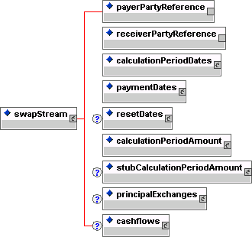

The components within a swapStream cannot be randomly combined and cannot be thought of as existing in their own right; they only make sense in the given context and in relationship to other components within the swapStream container.

In FpML, the schedule of dates within a swapStream is based around the calculationPeriodDates component. The definition of a calculation period in FpML differs in some respects from the International Swaps and Derivatives Association (ISDA) definition of Calculation Period. In the case of a trade involving compounding, ISDA introduces the concept of a Compounding Period, with several Compounding Periods contributing to a single Calculation Period. The FpML calculation period is equivalent to the ISDA definition of Compounding Period when compounding is applicable, i.e. the calculation period frequency will correspond to the compounding frequency. An FpML calculation period is directly comparable to the ISDA defined Calculation Period when only one calculation period contributes to a payment.

The other date components within swapStream are related to the calculationPeriodDates component. The paymentDates and resetDates components contain the information necessary to construct a schedule of payment and reset dates relative to the calculation period dates.

FpML uses the ISDA Floating Rate Option to specify the floating rate being observed. This scheme was used rather than attempting to parameterize all the relevant data into elements because although most floating rate indices are defined fully by a standard set of parameters (namely index, currency and fixing source) there are sometimes other details including fixing offsets and formulas. This approach allows for more flexibility in adding new floating rate indices without having to introduce new elements, although this comes at the expense of a self contained definition within the standard.

The information relating to amounts and rates is collected in the calculationPeriodAmount and stubCalculationPeriodAmount components. FpML 2.0 has introduced fxLinkedNotionalSchedule as an alternative to notionalSchedule for defining notionals. This allows for the definition of FX Resetable trades by allowing for the notional of a stream to be derived from notionals of another stream by way of a spot fx rate.

Certain swapStream components are designated as being optional (although it would be more accurate to say that they are conditional). Thus a fixed rate stream never includes a resetDates component, but this is required for a floating rate stream. Similarly, the stubCalculationPeriodAmount component will be required if the swap leg has either an initial or final stub, or indeed both, but should otherwise not be specified. The principalExchanges component is required in the case of cross currency swaps or other types of swap involving exchanges of principal amounts.

The payerPartyReference and receiverPartyReference elements indicate which party is paying and which receiving the stream payments. This is done by referencing the appropriate party within the party component.

The detailed structures within the swapStream are shown diagrammatically below:

Swap Stream Diagrams
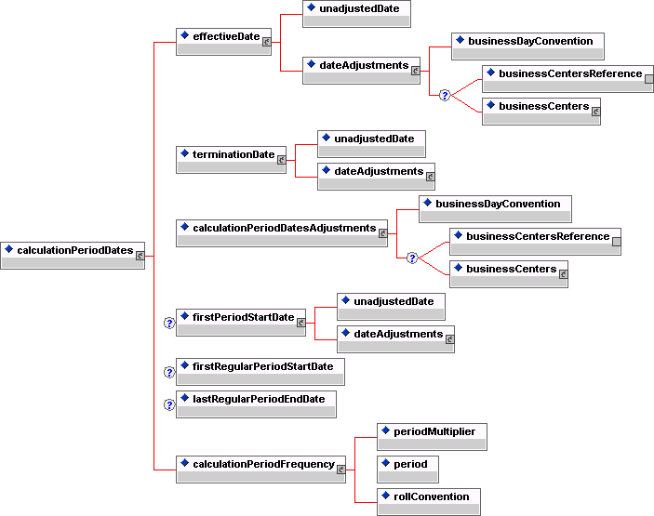
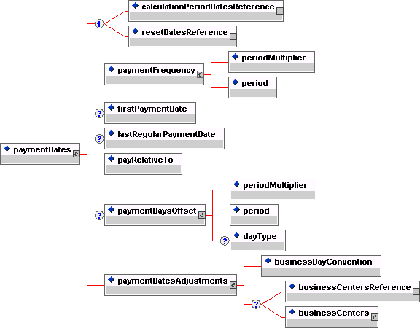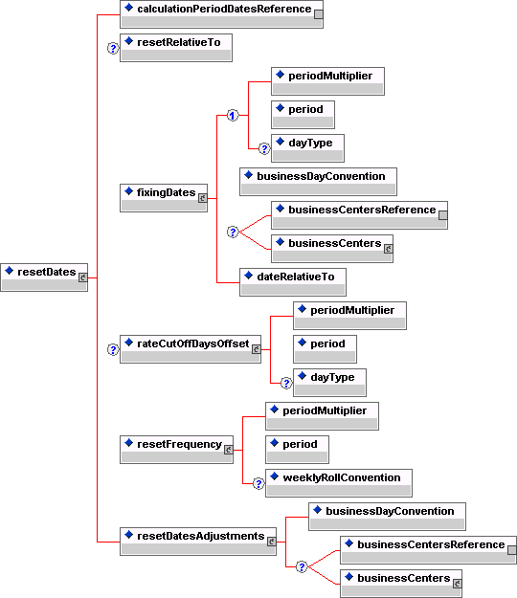
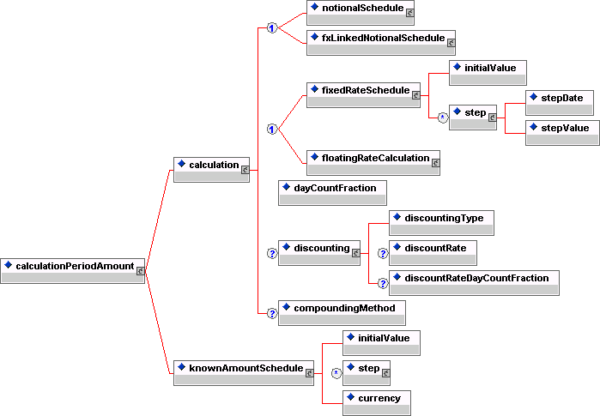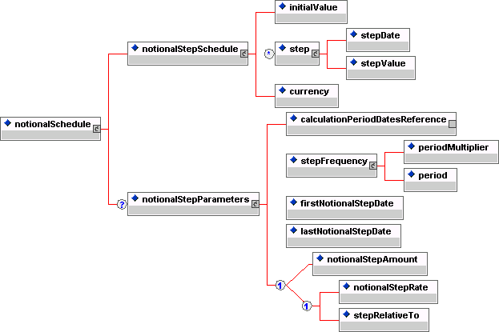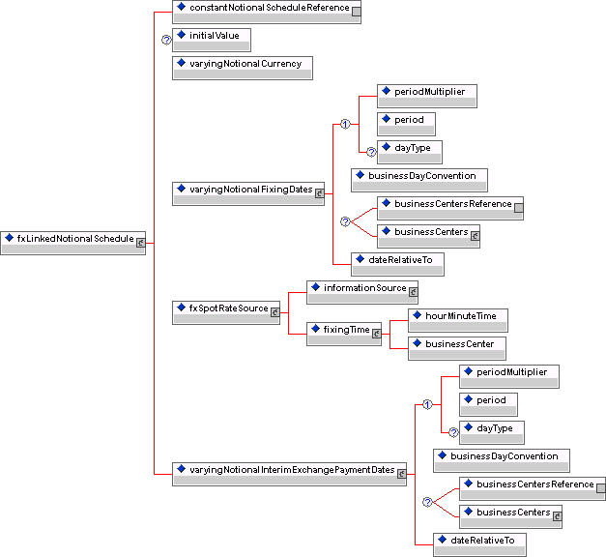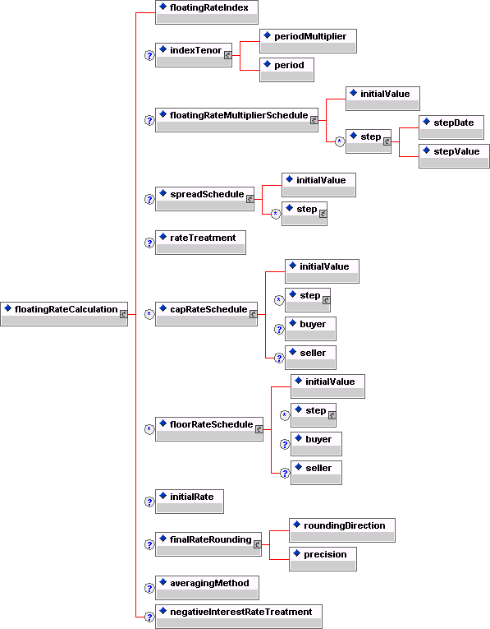

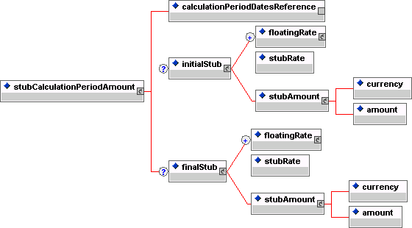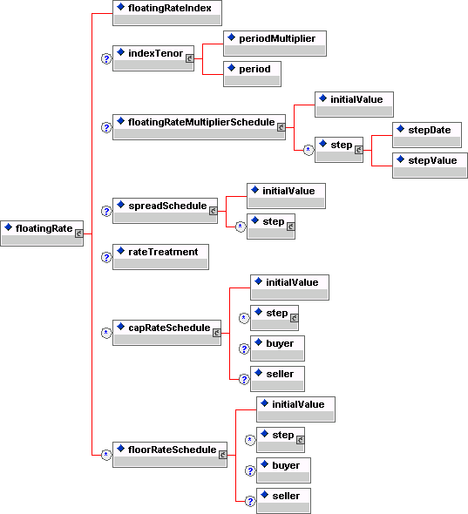

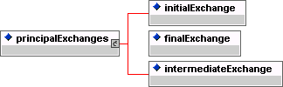

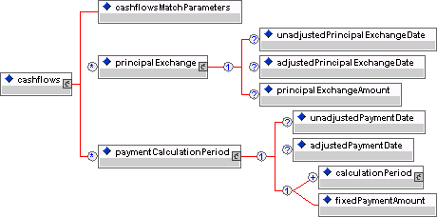

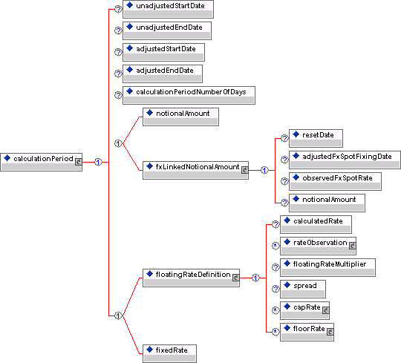

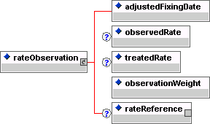

Forward Rate Agreement

As noted above, the definition of a forward rate agreement trade is contained within a single component. A forward rate agreement is a simple and commoditized product. This means there is no variation in the product traded and it is not expected to become more complex in the future.

The structure of the fra component is shown diagrammatically below:

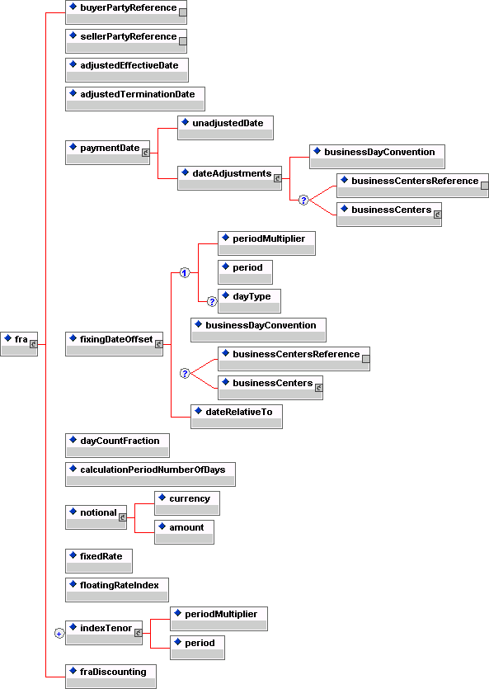

Option Components

FpML 2.0 has introduced interest rate options. The components introduced are:

- Early Termination Provision (Optional or Mandatory) for a swap
- Cancelable Provision for a swap
- Extendible Provision for a swap
- Swaption
- Cap / Floor

The ISDA 2000 Definitions have been followed closely in defining the various option dates and element names. Thus components for European, Bermuda and American exercise have been defined which are re-used in each of the first four components above. These components share an element called relevantUnderlyingDate whose meaning is dependent on the option component it is contained in:

Containing Component | RelevantUnderlyingDate Meaning
OptionalEarlyTermination | This represents the new terminationDate of the underlying swapStreams if the trade is terminated early.
CancelableProvision | This represents the new terminationDate of the underlying swapStreams if the trade is cancelled.
ExtendibleProvision | This represents the new terminationDate of the underlying swapStreams if the trade is extended.
Swaption | This represents the effectiveDate of the underlying swapStreams if the swaption is exercised.

European Exercise

This is a style of option to which the right or rights granted are exercisable on a single date referred to as the expiration date. This date can be specified either as an adjustableDate or as a relativeDate though the latter is only expected to be used in the case of cash settled cancellations where the expiration date may be defined as an offset to the cash settlement payment date.

The relevantUnderlyingDate is optional, in its absence the effectiveDate of the underlying is the effectiveDate defined in the swapStreams. This can be excluded for european swaptions or a swap with optional early termination where cash settlement is applicable and where the optional early termination date is equal to the cash settlement payment date.

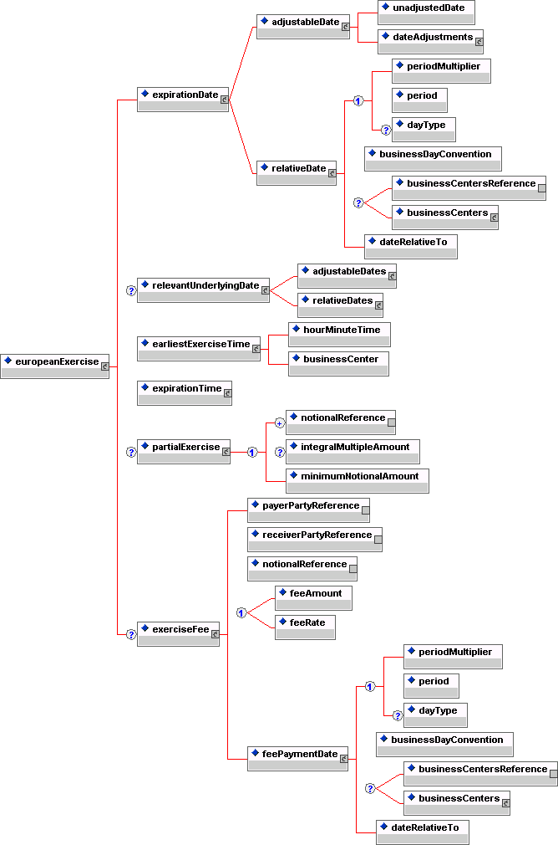

American Exercise

This is a style of option to which the right or rights granted are exercisable during the exercise period which consists of a period of days. The underlying should specify its effective date based on the earliest possible exercise. When exercise implies a stub period this will be taken to be a short stub at the start, i.e. the underlying swap defines a series of flows, exercise merely brings the flows into existence from the relevantUnderlyingDate.
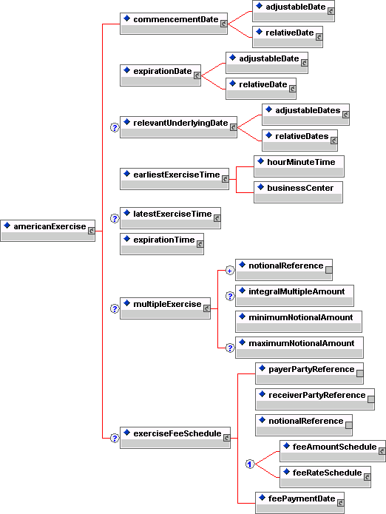

Bermuda Exercise

This is a style of option to which the right or rights granted are exercisable during an exercise period which consists of a number of specified dates. These dates can be defined as a list together with adjustments or by reference to an existing schedule elsewhere in the trade (e.g. resetDates). In the latter case bounds can be placed on the referenced schedule to define a subset of the whole schedule.

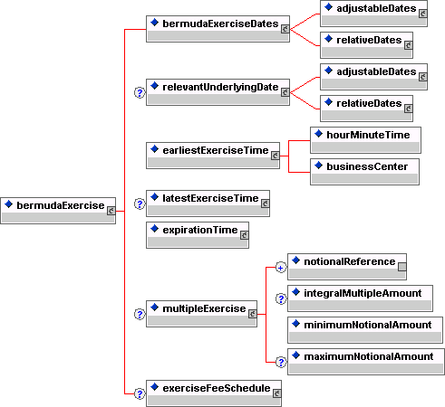

Early Termination Provision
The right for one or both parties to terminate the trade and settle the remaining term of the swap for fair value. In the case of a mandatory early termination the termination is mandatory.
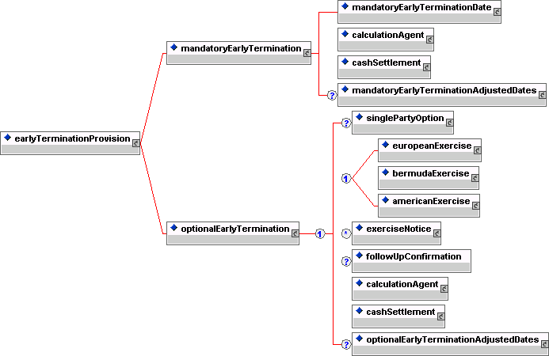

Cancelable Provision

With a cancelableProvision the seller grants the buyer the right to terminate all swapStreams, typically in exchange for an upfront premium. Unlike optionalEarlyTermination, the cancellation of the swap does not require the parties to exchange a cash settlement amount on exercise representing the fair value of the remaining life of the swap although an exercise fee can be specified in the exerciseFeeSchedule.
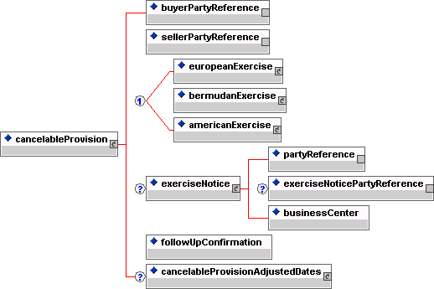

Extendible Provision

With an extendibleProvision the seller grants the buyer the right to extend all swapStreams, typically in exchange for an upfront premium. This provision is very similar to a cancelableProvision and in fact the two share the same market risk profile. FpML makes a clear distinction between the two since the operational risk associated with mis-recording the type of applicable provision can be high. For example, a 10 year swap with the right to cancel after 5 years has exactly the same risk profile as a 5 year swap with the right to extend for 5 years after 5 years. However, failing to give notice of exercise after 5 years will in one case (extendibleProvision) result in the swap terminating after 5 years and in the other case (cancelableProvision) result in the swap terminating after 10 years, i.e. action after 5 years is required in one case to lengthen the term of the swap in the other to shorten it.

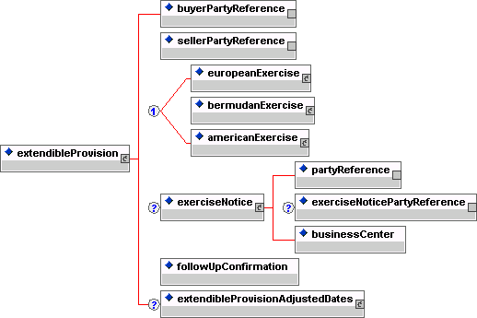

Swaption

The option to enter into a swap is defined as it’s own product and contains the underlying swap as a swap element. A swaption straddle is defined by setting the swaptionStraddle element to true: this implies that the swaption buyer has the right, on exercise, to decide whether to pay or receive fixed on the underlying swap. If the underlying does not contain a single fixed stream and a single floating stream then the straddle is invalid and thus this flag should be set to false..

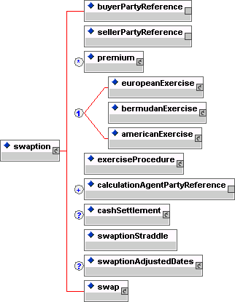

Cap / Floor

Caps and Floors are defined as one or more capFloorStreams and zero or more additionalPayments. The capFloorStream re-uses the FpML_InterestRateStream entity and thus its content is identical to a swapStream.

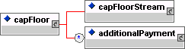

Though a capFloorStream allows the definition of fixed streams or known amount streams these are not the intended use of this component and their use would be considered an invalid FpML trade.

The floatingRateCalculation component has been amended in FpML 2.0 to allow the specification of cap/floor structures within a single stream (e.g. straddles, corridors). The changes are:

- The occurrence rules for the components capRateSchedule and floorRateSchedule have been changed from ‘zero or one’ to ‘zero or more’.
- An optional buyer and seller reference have been added to these schedules

These additions allow for multiple cap and floor rates to be added to the stream and to define precisely which party bought and sold them. To maintain backward compatibility with FpML the buyer and seller are optional. When absent the following rules apply:

 | Buyer | Seller
capRateSchedule | Stream payer | Stream receiver
floorRateSchedule | Stream receiver | Stream payer

Cash Settlement

The cash settlement component is used by mandatoryEarlyTermination, optionEarlyTermination and swaption. The language used within the component corresponds to the ISDA language for the various cash settlement methods. Of the five methods included, three share one underlying component and the other two share another component. Thus there is re-use whilst maintaining ease of identification of the type. Also, this approach allows for easy integration of other methods should they arise.

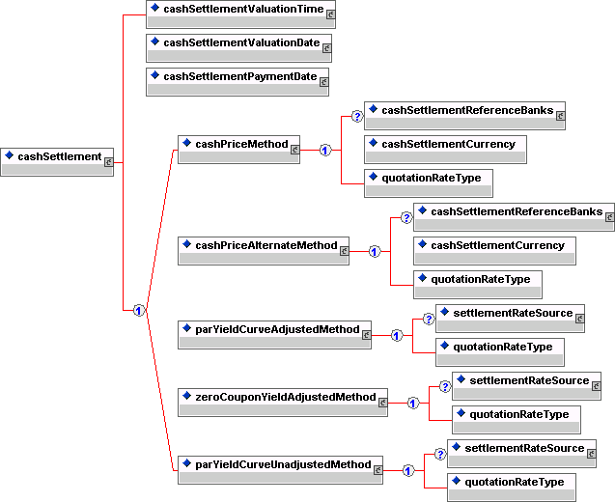

Component Definitions

Interpreting the Diagrams

The DTD source shown below is graphically represented in Figure 4.1. Important features of the diagram are highlighted, which include:
- Graphical representation of an XML entity definition
- Sequence indicators, i.e. comma ( , ) and vertical bar ( | )
- Content specifications, i.e. text or sub-elements
- Occurrence indicators, i.e. can appear zero or once ( ? ), can appear one or more times ( + ), can appear zero or more times ( * ).

<!ENTITY % FpML_Root "SubElementA?,SubElementB+">
<!ELEMENT SubElementA (LeafElementA*,(LeafElementB | LeafElementC))>
<!ELEMENT SubElementB (LeafElementA,LeafElementB,LeafElementC,LeafElementD)*>
<!ELEMENT LeafElementA (#PCDATA)>
<!ELEMENT LeafElementB (#PCDATA)>
<!ELEMENT LeafElementC (#PCDATA)>
<!ELEMENT LeafElementD (#PCDATA)>

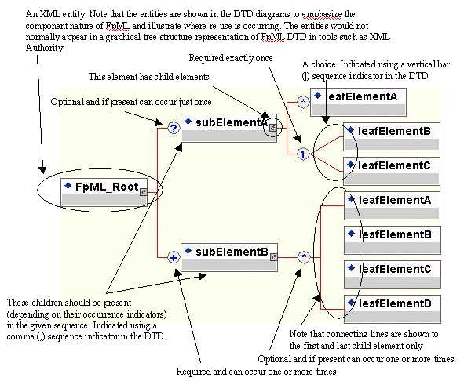

Figure 5.1: Graphical Representation of a DTD

Root Element Definition

FpML
Description:
The root element in an FpML trade document.
Figure:
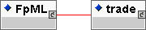
Contents:
trade (exactly one occurrence; contains the sub-element(s) defined by exactly one occurrence of the entity FpML_Trade)

- The FpML trade definition.
DTD Fragment:
<!ELEMENT FpML (trade)>

Entity Definitions

FpML_AdjustableDate
Description:
An entity for defining a date that shall be subject to adjustment if it would otherwise fall on a day that is not a business day in the specified business centers, together with the convention for adjusting the date.
Figure:
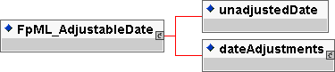
Contents:
unadjustedDate (exactly one occurrence; of type date)
- A date subject to adjustment.
dateAdjustments (exactly one occurrence; contains the sub-element(s) defined by exactly one occurrence of the entity FpML_BusinessDayAdjustments)
- The business day convention and financial business centers used for adjusting the date if it would otherwise fall on a day that is not a business day in the specified business centers.
Used by:
adjustableDate
effectiveDate
firstPeriodStartDate
mandatoryEarlyTerminationDate
paymentDate
terminationDate
DTD Fragment:
<!ENTITY % FpML_AdjustableDate "unadjustedDate , dateAdjustments">

FpML_AdjustableDates
Description:
An entity for defining a series of dates that shall be subject to adjustment if they would otherwise fall on a day that is not a business day in the specified business centers, together with the convention for adjusting the dates.
Figure:
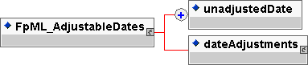
Contents:
unadjustedDate (one or more occurrences; of type date)
- A date subject to adjustment.
dateAdjustments (exactly one occurrence; contains the sub-element(s) defined by exactly one occurrence of the entity FpML_BusinessDayAdjustments)
- The business day convention and financial business centers used for adjusting the date if it would otherwise fall on a day that is not a business day in the specified business centers.
Used by:
adjustableDates
DTD Fragment:
<!ENTITY % FpML_AdjustableDates "unadjustedDate+ , dateAdjustments">

FpML_AdjustableOrRelativeDate
Description:
An entity for the choice between defining a date as an explicit date together with applicable adjustments or as relative to some other (anchor) date.
Figure:
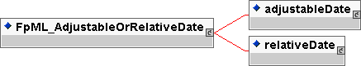
Contents:
Either
adjustableDate (exactly one occurrence; contains the sub-element(s) defined by exactly one occurrence of the entity FpML_AdjustableDate)
- A date that shall be subject to adjustment if it would otherwise fall on a day that is not a business day in the specified business centers, together with the convention for adjusting the date.
Or
relativeDate (exactly one occurrence; contains the sub-element(s) defined by exactly one occurrence of the entity FpML_RelativeDateOffset)
- A date specified as some offset to another date (the anchor date).
Used by:
commencementDate
expirationDate
DTD Fragment:
<!ENTITY % FpML_AdjustableOrRelativeDate "adjustableDate | relativeDate">

FpML_AdjustableOrRelativeDates
Description:
An entity for the choice between defining a series of dates as an explicit list of dates together with applicable adjustments or as relative to some other series of (anchor) dates.
Figure:
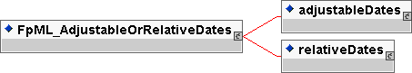
Contents:
Either
adjustableDates (exactly one occurrence; contains the sub-element(s) defined by exactly one occurrence of the entity FpML_AdjustableDates)
- A series of dates that shall be subject to adjustment if they would otherwise fall on a day that is not a business day in the specified business centers, together with the convention for adjusting the date.
Or
relativeDates (exactly one occurrence; contains the sub-element(s) defined by exactly one occurrence of the entity FpML_RelativeDates)
- A series of dates specified as some offset to another series of dates (the anchor dates).
Used by:
bermudaExerciseDates
relevantUnderlyingDate
DTD Fragment:
<!ENTITY % FpML_AdjustableOrRelativeDates "adjustableDates | relativeDates">

FpML_AmericanExercise
Description:
An entity for defining the exercise period for an American style option together with any rules governing the notional amount of the underlying which can be exercised on any given exercise date and any associated exercise fees.
Figure:
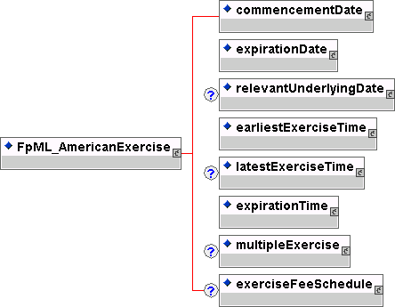
Contents:
commencementDate (exactly one occurrence; contains the sub-element(s) defined by exactly one occurrence of the entity FpML_AdjustableOrRelativeDate)
- The first day of the exercise period for an American style option.
expirationDate (exactly one occurrence; contains the sub-element(s) defined by exactly one occurrence of the entity FpML_AdjustableOrRelativeDate)
- The last day within an exercise period for an American style option. For a European style option it is the only day within the exercise period.
relevantUnderlyingDate (zero or one occurrence; contains the sub-element(s) defined by exactly one occurrence of the entity FpML_AdjustableOrRelativeDates)
- The date on the underlying set by the exercise of an option. What this date is depends on the option (eg in a swaption it is the effective date, in a extendible / cancelable provision is is the termination date).
earliestExerciseTime (exactly one occurrence; contains the sub-element(s) defined by exactly one occurrence of the entity FpML_BusinessCenterTime)
- The earliest time at which notice of exercise can be given by the buyer to the seller (or seller's agent) i) on the expiration date, in the case of a European style option, (ii) on each bermuda option exercise date and the expiration date, in the case of a Bermuda style option and (iii) all days that are exercise business days from and including the commencement date to, and including, the expiration date, in the case of an American style option.
latestExerciseTime (zero or one occurrence; contains the sub-element(s) defined by exactly one occurrence of the entity FpML_BusinessCenterTime)
- For a Bermuda or American style options, the latest time on an exercise business day (excluding the expiration date) within the exercise period that notice of exercise can be given by buyer to the seller or seller's agent. Notice of exercise given after this time will be deemed to have been given on the next exercise business day.
expirationTime (exactly one occurrence; contains the sub-element(s) defined by exactly one occurrence of the entity FpML_BusinessCenterTime)
- The latest time for exercise on expirationDate.
multipleExercise (zero or one occurrence; contains the sub-element(s) defined by exactly one occurrence of the entity FpML_MultipleExercise)
- As defined in the 2000 ISDA Definitions, Section 12.4. Multiple Exercise, the buyer of the option has the right to exercise all or less than all the unexercised notional amount of the underlying swap on one or more days in the exercise period, but on any such day may not exercise less than the minimum notional amount or more than the maximum notional amount, and if an integral multiple amount is specified, the notional amount exercised must be equal to, or be an integral multiple of, the integral multiple amount.
exerciseFeeSchedule (zero or one occurrence; contains the sub-element(s) defined by exactly one occurrence of the entity FpML_ExerciseFeeSchedule)
- The fees associated with an exercise date. The fees are conditional on the exercise occurring. The fees can be specified as actual currency amounts or as percentages of the notional amount being exercised.
Used by:
americanExercise
DTD Fragment:
<!ENTITY % FpML_AmericanExercise "commencementDate , expirationDate , relevantUnderlyingDate? , earliestExerciseTime , latestExerciseTime? , expirationTime , multipleExercise? , exerciseFeeSchedule?">

FpML_AmountSchedule
Description:
An entity for defining a currency amount or a currency amount schedule. This entity inherits from a base entity, FpML_Schedule.
Figure:
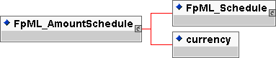
Contents:
inherited element(s) (this entity inherits the element(s) defined by exactly one occurrence of the entity FpML_Schedule)
- An entity for defining a schedule of rate or amounts in terms of an initial value and then a series of step date and value pairs. On each step date the rate or amount changes to the new step value. The series of step date and value pairs are optional. If not specified, this implies that the initial value remains unchanged over time.
currency (exactly one occurrence; of type string, an enumerated domain value defined by currencyScheme)
- The currency in which an amount is denominated.
Used by:
knownAmountSchedule
notionalStepSchedule
DTD Fragment:
<!ENTITY % FpML_AmountSchedule "(%FpML_Schedule; , currency)">

FpML_AutomaticExercise
Description:
An entity to define automatic exercise of a swaption. With automatic exercise the option is deemed to have exercised if it is in the money by more than the threshold amount on the exercise date.
Figure:
Contents:
thresholdRate (exactly one occurrence; of type decimal)
- A threshold rate. A threshold of 0.10% would be represented as 0.001.
Used by:
automaticExercise
DTD Fragment:
<!ENTITY % FpML_AutomaticExercise "thresholdRate">

FpML_BermudaExercise
Description:
An entity to define the bermuda option exercise dates and the expiration date together with any rules governing the notional amount of the underlying which can be exercised on any given exercise date and any associated exercise fees.
Figure:
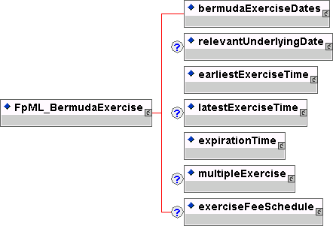
Contents:
bermudaExerciseDates (exactly one occurrence; contains the sub-element(s) defined by exactly one occurrence of the entity FpML_AdjustableOrRelativeDates)
- The dates that define the bermuda option exercise dates and the expiration date. The last specified exercise date is assumed to be the expiration date. The dates can either be specified as a series of explicit dates and associated adjustments or as a series of dates defined relative to another schedule of dates, for example, the calculation period start dates. Where a relative series of dates are defined the first and last possible exercise dates can be separately specified.
relevantUnderlyingDate (zero or one occurrence; contains the sub-element(s) defined by exactly one occurrence of the entity FpML_AdjustableOrRelativeDates)
- The date on the underlying set by the exercise of an option. What this date is depends on the option (eg in a swaption it is the effective date, in a extendible / cancelable provision is is the termination date).
earliestExerciseTime (exactly one occurrence; contains the sub-element(s) defined by exactly one occurrence of the entity FpML_BusinessCenterTime)
- The earliest time at which notice of exercise can be given by the buyer to the seller (or seller's agent) i) on the expiration date, in the case of a European style option, (ii) on each bermuda option exercise date and the expiration date, in the case of a Bermuda style option and (iii) all days that are exercise business days from and including the commencement date to, and including, the expiration date, in the case of an American style option.
latestExerciseTime (zero or one occurrence; contains the sub-element(s) defined by exactly one occurrence of the entity FpML_BusinessCenterTime)
- For a Bermuda or American style options, the latest time on an exercise business day (excluding the expiration date) within the exercise period that notice of exercise can be given by buyer to the seller or seller's agent. Notice of exercise given after this time will be deemed to have been given on the next exercise business day.
expirationTime (exactly one occurrence; contains the sub-element(s) defined by exactly one occurrence of the entity FpML_BusinessCenterTime)
- The latest time for exercise on expirationDate.
multipleExercise (zero or one occurrence; contains the sub-element(s) defined by exactly one occurrence of the entity FpML_MultipleExercise)
- As defined in the 2000 ISDA Definitions, Section 12.4. Multiple Exercise, the buyer of the option has the right to exercise all or less than all the unexercised notional amount of the underlying swap on one or more days in the exercise period, but on any such day may not exercise less than the minimum notional amount or more than the maximum notional amount, and if an integral multiple amount is specified, the notional amount exercised must be equal to, or be an integral multiple of, the integral multiple amount.
exerciseFeeSchedule (zero or one occurrence; contains the sub-element(s) defined by exactly one occurrence of the entity FpML_ExerciseFeeSchedule)
- The fees associated with an exercise date. The fees are conditional on the exercise occurring. The fees can be specified as actual currency amounts or as percentages of the notional amount being exercised.
Used by:
bermudaExercise
DTD Fragment:
<!ENTITY % FpML_BermudaExercise "bermudaExerciseDates , relevantUnderlyingDate? , earliestExerciseTime , latestExerciseTime? , expirationTime , multipleExercise? , exerciseFeeSchedule?">

FpML_BulletPayment
Description:
An product to represent a single cashflow. This entity inherits from the base entity, FpML_Product.
Figure:
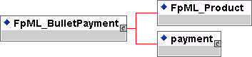
Contents:
inherited element(s) (this entity inherits the element(s) defined by exactly one occurrence of the entity FpML_Product)
- The base entity which all FpML products extend.
payment (exactly one occurrence; contains the sub-element(s) defined by exactly one occurrence of the entity FpML_Payment)
- A known payment between two parties.
Used by:
bulletPayment
DTD Fragment:
<!ENTITY %FpML_BulletPayment "%FpML_Product;,payment">

FpML_BusinessCenters
Description:
An entity for defining financial business centers used in determining whether a day is a business day or not.
Figure:
Contents:
businessCenter (one or more occurrences; of type string, an enumerated domain value defined by businessCenterScheme)
- A code identifying a financial business center location. A list of business centers may be ordered in the document alphabetically based on business center code. An FpML document containing an unordered business center list is still regarded as a conformant document.
Used by:
businessCenters
DTD Fragment:
<!ENTITY % FpML_BusinessCenters "businessCenter+">

FpML_BusinessCenterTime
Description:
An entity for defining a time with respect to a business center location. For example, 11:00 am London time.
Figure:
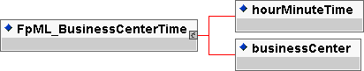
Contents:
hourMinuteTime (exactly one occurrence; of type time)
- A time specified in hh:mm:ss format where the second component must be '00', e.g. 11am would be represented as 11:00:00.
businessCenter (exactly one occurrence; of type string, an enumerated domain value defined by businessCenterScheme)
- A code identifying a financial business center location. A list of business centers may be ordered in the document alphabetically based on business center code. An FpML document containing an unordered business center list is still regarded as a conformant document.
Used by:
cashSettlementValuationTime
earliestExerciseTime
expirationTime
fixingTime
latestExerciseTime
DTD Fragment:
<!ENTITY % FpML_BusinessCenterTime "hourMinuteTime , businessCenter">

FpML_BusinessDateRange
Description:
An entity for defining a range of contiguous business days by defining an unadjusted first date, an unadjusted last date and a business day convention and business centers for adjusting the first and last dates if they would otherwise fall on a non business day in the specified business centers. The days between the first and last date must also be good business days in the specified business centers to be counted in the range. This entity inherits from the base entity, FpML_DateRange.
Figure:
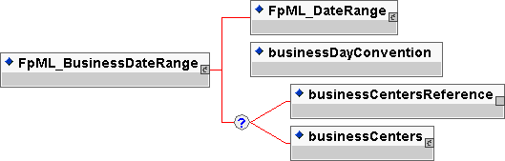
Contents:
inherited element(s) (this entity inherits the element(s) defined by exactly one occurrence of the entity FpML_DateRange)
- A range of dates
businessDayConvention (exactly one occurrence; of type string, an enumerated domain value defined by businessDayConventionScheme)
- The convention for adjusting a date if it would otherwise fall on a day that is not a business day.
Zero or one occurrence of either
businessCentersReference (exactly one occurrence; an empty element containing an href attribute)
- A pointer style reference to a set of financial business centers defined elsewhere in the document. This set of business centers is used to determine whether a particular day is a business day or not.
Or
businessCenters (zero or one occurrence; contains the sub-element(s) defined by exactly one occurrence of the entity FpML_BusinessCenters)
- A container for a set of financial business centers. This set of business centers is used to determine whether a day is a business day or not.
Used by:
businessDateRange
DTD Fragment:
<!ENTITY % FpML_BusinessDateRange "(%FpML_DateRange; , businessDayConvention , (businessCentersReference | businessCenters)?)">

FpML_BusinessDayAdjustments
Description:
An entity for defining the business day convention and financial business centers used for adjusting any relevant date if it would otherwise fall on a day that is not a business day in the specified business centers.
Figure:
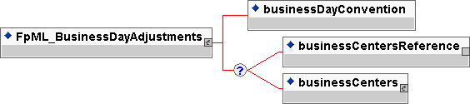
Contents:
businessDayConvention (exactly one occurrence; of type string, an enumerated domain value defined by businessDayConventionScheme)
- The convention for adjusting a date if it would otherwise fall on a day that is not a business day. If the business day convention value is NONE then neither the businessCentersReference or businessCenters element should be included
Zero or one occurrence of either
businessCentersReference (exactly one occurrence; an empty element containing an href attribute)
- A pointer style reference to a set of financial business centers defined elsewhere in the document. This set of business centers is used to determine whether a particular day is a business day or not.
Or
businessCenters (zero or one occurrence; contains the sub-element(s) defined by exactly one occurrence of the entity FpML_BusinessCenters)
- A container for a set of financial business centers. This set of business centers is used to determine whether a day is a business day or not.
Used by:
calculationPeriodDatesAdjustments
dateAdjustments
paymentDatesAdjustments
resetDatesAdjustments
DTD Fragment:
<!ENTITY % FpML_BusinessDayAdjustments "businessDayConvention , (businessCentersReference | businessCenters)?">

FpML_Calculation
Description:
An entity for defining the parameters used in the calculation of fixed or floating calculation period amounts.
Figure:
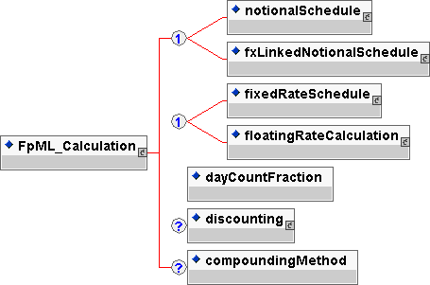
Contents:
Either
notionalSchedule (exactly one occurrence; contains the sub-element(s) defined by exactly one occurrence of the entity FpML_Notional)
- The notional amount or notional amount schedule.
Or
fxLinkedNotionalSchedule (exactly one occurrence; contains the sub-element(s) defined by exactly one occurrence of the entity FpML_FxLinkedNotionalSchedule)
- A notional amount schedule where each notional that applies to a calculation period is calculated with reference to a notional amount or notional amount schedule in a different currency by means of a spot currency exchange rate which is normally observed at the beginning of each period.
Either
fixedRateSchedule (exactly one occurrence; contains the sub-element(s) defined by exactly one occurrence of the entity FpML_Schedule)
- The fixed rate or fixed rate schedule expressed as explicit fixed rates and dates. In the case of a schedule, the step dates may be subject to adjustment in accordance with any adjustments specified in calculationPeriodDatesAdjustments.
Or
floatingRateCalculation (exactly one occurrence; contains the sub-element(s) defined by exactly one occurrence of the entity FpML_FloatingRateCalculation)
- The floating rate calculation definitions.
dayCountFraction (exactly one occurrence; of type string, an enumerated domain value defined by dayCountFractionScheme)
- The day count fraction.
discounting (zero or one occurrence; contains the sub-element(s) defined by exactly one occurrence of the entity FpML_Discounting)
- The parameters specifying any discounting conventions that may apply. This element must only be included if discounting applies.
compoundingMethod (zero or one occurrence; of type string, an enumerated domain value defined by compoundingMethodScheme)
- If more than one calculation period contributes to a single payment amount this element specifies whether compounding is applicable, and if so, what compounding method is to be used. This element must only be included when more than one calculation period contributes to a single payment amount.
Used by:
calculation
DTD Fragment:
<!ENTITY % FpML_Calculation "((notionalSchedule | fxLinkedNotionalSchedule) , (fixedRateSchedule | floatingRateCalculation) , dayCountFraction , discounting? , compoundingMethod?)">

FpML_CalculationAgent
Description:
An entity for defining the ISDA Calculation Agent responsible for performing duties associated with the optional early termination on a swap transaction.
Figure:
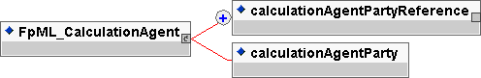
Contents:
Either
calculationAgentPartyReference (one or more occurrences; an empty element containing an href attribute)
- A pointer style reference to a party identifier defined elsewhere in the document. The party referenced is the ISDA Calculation Agent for the trade. If more than one party is referenced then the parties are assumed to be co-calculation agents, i.e. they have joint responsibility.
Or
calculationAgentParty (exactly one occurrence; of type string, an enumerated domain value defined by calculationAgentPartyScheme)
- The ISDA Calculation Agent where the actual party responsible for performing the duties associated with a mandatory or optional early termination provision on a Swap Transaction will be determined at exercise, or in the case of mandatory early termination on the Cash Settlement Valuation Date. For example, the Calculation Agent in an optional early termination may be defined as being the Non-Exercising Party. Alternatively, the party responsible may be determined by reference to the relevant master agreement.
Used by:
calculationAgent
DTD Fragment:
<!ENTITY % FpML_CalculationAgent "calculationAgentPartyReference+ | calculationAgentParty">

FpML_CalculationPeriod
Description:
An entity for defining the parameters used in the calculation of a fixed or floating rate calculation period amount. This entity forms part of the cashflows representation of a swap stream.
Figure:
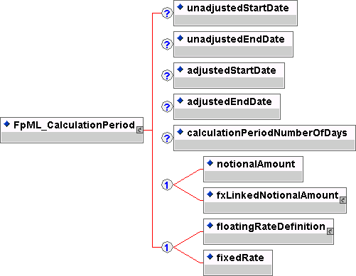
Contents:
unadjustedStartDate (zero or one occurrence; of type date)
- The unadjusted calculation period start date.
unadjustedEndDate (zero or one occurrence; of type date)
- The unadjusted calculation period end date.
adjustedStartDate (zero or one occurrence; of type date)
- The calculation period start date, adjusted according to any relevant business day convention.
adjustedEndDate (zero or one occurrence; of type date)
- The calculation period end date, adjusted according to any relevant business day convention.
calculationPeriodNumberOfDays (exactly one occurrence; of type positiveInteger)
The number of days from the adjusted effective / start date to the adjusted termination / end date calculated in accordance with the applicable day count fraction.

Either
notionalAmount (exactly one occurrence; of type decimal)
- The calculation period notional amount.
Or
fxLinkedNotionalAmount (exactly one occurrence; contains the sub-element(s) defined by exactly one occurrence of the entity FpML_FxLinkedNotionalAmount)
- The amount that a cashflow will accrue interest on. This is the calculated amount of the fx linked notional - ie the other currency notional amount multiplied by the appropriate fx spot rate.
Either
floatingRateDefinition (exactly one occurrence; contains the sub-element(s) defined by exactly one occurrence of the entity FpML_FloatingRateDefinition)
- The floating rate reset information for the calculation period.
Or
fixedRate (exactly one occurrence; of type decimal)
- The calculation period fixed rate. A per annum rate, expressed as a decimal. A fixed rate of 5% would be represented as 0.05.
Used by:
calculationPeriod
DTD Fragment:
<!ENTITY % FpML_CalculationPeriod "unadjustedStartDate?, unadjustedEndDate?, adjustedStartDate? , adjustedEndDate?, calculationPeriodNumberOfDays? , (notionalAmount | fxLinkedNotionalAmount) , (floatingRateDefinition | fixedRate)">

FpML_CalculationPeriodAmount
Description:
An entity for defining the parameters used in the calculation of fixed or floating rate calculation period amounts or for specifying a known calculation period amount or known amount schedule.
Figure:
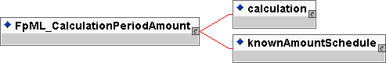
Contents:
Either
calculation (exactly one occurrence; contains the sub-element(s) defined by exactly one occurrence of the entity FpML_Calculation)
- The parameters used in the calculation of fixed or floating rate calculation period amounts.
Or
knownAmountSchedule (exactly one occurrence; contains the sub-element(s) defined by exactly one occurrence of the entity FpML_AmountSchedule)
- The known calculation period amount or a known amount schedule expressed as explicit known amounts and dates. In the case of a schedule, the step dates may be subject to adjustment in accordance with any adjustments specified in calculationPeriodDatesAdjustments.
Used by:
calculationPeriodAmount
DTD Fragment:
<!ENTITY % FpML_CalculationPeriodAmount "calculation | knownAmountSchedule">

FpML_CalculationPeriodDates
Description:
An entity for defining the parameters used to generate the calculation periods dates schedule, including the specification of any initial or final stub calculation periods. A calculation period schedule consists of an optional initial stub calculation period, one or more regular calculation periods and an optional final stub calculation period. In the absence of any initial or final stub calculation periods, the regular part of the calculation period schedule is assumed to be between the effective date and the termination date. No implicit stubs are allowed, i.e. stubs must be explicitly specified using an appropriate combination of firstPeriodStartDate, firstRegularPeriodStartDate and lastRegularPeriodEndDate.
Figure:
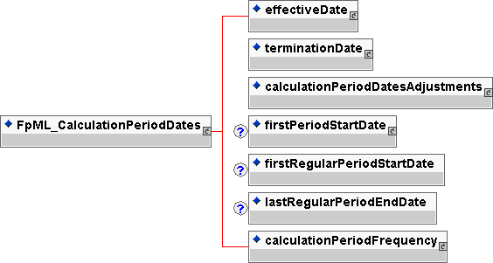
Contents:
effectiveDate (exactly one occurrence; contains the sub-element(s) defined by exactly one occurrence of the entity FpML_AdjustableDate)
- The first day of the term of the trade. This day may be subject to adjustment in accordance with a business day convention.
terminationDate (exactly one occurrence; contains the sub-element(s) defined by exactly one occurrence of the entity FpML_AdjustableDate)
- The last day of the term of the trade. This day may be subject to adjustment in accordance with a business day convention.
calculationPeriodDatesAdjustments (exactly one occurrence; contains the sub-element(s) defined by exactly one occurrence of the entity FpML_BusinessDayAdjustments)
- The business day convention to apply to each calculation period end date if it would otherwise fall on a day that is not a business day in the specified financial business centers.
firstPeriodStartDate (zero or one occurrence; contains the sub-element(s) defined by exactly one occurrence of the entity FpML_AdjustableDate)
- The start date of the first calculation period if the date falls before the effective date. It must only be specified if it is not equal to the effective date. This day may be subject to adjustment in accordance with a business day convention.
firstRegularPeriodStartDate (zero or one occurrence; of type date)
- The start date of the regular part of the calculation period schedule. It must only be specified if there is an initial stub calculation period. This day may be subject to adjustment in accordance with any adjustments specified in calculationPeriodDatesAdjustments.
lastRegularPeriodEndDate (zero or one occurrence; of type date)
- The end date of the regular part of the calculation period schedule. It must only be specified if there is a final stub calculation period. This day may be subject to adjustment in accordance with any adjustments specified in calculationPeriodDatesAdjustments.
calculationPeriodFrequency (exactly one occurrence; contains the sub-element(s) defined by exactly one occurrence of the entity FpML_CalculationPeriodFrequency)
- The frequency at which calculation period end dates occur within the regular part of the calculation period schedule and their roll date convention.
Used by:
calculationPeriodDates
DTD Fragment:
<!ENTITY % FpML_CalculationPeriodDates "effectiveDate , terminationDate , calculationPeriodDatesAdjustments , firstPeriodStartDate? , firstRegularPeriodStartDate? , lastRegularPeriodEndDate? , calculationPeriodFrequency">

FpML_CalculationPeriodFrequency
Description:
An entity for defining the frequency at which calculation period end dates occur within the regular part of the calculation period schedule and their roll date convention. This entity inherits from a base entity, FpML_Interval.
Figure:
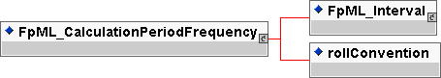
Contents:
inherited element(s) (this entity inherits the element(s) defined by exactly one occurrence of the entity FpML_Interval)
- An entity for defining a time interval or offset, e.g. one day, three months. Used for specifying frequencies at which events occur, the tenor of a floating rate or an offset relative to another date.
rollConvention (exactly one occurrence; of type string, an enumerated domain value defined by rollConventionScheme)
- Used in conjunction with a frequency and the regular period start date of a calculation period, determines each calculation period end date within the regular part of a calculation period schedule.
Used by:
calculationPeriodFrequency
DTD Fragment:
<!ENTITY % FpML_CalculationPeriodFrequency "(%FpML_Interval; , rollConvention)">

FpML_CancelableProvision
Description:
An entity to define the the right for a party to cancel a swap transaction on the specified exercise dates. This provision is for 'walkaway' cancellation (ie the fair value of the swap is not paid). A fee payable on exercise can be specified.
Figure:
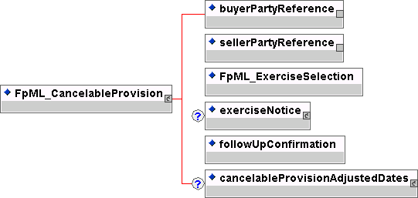
Contents:
buyerPartyReference (exactly one occurrence; an empty element containing an href attribute)
- A pointer style reference to a party identifier defined elsewhere in the document. The party referenced is the buyer of the instrument, also known as the fixed rate payer.
sellerPartyReference (exactly one occurrence; an empty element containing an href attribute)
- A pointer style reference to a party identifier defined elsewhere in the document. The party referenced is the seller of the instrument, also known as the floating rate payer.
inherited element(s) (this entity inherits the element(s) defined by exactly one occurrence of the entity FpML_ExerciseSelection)
- Entity to defined the types of exercise. The choice is european, bermuda or american exercise.
exerciseNotice (zero or one occurrence; contains the sub-element(s) defined by exactly one occurrence of the entity FpML_ExerciseNotice)
- Definition of the party to whom notice of exercise should be given.
followUpConfirmation (exactly one occurrence; of type boolean)
- A flag to indicate whether follow-up confirmation of exercise (written or electronic) is required following telephonic notice by the buyer to the seller or seller's agent.
cancelableProvisionAdjustedDates (zero or one occurrence; contains the sub-element(s) defined by exactly one occurrence of the entity FpML_CancelableProvisionAdjustedDates)
- The adjusted dates associated with a cancelable provision. These dates have been adjusted for any applicable business day convention.
Used by:
cancelableProvision
DTD Fragment:
<!ENTITY % FpML_CancelableProvision "buyerPartyReference , sellerPartyReference , (%FpML_ExerciseSelection;) , exerciseNotice? , followUpConfirmation , cancelableProvisionAdjustedDates?">

FpML_CancelableProvisionAdjustedDates
Description:
An entity to define the adjusted dates for a cancelable provision on a swap transaction.
Figure:
Contents:
cancellationEvent (one or more occurrences; contains the sub-element(s) defined by exactly one occurrence of the entity FpML_CancellationEvent)
- The adjusted dates for an individual cancellation date.
Used by:
cancelableProvisionAdjustedDates
DTD Fragment:
<!ENTITY % FpML_CancelableProvisionAdjustedDates "cancellationEvent+">

FpML_CancellationEvent
Description:
The adjusted dates for a specific cancellation date - this includes the adjusted exercise date and adjusted termination date
Figure:
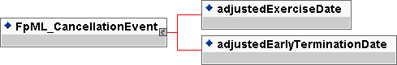
Contents:
adjustedExerciseDate (exactly one occurrence; of type date)
- The date on which option exercise takes place. This date should already be adjusted for any applicable business day convention.
adjustedEarlyTerminationDate (exactly one occurrence; of type date)
- The early termination date that is applicable if an early termination provision is exercised. This date should already be adjusted for any applicable business day convention.
Used by:
cancellationEvent
DTD Fragment:
<!ENTITY % FpML_CancellationEvent "adjustedExerciseDate , adjustedEarlyTerminationDate">

FpML_CapFloor
Description:
An entity for defining an interest rate cap, floor or cap/floor strategy (eg collar) product. This entity inherits from the base entity, FpML_Product.
Figure:
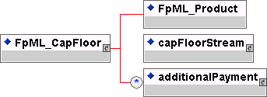
Contents:

inherited element(s) (this entity inherits the element(s) defined by exactly one occurrence of the entity FpML_Product)
- The base entity which all FpML products extend.
capFloorStream (exactly one occurrence; contains the sub-element(s) defined by exactly one occurrence of the entity FpML_InterestRateStream)
- A cap, floor or cap floor structure stream.
additionalPayment (zero or more occurrences; contains the sub-element(s) defined by exactly one occurrence of the entity FpML_Fee)
- Additional payments between the principal parties.
Used by:
capFloor
DTD Fragment:
<!ENTITY % FpML_CapFloor "%FpML_Product;,capFloorStream , additionalPayment*">

FpML_Cashflows
Description:
An entity for defining the cashflow representation of a swap trade.
Figure:
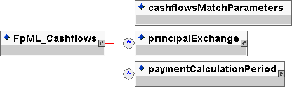
Contents:
cashflowsMatchParameters (exactly one occurrence; of type boolean)
- A true/false flag to indicate whether the cashflows match the parametric definition of the stream, i.e. whether the cashflows could be regenerated from the parameters without loss of information.
principalExchange (zero or more occurrences; contains the sub-element(s) defined by exactly one occurrence of the entity FpML_PrincipalExchange)
- The initial, intermediate and final principal exchange amounts. Typically required on cross currency interest rate swaps where actual exchanges of principal occur. A list of principal exchange elements may be ordered in the document by ascending adjusted principal exchange date. An FpML document containing an unordered principal exchange list is still regarded as a conformant document.
paymentCalculationPeriod (zero or more occurrences; contains the sub-element(s) defined by exactly one occurrence of the entity FpML_PaymentCalculationPeriod)
- The adjusted payment date and associated calculation period parameters required to calculate the actual or projected payment amount. A list of payment calculation period elements may be ordered in the document by ascending adjusted payment date. An FpML document containing an unordered list of payment calculation periods is still regarded as a conformant document.
Used by:
cashflows
DTD Fragment:
<!ENTITY % FpML_Cashflows "cashflowsMatchParameters , principalExchange* , paymentCalculationPeriod*">

FpML_CashPriceMethod
Description:
An entity to define the parameters necessary for each of the ISDA defined cash price methods for cash settlement.
Figure:
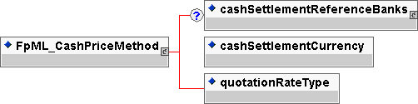
Contents:
cashSettlementReferenceBanks (zero or one occurrence; contains the sub-element(s) defined by exactly one occurrence of the entity FpML_CashSettlementReferenceBanks)
- A container for a set of reference institutions. These reference institutions may be called upon to provide rate quotations as part of the method to determine the applicable cash settlement amount. If institutions are not specified, it is assumed that reference institutions will be agreed between the parties on the exercise date, or in the case of swap transaction to which mandatory early termination is applicable, the cash settlement valuation date.
cashSettlementCurrency (exactly one occurrence; of type string, an enumerated domain value defined by currencyScheme)
- The currency in which the cash settlement amount will be calculated and settled.
quotationRateType (exactly one occurrence; of type string, an enumerated domain value defined by quotationRateTypeScheme)
- Which rate quote is to be observed, either Bid, Mid, Offer or Exercising Party Pays. The meaning of Exercising Party Pays is defined in the 2000 ISDA Definitions, Section 17.2. Certain Definitions Relating to Cash Settlement, paragraph (j)
Used by:
cashPriceAlternateMethod
cashPriceMethod
DTD Fragment:
<!ENTITY % FpML_CashPriceMethod "cashSettlementReferenceBanks? , cashSettlementCurrency , quotationRateType">

FpML_CashSettlement
Description:
An entity to define the cash settlement terms for a product where cash settlement is applicable.
Figure:
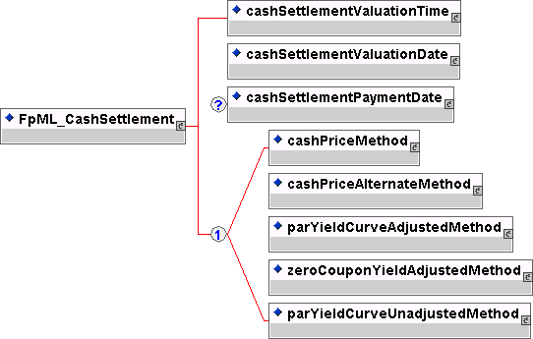
Contents:
cashSettlementValuationTime (exactly one occurrence; contains the sub-element(s) defined by exactly one occurrence of the entity FpML_BusinessCenterTime)
- The time on the cash settlement valuation date when the cash settlement amount will be determined according to the cash settlement method if the parties have not otherwise been able to agree the cash settlement amount.
cashSettlementValuationDate (exactly one occurrence; contains the sub-element(s) defined by exactly one occurrence of the entity FpML_RelativeDateOffset)
- The date on which the cash settlement amount will be determined according to the cash settlement method if the parties have not otherwise been able to agree the cash settlement amount.
cashSettlementPaymentDate (zero or one occurrence; contains the sub-element(s) defined by exactly one occurrence of the entity FpML_CashSettlementPaymentDate)
- The date on which the cash settlement amount will be paid, subject to adjustment in accordance with any applicable business day convention. This element would not be present for a mandatory early termination provision where the cash settlement payment date is the mandatory early termination date.
Either
cashPriceMethod (exactly one occurrence; contains the sub-element(s) defined by exactly one occurrence of the entity FpML_CashPriceMethod)
- An ISDA defined cash settlement method used for the determination of the applicable cash settlement amount. The method is defined in the 2000 ISDA Definitions, Section 17.3. Cash Settlement Methods, paragraph (a).
Or
cashPriceAlternateMethod (exactly one occurrence; contains the sub-element(s) defined by exactly one occurrence of the entity FpML_CashPriceMethod)
- An ISDA defined cash settlement method used for the determination of the applicable cash settlement amount. The method is defined in the 2000 ISDA Definitions, Section 17.3. Cash Settlement Methods, paragraph (b).
Or
parYieldCurveAdjustedMethod (exactly one occurrence; contains the sub-element(s) defined by exactly one occurrence of the entity FpML_YieldCurveMethod)
- An ISDA defined cash settlement method used for the determination of the applicable cash settlement amount. The method is defined in the 2000 ISDA Definitions, Section 17.3. Cash Settlement Methods, paragraph (c).
Or
zeroCouponYieldAdjustedMethod (exactly one occurrence; contains the sub-element(s) defined by exactly one occurrence of the entity FpML_YieldCurveMethod)
- An ISDA defined cash settlement method used for the determination of the applicable cash settlement amount. The method is defined in the 2000 ISDA Definitions, Section 17.3. Cash Settlement Methods, paragraph (d).
Or
parYieldCurveUnadjustedMethod (exactly one occurrence; contains the sub-element(s) defined by exactly one occurrence of the entity FpML_YieldCurveMethod)
- An ISDA defined cash settlement method used for the determination of the applicable cash settlement amount. The method is defined in the 2000 ISDA Definitions, Section 17.3. Cash Settlement Methods, paragraph (e).
Used by:
cashSettlement
DTD Fragment:
<!ENTITY % FpML_CashSettlement "cashSettlementValuationTime , cashSettlementValuationDate , cashSettlementPaymentDate? , (cashPriceMethod | cashPriceAlternateMethod | parYieldCurveAdjustedMethod | zeroCouponYieldAdjustedMethod | parYieldCurveUnadjustedMethod)">

FpML_CashSettlementPaymentDate
Description:
An entity for defining the cash settlement payment date(s) as either a set of explicit dates, together with applicable adjustments, or as a date relative to some other (anchor) date, or as any date in a range of contiguous business days.
Figure:
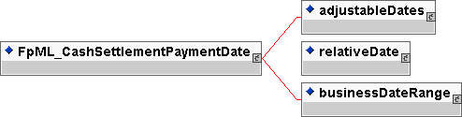
Contents:
Either
adjustableDates (exactly one occurrence; contains the sub-element(s) defined by exactly one occurrence of the entity FpML_AdjustableDates)
- A series of dates that shall be subject to adjustment if they would otherwise fall on a day that is not a business day in the specified business centers, together with the convention for adjusting the date.
Or
relativeDate (exactly one occurrence; contains the sub-element(s) defined by exactly one occurrence of the entity FpML_RelativeDateOffset)
- A date specified as some offset to another date (the anchor date).
Or
businessDateRange (exactly one occurrence; contains the sub-element(s) defined by exactly one occurrence of the entity FpML_BusinessDateRange)
- A range of contiguous business days.
Used by:
cashSettlementPaymentDate
DTD Fragment:
<!ENTITY % FpML_CashSettlementPaymentDate "adjustableDates | relativeDate | businessDateRange">

FpML_CashSettlementReferenceBanks
Description:
An entity for defining the list of reference institutions polled for relevant rates or prices when determining the cash settlement amount for a product where cash settlement is applicable.
Figure:
Contents:
referenceBank (one or more occurrences; contains the sub-element(s) defined by exactly one occurrence of the entity FpML_ReferenceBank)
- An institution (party) identified by means of a coding scheme and an optional name.
Used by:
cashSettlementReferenceBanks
DTD Fragment:
<!ENTITY % FpML_CashSettlementReferenceBanks "referenceBank+">

FpML_DateRange
Description:
A entity for defining a contiguous series of calendar dats. The date range is defined as all the dates between and including the first and the last date. The first date must fall before the last date.
Figure:
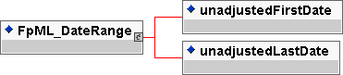
Contents:
unadjustedFirstDate (exactly one occurrence; of type date)
- The first date of a date range.
unadjustedLastDate (exactly one occurrence; of type date)
- The last date of a date range.
Used by:
FpML_BusinessDateRange
scheduleBounds
DTD Fragment:
<!ENTITY % FpML_DateRange "unadjustedFirstDate , unadjustedLastDate">

FpML_Discounting
Description:
An entity for defining discounting information. The 2000 ISDA Definitions, Section 8.4. Discounting (related to the calculation of a discounted fixed amount or floating amount) apply. This entity must only be included if discounting applies.
Figure:
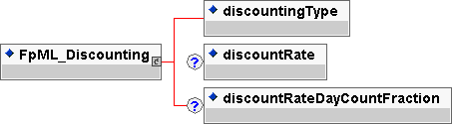
Contents:
discountingType (exactly one occurrence; of type string, an enumerated domain value defined by discountingTypeScheme)
- The discounting method that is applicable.
discountRate (zero or one occurrence; of type decimal)
- A discount rate, expressed as a decimal, to be used in the calculation of a discounted amount. A discount rate of 5% would be represented as 0.05.
discountRateDayCountFraction (zero or one occurrence; of type string, an enumerated domain value defined by dayCountFractionScheme)
- A discount day count fraction to be used in the calculation of a discounted amount.
Used by:
discounting
DTD Fragment:
<!ENTITY % FpML_Discounting "discountingType , discountRate? , discountRateDayCountFraction?">

FpML_EarlyTerminationEvent
Description:
An entity to define the adjusted dates associated with an early termination provision.
Figure:
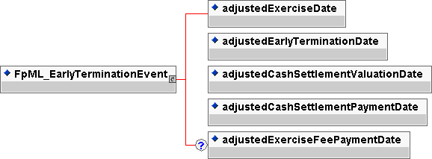
Contents:
adjustedExerciseDate (exactly one occurrence; of type date)
- The date on which option exercise takes place. This date should already be adjusted for any applicable business day convention.
adjustedEarlyTerminationDate (exactly one occurrence; of type date)
- The early termination date that is applicable if an early termination provision is exercised. This date should already be adjusted for any applicable business day convention.
adjustedCashSettlementValuationDate (exactly one occurrence; of type date)
- The date by which the cash settlement amount must be agreed. This date should already be adjusted for any applicable business day convention.
adjustedCashSettlementPaymentDate (exactly one occurrence; of type date)
- The date on which the cash settlement amount is paid. This date should already be adjusted for any applicable business day convention.
adjustedExerciseFeePaymentDate (zero or one occurrence; of type date)
- The date on which the exercise fee amount is paid. This date should already be adjusted for any applicable business day convention.
Used by:
earlyTerminationEvent
DTD Fragment:
<!ENTITY % FpML_EarlyTerminationEvent "adjustedExerciseDate , adjustedEarlyTerminationDate , adjustedCashSettlementValuationDate , adjustedCashSettlementPaymentDate , adjustedExerciseFeePaymentDate?">

FpML_EarlyTerminationProvision
Description:
An entity to define an early termination provision for a swap. This early termination is at fair value, ie on termination the fair value of the product must be settled between the parties.
Figure:
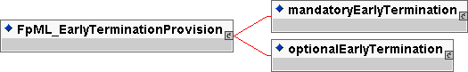
Contents:
Either
mandatoryEarlyTermination (exactly one occurrence; contains the sub-element(s) defined by exactly one occurrence of the entity FpML_MandatoryEarlyTermination)
- A mandatory early termination provision to terminate the swap at fair value.
Or
optionalEarlyTermination (exactly one occurrence; contains the sub-element(s) defined by exactly one occurrence of the entity FpML_OptionalEarlyTermination)
- An option for either or both parties to terminate the swap at fair value.
Used by:
earlyTerminationProvision
DTD Fragment:
<!ENTITY % FpML_EarlyTerminationProvision "mandatoryEarlyTermination | optionalEarlyTermination">

FpML_EuropeanExercise
Description:
An entity to define the exercise period for a European style option together with any rules governing the notional amount of the underlying which can be exercised on any given exercise date and any associated exercise fees.
Figure:
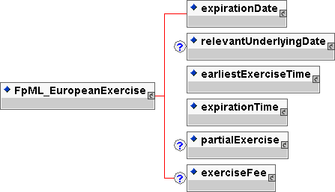
Contents:
expirationDate (exactly one occurrence; contains the sub-element(s) defined by exactly one occurrence of the entity FpML_AdjustableOrRelativeDate)
- The last day within an exercise period for an American style option. For a European style option it is the only day within the exercise period.
relevantUnderlyingDate (zero or one occurrence; contains the sub-element(s) defined by exactly one occurrence of the entity FpML_AdjustableOrRelativeDates)
- The date on the underlying set by the exercise of an option. What this date is depends on the option (eg in a swaption it is the effective date, in a extendible / cancelable provision is is the termination date).
earliestExerciseTime (exactly one occurrence; contains the sub-element(s) defined by exactly one occurrence of the entity FpML_BusinessCenterTime)
- The earliest time at which notice of exercise can be given by the buyer to the seller (or seller's agent) i) on the expiration date, in the case of a European style option, (ii) on each bermuda option exercise date and the expiration date, in the case of a Bermuda style option and (iii) all days that are exercise business days from and including the commencement date to, and including, the expiration date, in the case of an American style option.
expirationTime (exactly one occurrence; contains the sub-element(s) defined by exactly one occurrence of the entity FpML_BusinessCenterTime)
- The latest time for exercise on expirationDate.
partialExercise (zero or one occurrence; contains the sub-element(s) defined by exactly one occurrence of the entity FpML_PartialExercise)
- As defined in the 2000 ISDA Definitions, Section 12.3. Partial Exercise, the buyer of the option has the right to exercise all or less than all the notional amount of the underlying swap on the expiration date, but may not exercise less than the minimum notional amount, and if an integral multiple amount is specified, the notional amount exercised must be equal to, or be an integral multiple of, the integral multiple amount.
exerciseFee (zero or one occurrence; contains the sub-element(s) defined by exactly one occurrence of the entity FpML_ExerciseFee)
- A fee to be paid on exercise. This could be represented as an amount or a rate and notional reference on which to apply the rate.
Used by:
europeanExercise
DTD Fragment:
<!ENTITY % FpML_EuropeanExercise "expirationDate , relevantUnderlyingDate? , earliestExerciseTime , expirationTime , partialExercise? , exerciseFee?">

FpML_ExerciseEvent
Description:
An entity to define the adjusted dates associated with a particular exercise event.
Figure:
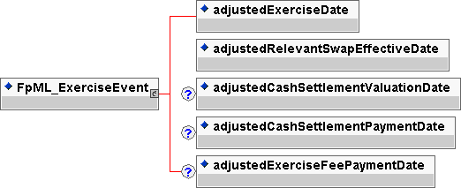
Contents:
adjustedExerciseDate (exactly one occurrence; of type date)
- The date on which option exercise takes place. This date should already be adjusted for any applicable business day convention.
adjustedRelevantSwapEffectiveDate (exactly one occurrence; of type date)
- The effective date of the underlying swap associated with a given exercise date. This date should already be adjusted for any applicable business day convention.
adjustedCashSettlementValuationDate (zero or one occurrence; of type date)
- The date by which the cash settlement amount must be agreed. This date should already be adjusted for any applicable business day convention.
adjustedCashSettlementPaymentDate (zero or one occurrence; of type date)
- The date on which the cash settlement amount is paid. This date should already be adjusted for any applicable business day convention.
adjustedExerciseFeePaymentDate (zero or one occurrence; of type date)
- The date on which the exercise fee amount is paid. This date should already be adjusted for any applicable business day convention.
Used by:
exerciseEvent
DTD Fragment:
<!ENTITY % FpML_ExerciseEvent "adjustedExerciseDate , adjustedRelevantSwapEffectiveDate , adjustedCashSettlementValuationDate? , adjustedCashSettlementPaymentDate? , adjustedExerciseFeePaymentDate?">

FpML_ExerciseFee
Description:
An entity to define a fee to be payable on exercise of an option. This fee may be defined as an amount or a percentage of the notional exercised.
Figure:
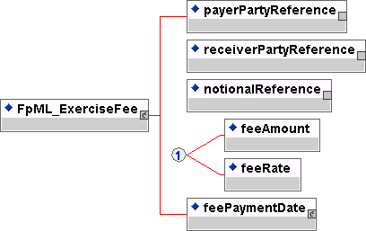
Contents:
payerPartyReference (exactly one occurrence; an empty element containing an href attribute)
- A pointer style reference to a party identifier defined elsewhere in the document.
receiverPartyReference (exactly one occurrence; an empty element containing an href attribute)
- A pointer style reference to a party identifier defined elsewhere in the document.
notionalReference (exactly one occurrence; an empty element containing an href attribute)
- A pointer style reference to the associated notional schedule defined elsewhere in the document.
Either
feeAmount (exactly one occurrence; of type decimal)
- The amount of fee to be paid on exercise. The fee currency is that of the referenced notional
Or
feeRate (exactly one occurrence; of type decimal)
- A fee represented as a percentage of some referenced notional. A percentage of 5% would be represented as 0.05.
feePaymentDate (exactly one occurrence; contains the sub-element(s) defined by exactly one occurrence of the entity FpML_RelativeDateOffset)
- The date on which exercise fee(s) will be paid. It is specified as a relative date.
Used by:
exerciseFee
DTD Fragment:

<!ENTITY % FpML_ExerciseFee " payerPartyReference, receiverPartyReference, notionalReference , (feeAmount | feeRate) , feePaymentDate">

FpML_ExerciseFeeSchedule
Description:
An entity to define a fee or schedule of fees to be payable on exercise of an option. This fee may be defined as an amount or a percentage of the notional exercised.
Figure:
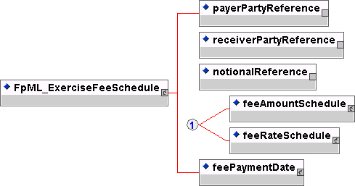
Contents:
payerPartyReference (exactly one occurrence; an empty element containing an href attribute)
- A pointer style reference to a party identifier defined elsewhere in the document.
receiverPartyReference (exactly one occurrence; an empty element containing an href attribute)
- A pointer style reference to a party identifier defined elsewhere in the document.
notionalReference (exactly one occurrence; an empty element containing an href attribute)
- A pointer style reference to the associated notional schedule defined elsewhere in the document.
Either
feeAmountSchedule (exactly one occurrence; contains the sub-element(s) defined by exactly one occurrence of the entity FpML_Schedule)
- The exercise fee amount schedule. The fees are expressed as currency amounts. The currency of the fee is assumed to be that of the notional schedule referenced.
Or
feeRateSchedule (exactly one occurrence; contains the sub-element(s) defined by exactly one occurrence of the entity FpML_Schedule)
- The exercise fee rate schedule. The fees are expressed as percentage rates of the notional being exercised. The currency of the fee is assumed to be that of the notional schedule referenced.
feePaymentDate (exactly one occurrence; contains the sub-element(s) defined by exactly one occurrence of the entity FpML_RelativeDateOffset)
- The date on which exercise fee(s) will be paid. It can be specified as a reference date or a relative date.
Used by:
exerciseFeeSchedule
DTD Fragment:
<!ENTITY % FpML_ExerciseFeeSchedule "payerPartyReference, receiverPartyReference, notionalReference , (feeAmountSchedule | feeRateSchedule) , feePaymentDate">

FpML_ExerciseNotice
Description:
An entity to define to whom and where notice of exercise should be given. The partyReference refers to one of the principal parties of the trade. If present the exerciseNoticePartyReference refers to a party, other than the principal party, to whom notice should be given.
Figure:
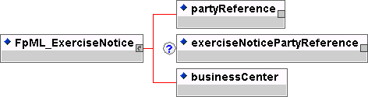
Contents:

partyReference (exactly one occurrence; an empty element containing an href attribute)
- A pointer style reference to a party identifier defined elsewhere in the document. The party referenced has allocated the trade identifier.
exerciseNoticePartyReference (zero or one occurrence; an empty element containing an href attribute)
- A pointer style reference to a party identifier defined elsewhere in the document. The party referenced is the party to which notice of exercise should be given by the buyer. This element need only be included where the party identified in the partyReference is not the party to which notice should be given.
businessCenter (exactly one occurrence; of type string, an enumerated domain value defined by businessCenterScheme)
- A code identifying a financial business center location. A list of business centers may be ordered in the document alphabetically based on business center code. An FpML document containing an unordered business center list is still regarded as a conformant document.
Used by:
exerciseProcedure
DTD Fragment:
<!ENTITY % FpML_ExerciseNotice "partyReference ,exerciseNoticePartyReference? , businessCenter">

FpML_ExerciseProcedure
Description:
An entity to describe how notice of exercise should be given. This can either be manual or automatic.
Figure:
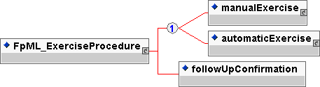
Contents:
Either
manualExercise (exactly one occurrence; contains the sub-element(s) defined by exactly one occurrence of the entity FpML_ManualExercise)
- Specifies that the notice of exercise must be given by the buyer to the seller or seller's agent.
Or
automaticExercise (exactly one occurrence; contains the sub-element(s) defined by exactly one occurrence of the entity FpML_AutomaticExercise)
- If automatic exercise is specified then the notional amount of the underlying swap, not previously exercised under the swaption, will be automatically exercised at the expiration time on the expiration date if at such time the buyer is in-the-money, provided that the difference between the settlement rate and the fixed rate under the relevant underlying swap is not less than the specified thresholdRate. The term In-the-money is assumed to have the meaning defined in the 2000 ISDA Definitions, Section 17.4. In-the-money.
followUpConfirmation (exactly one occurrence; of type boolean)
- A flag to indicate whether follow-up confirmation of exercise (written or electronic) is required following telephonic notice by the buyer to the seller or seller's agent.
Used by:
exerciseProcedure
DTD Fragment:
<!ENTITY % FpML_ExerciseProcedure "(manualExercise | automaticExercise) , followUpConfirmation">

FpML_ExerciseSelection
Description:
Entity to define the possible styles of exercise. The choice is between European, Bermuda or American exercise.
Figure:
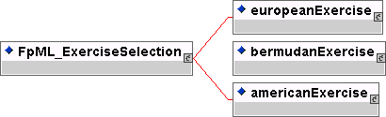
Contents:
Either
europeanExercise (exactly one occurrence; contains the sub-element(s) defined by exactly one occurrence of the entity FpML_EuropeanExercise)
- The parameters for defining the exercise period for a European style option together with any rules governing the notional amount of the underlying which can be exercised on any given exercise date and any associated exercise fees.
Or
bermudaExercise (exactly one occurrence; contains the sub-element(s) defined by exactly one occurrence of the entity FpML_BermudaExercise)
- The parameters for defining the exercise period for a Bermuda style option together with any rules governing the notional amount of the underlying which can be exercised on any given exercise date and any associated exercise fees.

Or
americaExercise (exactly one occurrence; contains the sub-element(s) defined by exactly one occurrence of the entity FpML_AmericanExercise)
- The parameters for defining the exercise period for an American style option together with any rules governing the notional amount of the underlying which can be exercised on any given exercise date and any associated exercise fees.
Used by:
FpML_CancelableProvision
FpML_ExtendibleProvision
FpML_OptionalEarlyTermination
FpML_Swaption
DTD Fragment:
<!ENTITY % FpML_ExerciseSelection "europeanExercise | bermudaExercise | americanExercise">

FpML_ExtendibleProvision
Description:
An entity to define an option to extend an existing swap transaction on the specified exercise dates for a term ending on a specified new termination date.
Figure:
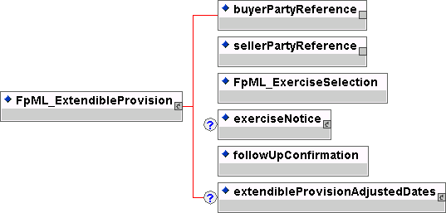
Contents:
buyerPartyReference (exactly one occurrence; an empty element containing an href attribute)
- A pointer style reference to a party identifier defined elsewhere in the document. The party referenced is the buyer of the instrument.
sellerPartyReference (exactly one occurrence; an empty element containing an href attribute)
- A pointer style reference to a party identifier defined elsewhere in the document. The party referenced is the seller of the instrument.
inherited element(s) (this entity inherits the element(s) defined by exactly one occurrence of the entity FpML_ExerciseSelection)
- Entity to defined the types of exercise. The choice is european, bermuda or american exercise.
exerciseNotice (zero or one occurrence; contains the sub-element(s) defined by exactly one occurrence of the entity FpML_ExerciseNotice)
- Definition of the party to whom notice of exercise should be given.
followUpConfirmation (exactly one occurrence; of type boolean)
- A flag to indicate whether follow-up confirmation of exercise (written or electronic) is required following telephonic notice by the buyer to the seller or seller's agent.
extendibleProvisionAdjustedDates (zero or one occurrence; contains the sub-element(s) defined by exactly one occurrence of the entity FpML_ExtendibleProvisionAdjustedDates)
- The adjusted dates associated with a extendible provision. These dates have been adjusted for any applicable business day convention.
Used by:
extendibleProvision
DTD Fragment:
<!ENTITY % FpML_ExtendibleProvision "buyerPartyReference , sellerPartyReference , (%FpML_ExerciseSelection;) , exerciseNotice? , followUpConfirmation , extendibleProvisionAdjustedDates?">

FpML_ExtendibleProvisionAdjustedDates
Description:
An entity to define the adjusted dates associated with a provision to extend a swap.
Figure:
Contents:
extensionEvent (one or more occurrences; contains the sub-element(s) defined by exactly one occurrence of the entity FpML_ExtensionEvent)
- The adjusted dates associated with a single extendible exercise date.
Used by:
extendibleProvisionAdjustedDates
DTD Fragment:
<!ENTITY % FpML_ExtendibleProvisionAdjustedDates "extensionEvent+">

FpML_ExtensionEvent
Description:
An entity to define the adjusted dates associated with an individual extension event.
Figure:
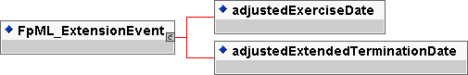
Contents:
adjustedExerciseDate (exactly one occurrence; of type date)
- The date on which option exercise takes place. This date should already be adjusted for any applicable business day convention.
adjustedExtendedTerminationDate (exactly one occurrence; of type date)
- The termination date if an extendible provision is exercised. This date should already be adjusted for any applicable business day convention.
Used by:
extensionEvent
DTD Fragment:
<!ENTITY % FpML_ExtensionEvent "adjustedExerciseDate , adjustedExtendedTerminationDate">

FpML_Fee
Description:
An entity for defining additional payments associated with a trade which are not defined as part of the stream payments. It may be used to define additional payments between the principal parties involved in the trade or other third parties such as a broker. This entity inherits from a base entity, FpML_Payment.
Figure:
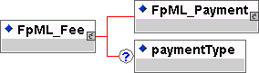
Contents:
inherited element(s) (this entity inherits the element(s) defined by exactly one occurrence of the entity FpML_Payment)
- An entity for defining payments.
paymentType (zero or one occurrence; of type string, an enumerated domain value defined by paymentTypeScheme)
- A classification of the type of fee or additional payment, e.g. brokerage, upfront fee etc. FpML does not define domain values for this element.

Used by:
additionalPayment
otherPartyPayment
DTD Fragment:
<!ENTITY % FpML_Fee "%FpML_Payment; , paymentType?">

FpML_FloatingRate
Description:
An entity for defining the floating rate definitions.
Figure:
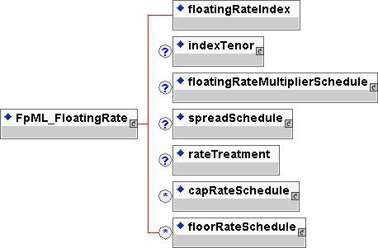
Contents:
floatingRateIndex (exactly one occurrence; of type string, an enumerated domain value defined by floatingRateIndexScheme)
- The ISDA Floating Rate Option, i.e. the floating rate index.
indexTenor (zero or one occurrence; contains the sub-element(s) defined by exactly one occurrence of the entity FpML_Interval)
- The ISDA Designated Maturity, i.e. the tenor of the floating rate.
floatingRateMultiplierSchedule (zero or one occurrence; contains the sub-element(s) defined by exactly one occurrence of the entity FpML_Schedule)
- A rate mutliplier or multiplier scheduel to apply to the floating rate. A multiplier schedule is expressed as explicit multipliers and dates. In the case of a schedule, the step dates may be subject to adjustment in accordance with any adjustments specified in the calculationPeriodDatesAdjustments. The multiplier can be a positive or negative decimal. This element should only be included if the multiplier is not equal to 1 (one) for the term of the stream.
spreadSchedule (zero or one occurrence; contains the sub-element(s) defined by exactly one occurrence of the entity FpML_Schedule)
- The ISDA Spread or a Spread schedule expressed as explicit spreads and dates. In the case of a schedule, the step dates may be subject to adjustment in accordance with any adjustments specified in calculationPeriodDatesAdjustments. The spread is a per annum rate, expressed as a decimal. For purposes of determining a calculation period amount, if positive the spread will be added to the floating rate and if negative the spread will be subtracted from the floating rate. A positive 10 basis point (0.1%) spread would be represented as 0.001.
rateTreatment (zero or one occurrence; of type string, an enumerated domain value defined by rateTreatmentScheme)
- The specification of any rate conversion which needs to be applied to the observed rate before being used in any calculations. The two common conversions are for securities quoted on a bank discount basis which will need to be converted to either a Money Market Yield or Bond Equivalent Yield. See the Annex to the 2000 ISDA Definitions, Section 7.3. Certain General Definitions Relating to Floating Rate Options, paragraphs (g) and (h) for definitions of these terms.
capRateSchedule (zero or more occurrences; contains the sub-element(s) defined by exactly one occurrence of the entity FpML_StrikeSchedule)
- The cap rate or cap rate schedule, if any, which applies to the floating rate. The cap rate (strike) is only required where the floating rate on a swap stream is capped at a certain strike level. A cap rate schedule is expressed as explicit cap rates and dates and the step dates may be subject to adjustment in accordance with any adjustments specified in calculationPeriodDatesAdjustments. The cap rate is assumed to be exclusive of any spread and is a per annum rate, expressed as a decimal. A cap rate of 5% would be represented as 0.05.
floorRateSchedule (zero or more occurrences; contains the sub-element(s) defined by exactly one occurrence of the entity FpML_StrikeSchedule)
- The floor rate or floor rate schedule, if any, which applies to the floating rate. The floor rate (strike) is only required where the floating rate on a swap stream is floored at a certain strike level. A floor rate schedule is expressed as explicit floor rates and dates and the step dates may be subject to adjustment in accordance with any adjustments specified in calculationPeriodDatesAdjustments. The floor rate is assumed to be exclusive of any spread and is a per annum rate, expressed as a decimal. A floor rate of 5% would be represented as 0.05.
Used by:
FpML_FloatingRateCalculation
floatingRate
DTD Fragment:
<!ENTITY % FpML_FloatingRate "floatingRateIndex , indexTenor? , floatingRateMultiplierSchedule? , spreadSchedule? , rateTreatment? , capRateSchedule* , floorRateSchedule*">

FpML_FloatingRateCalculation
Description:
An entity for defining the floating rate definitions and definitions relating to the calculation of floating rate amounts. This entity inherits from a base entity, FpML_FloatingRate.
Figure:
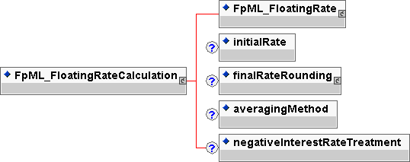
Contents:
inherited element(s) (this entity inherits the element(s) defined by exactly one occurrence of the entity FpML_FloatingRate)
- An entity for defining the floating rate definitions.
initialRate (zero or one occurrence; of type decimal)
- The initial floating rate reset agreed between the principal parties involved in the trade. This is assumed to be the first required reset rate for the first regular calculation period. It should only be included when the rate is not equal to the rate published on the source implied by the floating rate index. An initial rate of 5% would be represented as 0.05.
finalRateRounding (zero or one occurrence; contains the sub-element(s) defined by exactly one occurrence of the entity FpML_Rounding)
- The rounding convention to apply to the final rate used in determination of a calculation period amount.
averagingMethod (zero or one occurrence; of type string, an enumerated domain value defined by averagingMethodScheme)
- If averaging is applicable, this element specifies whether a weighted or unweighted average method of calculation is to be used. The element must only be included when averaging applies.
negativeInterestRateTreatment (zero or one occurrence; of type string, an enumerated domain value defined by negativeInterestRateTreatmentScheme)
- The specification of any provisions for calculating payment obligations when a floating rate is negative (either due to a quoted negative floating rate or by operation of a spread that is subtracted from the floating rate).
Used by:
floatingRateCalculation
DTD Fragment:
<!ENTITY % FpML_FloatingRateCalculation "(%FpML_FloatingRate; , initialRate? , finalRateRounding? , averagingMethod? , negativeInterestRateTreatment?)">

FpML_FloatingRateDefinition
Description:
An entity defining parameters associated with a floating rate reset. This entity forms part of the cashflows representation of a stream.
Figure:
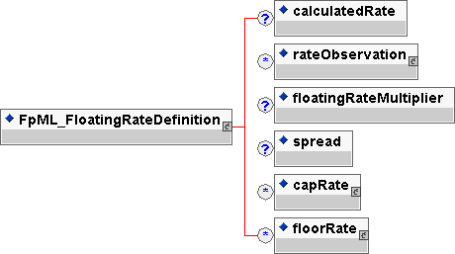
Contents:
calculatedRate (zero or one occurrence; of type decimal)
- The final calculated rate for a calculation period after any required averaging of rates. A calculated rate of 5% would be represented as 0.05.
rateObservation (zero or more occurrences; contains the sub-element(s) defined by exactly one occurrence of the entity FpML_RateObservation)
- The details of a particular rate observation, including the fixing date and observed rate. A list of rate observation elements may be ordered in the document by ascending adjusted fixing date. An FpML document containing an unordered list of rate observations is still regarded as a conformant document.
floatingRateMultiplier (zero or one occurrence; of type decimal)
- A rate multiplier to apply to the floating rate. The multiplier can be a positive or negative decimal. This element should only be included if the multiplier is not equal to 1 (one).
spread (zero or one occurrence; of type decimal)
- The ISDA Spread, if any, which applies for the calculation period. The spread is a per annum rate, expressed as a decimal. For purposes of determining a calculation period amount, if positive the spread will be added to the floating rate and if negative the spread will be subtracted from the floating rate. A positive 10 basis point (0.1%) spread would be represented as 0.001.
capRate (zero or more occurrences; contains the sub-element(s) defined by exactly one occurrence of the entity FpML_Strike)
- The cap rate, if any, which applies to the floating rate for the calculation period. The cap rate (strike) is only required where the floating rate on a swap stream is capped at a certain strike level. The cap rate is assumed to be exclusive of any spread and is a per annum rate, expressed as a decimal. A cap rate of 5% would be represented as 0.05.
floorRate (zero or more occurrences; contains the sub-element(s) defined by exactly one occurrence of the entity FpML_Strike)
- The floor rate, if any, which applies to the floating rate for the calculation period. The floor rate (strike) is only required where the floating rate on a swap stream is floored at a certain strike level. The floor rate is assumed to be exclusive of any spread and is a per annum rate, expressed as a decimal. A floor rate of 5% would be represented as 0.05.
Used by:
floatingRateDefinition
DTD Fragment:
<!ENTITY % FpML_FloatingRateDefinition "calculatedRate? , rateObservation* , floatingRateMultiplier? , spread? , capRate* , floorRate*">

FpML_Fra
Description:
An entity for defining the forward rate agreement (FRA) product.
Figure:
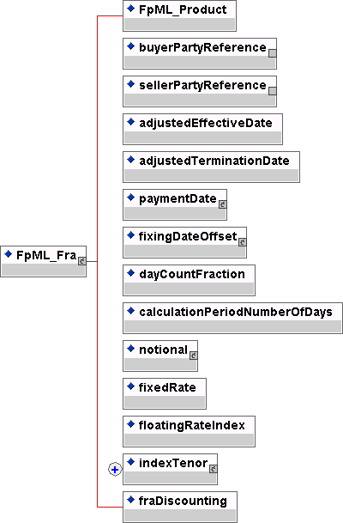
Contents:
inherited element(s) (this entity inherits the element(s) defined by exactly one occurrence of the entity FpML_Product)
- The base entity which all FpML products extend.
buyerPartyReference (exactly one occurrence; an empty element containing an href attribute)
- A pointer style reference to a party identifier defined elsewhere in the document. The party referenced is the buyer of the instrument, also known as the fixed rate payer.
sellerPartyReference (exactly one occurrence; an empty element containing an href attribute)
- A pointer style reference to a party identifier defined elsewhere in the document. The party referenced is the seller of the instrument, also known as the floating rate payer.
adjustedEffectiveDate (exactly one occurrence; of type date)
- The start date of the calculation period. This date should already be adjusted for any applicable business day convention. This is also the date when the observed rate is applied, the reset date.
adjustedTerminationDate (exactly one occurrence; of type date)
- The end date of the calculation period. This date should already be adjusted for any applicable business day convention.
paymentDate (exactly one occurrence; contains the sub-element(s) defined by exactly one occurrence of the entity FpML_AdjustableDate)
- The payment date. This date is subject to adjustment in accordance with any applicable business day convention.
fixingDateOffset (exactly one occurrence; contains the sub-element(s) defined by exactly one occurrence of the entity FpML_RelativeDateOffset)
- Specifies the fixing date relative to the reset date in terms of a business days offset and an associated set of financial business centers. Normally these offset calculation rules will be those specified in the ISDA definition for the relevant floating rate index (ISDA's Floating Rate Option). However, non-standard offset calculation rules may apply for a trade if mutually agreed by the principal parties to the transaction. The href attribute on the dateRelativeTo element should reference the id attribute on the adjustedEffectiveDate element.
dayCountFraction (exactly one occurrence; of type string, an enumerated domain value defined by dayCountFractionScheme)
- The day count fraction.
calculationPeriodNumberOfDays (exactly one occurrence; of type positiveInteger)
- The number of days from the adjusted effective date to the adjusted termination date calculated in accordance with the applicable day count fraction.
notional (exactly one occurrence; contains the sub-element(s) defined by exactly one occurrence of the entity FpML_Money)
- The notional amount.
fixedRate (exactly one occurrence; of type decimal)
- The calculation period fixed rate. A per annum rate, expressed as a decimal. A fixed rate of 5% would be represented as 0.05.
floatingRateIndex (exactly one occurrence; of type string, an enumerated domain value defined by floatingRateIndexScheme)
- The ISDA Floating Rate Option, i.e. the floating rate index.
indexTenor (one or more occurrences; contains the sub-element(s) defined by exactly one occurrence of the entity FpML_Interval)
- The ISDA Designated Maturity, i.e. the tenor of the floating rate.
fraDiscounting (exactly one occurrence; of type boolean)
- A true/false flag to indicate whether ISDA FRA Discounting applies. If false, then the calculation will be based on a par value and no discounting will apply.
Used by:
fra
DTD Fragment:
<!ENTITY % FpML_Fra "%FpML_Product;,buyerPartyReference , sellerPartyReference , adjustedEffectiveDate , adjustedTerminationDate , paymentDate , fixingDateOffset , dayCountFraction , calculationPeriodNumberOfDays , notional , fixedRate , floatingRateIndex , indexTenor+ , fraDiscounting">

FpML_FxLinkedNotionalAmount
Description:
An entity to describe the cashflow representation for fx linked notionals.
Figure:
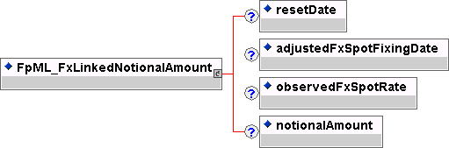
Contents:
resetDate (zero or one occurrence;of type date)
- The reset date.
adjustedFxSpotFixingDate (zero or one occurrence;of type date)
- The date on which the fx spot rate is observed. This date should already be adjusted for any applicable business day convention.
observedFxSpotRate (zero or one occurrence; of type decimal)
- The actual observed fx spot rate.
notionalAmount (zero or one occurrence; of type decimal)
- The calculation period notional amount. The notional in the currency of the stream. This notional can be calculated once the FX Spot rate is known. It is optional since it should not be present prior to the fx spot reset date.
Used by:
fxLinkedNotionalAmount
DTD Fragment:
<!ENTITY % FpML_FxLinkedNotionalAmount "resetDate?, adjustedFxSpotFixingDate? , observedFxSpotRate? , notionalAmount?">

FpML_FxLinkedNotionalSchedule
Description:
An entity to describe a notional amount schedule where each notional that applies to a calculation period is calculated with reference to a notional amount or notional amount schedule in a different currency by means of a spot currency exchange rate which is normally observed at the beginning of each period.
Figure:
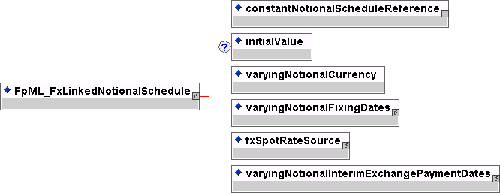
Contents:
constantNotionalScheduleReference (exactly one occurrence; an empty element containing an href attribute)
- A pointer style reference to the associated constant notional schedule defined elsewhere in the document which contains the currency amounts which will be converted into the varying notional currency amounts using the spot currency exchange rate.
initialValue (exactly one occurrence; of type decimal)
- The initial rate or amount, as the case may be. An initial rate of 5% would be represented as 0.05.
varyingNotionalCurrency (exactly one occurrence; of type string, an enumerated domain value defined by currencyScheme)
- The currency of the varying notional amount, i.e. the notional amount being determined periodically based on observation of a spot currency exchange rate.
varyingNotionalFixingDates (exactly one occurrence; contains the sub-element(s) defined by exactly one occurrence of the entity FpML_RelativeDateOffset)
- The dates on which spot currency exchange rates are observed for purposes of determining the varying notional currency amount that will apply to a calculation period.
fxSpotRateSource (exactly one occurrence; contains the sub-element(s) defined by exactly one occurrence of the entity FpML_FxSpotRateSource)
- The information source and time at which the spot currency exchange rate will be observed.
varyingNotionalInterimExchangePaymentDates (exactly one occurrence; contains the sub-element(s) defined by exactly one occurrence of the entity FpML_RelativeDateOffset)
- The dates on which interim exchanges of notional are paid. Interim exchanges will arise as a result of changes in the spot currency exchange amount or changes in the constant notional schedule (e.g. amortization).
Used by:
fxLinkedNotionalSchedule
DTD Fragment:
<!ENTITY % FpML_FxLinkedNotionalSchedule "constantNotionalScheduleReference, initialValue? , varyingNotionalCurrency , varyingNotionalFixingDates , fxSpotRateSource , varyingNotionalInterimExchangePaymentDates">

FpML_FxSpotRateSource
Description:
An entity to define the source and time for an fx rate.
Figure:
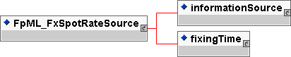
Contents:
informationSource (exactly one occurrence; contains the sub-element(s) defined by exactly one occurrence of the entity FpML_InformationSource)
- The information source where a published or displayed market rate will be obtained, e.g. Telerate Page 3750.
fixingTime (exactly one occurrence; contains the sub-element(s) defined by exactly one occurrence of the entity FpML_BusinessCenterTime)
- The time at which the spot currency exchange rate will be observed. It is specified as a time in a specific business center, e.g. 11:00 am London time.
Used by:
fxSpotRateSource
DTD Fragment:
<!ENTITY % FpML_FxSpotRateSource "informationSource , fixingTime">

FpML_InformationSource
Description:
An entity to define the source for a piece of information (eg a rate refix or a fx fixing).
Figure:
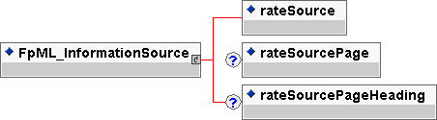
Contents:
rateSource (exactly one occurrence; of type string, an enumerated domain value defined by informationProviderScheme)
- An information source for obtaining a market rate. For example Bloomberg, Reuters, Telerate etc.
rateSourcePage (zero or one occurrence; of type string, an enumerated domain value defined by rateSourcePageScheme)
- The specific information source page for obtaining a market rate. For example, 3750 (Telerate), LIBO (Reuters) etc.
rateSourcePageHeading (zero or one occurrence; of type string)
- The heading for the rate source on a given rate source page.
Used by:
informationSource
DTD Fragment:
<!ENTITY % FpML_InformationSource "rateSource , rateSourcePage? , rateSourcePageHeading?">

FpML_InterestRateStream
Description:
An entity for defining the components specifying an interest rate payments stream, including both a parametric and cashflows representation for the stream of payments.
Figure:
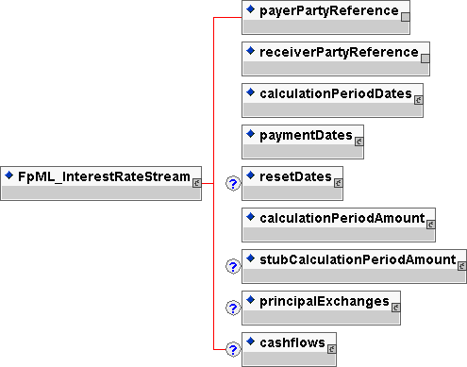
Contents:
payerPartyReference (exactly one occurrence; an empty element containing an href attribute)
- A pointer style reference to a party identifier defined elsewhere in the document.
receiverPartyReference (exactly one occurrence; an empty element containing an href attribute)
- A pointer style reference to a party identifier defined elsewhere in the document.
calculationPeriodDates (exactly one occurrence; contains the sub-element(s) defined by exactly one occurrence of the entity FpML_CalculationPeriodDates)
- The calculation periods dates schedule.
paymentDates (exactly one occurrence; contains the sub-element(s) defined by exactly one occurrence of the entity FpML_PaymentDates)
- The payment dates schedule.
resetDates (zero or one occurrence; contains the sub-element(s) defined by exactly one occurrence of the entity FpML_ResetDates)
- The reset dates schedule. The reset dates schedule only applies for a floating rate stream.
calculationPeriodAmount (exactly one occurrence; contains the sub-element(s) defined by exactly one occurrence of the entity FpML_CalculationPeriodAmount)
- The calculation period amount parameters.
stubCalculationPeriodAmount (zero or one occurrence; contains the sub-element(s) defined by exactly one occurrence of the entity FpML_StubCalculationPeriodAmount)
- The stub calculation period amount parameters. This element must only be included if there is an initial or final stub calculation period. Even then, it must only be included if either the stub references a different floating rate tenor to the regular calculation periods, or if the stub is calculated as a linear interpolation of two different floating rate tenors, or if a specific stub rate or stub amount has been negotiated.
principalExchanges (zero or one occurrence; contains the sub-element(s) defined by exactly one occurrence of the entity FpML_PrincipalExchanges)
- The true/false flags indicating whether initial, intermediate or final exchanges of principal should occur.
cashflows (zero or one occurrence; contains the sub-element(s) defined by exactly one occurrence of the entity FpML_Cashflows)
- The cashflows representation of the swap stream.
Used by:
capFloorStream
swapStream
DTD Fragment:
<!ENTITY % FpML_InterestRateStream "payerPartyReference , receiverPartyReference , calculationPeriodDates , paymentDates , resetDates? , calculationPeriodAmount , stubCalculationPeriodAmount? , principalExchanges? , cashflows?">

FpML_Interval
Description:
An entity for defining a time interval or offset, e.g. one day, three months. Used for specifying frequencies at which events occur, the tenor of a floating rate or an offset relative to another date.
Figure:
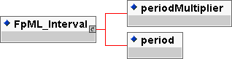
Contents:
periodMultiplier (exactly one occurrence; of type integer)
- A time period multiplier, e.g. 1, 2 or 3 etc. A negative value can be used when specifying an offset relative to another date, e.g. -2 days. If the period value is T (Term) then periodMultiplier must contain the value 1.
period (exactly one occurrence; of type string, an enumerated domain value defined by periodScheme)
- A time period, e.g. a day, week, month, year or term of the stream. If the periodMultiplier value is 0 (zero) then period must contain the value D (day).
Used by:
FpML_CalculationPeriodFrequency
FpML_Offset
FpML_ResetFrequency
indexTenor
paymentFrequency
stepFrequency
DTD Fragment:
<!ENTITY % FpML_Interval "periodMultiplier , period">

FpML_MandatoryEarlyTermination
Description:
An entity to define the an early termination provision for which exercise is mandatory.
Figure:
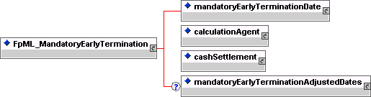
Contents:
mandatoryEarlyTerminationDate (exactly one occurrence; contains the sub-element(s) defined by exactly one occurrence of the entity FpML_AdjustableDate)
- The early termination date associated with a mandatory early termination of a swap.
calculationAgent (exactly one occurrence; contains the sub-element(s) defined by exactly one occurrence of the entity FpML_CalculationAgent)
- The ISDA Calculation Agent responsible for performing duties associated with an optional early termination.
cashSettlement (exactly one occurrence; contains the sub-element(s) defined by exactly one occurrence of the entity FpML_CashSettlement)
- If specified, this means that cash settlement is applicable to the transaction and defines the parameters associated with the cash settlement procedure. If not specified, then physical settlement is applicable.
mandatoryEarlyTerminationAdjustedDates (zero or one occurrence; contains the sub-element(s) defined by exactly one occurrence of the entity FpML_MandatoryEarlyTerminationAdjustedDates)
- The adjusted dates associated with a mandatory early termination provision. These dates have been adjusted for any applicable business day convention.
Used by:
mandatoryEarlyTermination
DTD Fragment:
<!ENTITY % FpML_MandatoryEarlyTermination "mandatoryEarlyTerminationDate , calculationAgentPartyReference+ , cashSettlement , mandatoryEarlyTerminationAdjustedDates?">

FpML_MandatoryEarlyTerminationAdjustedDates
Description:
An entity to define the adjusted dates associated with a mandatory early termination provision.
Figure:
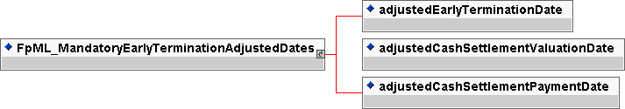
Contents:
adjustedEarlyTerminationDate (exactly one occurrence; of type date)
- The early termination date that is applicable if an early termination provision is exercised. This date should already be adjusted for any applicable business day convention.
adjustedCashSettlementValuationDate (exactly one occurrence; of type date)
- The date by which the cash settlement amount must be agreed. This date should already be adjusted for any applicable business day convention.
adjustedCashSettlementPaymentDate (exactly one occurrence; of type date)
- The date on which the cash settlement amount is paid. This date should already be adjusted for any applicable business day convention.
Used by:
mandatoryEarlyTerminationAdjustedDates
DTD Fragment:
<!ENTITY % FpML_MandatoryEarlyTerminationAdjustedDates "adjustedEarlyTerminationDate , adjustedCashSettlementValuationDate , adjustedCashSettlementPaymentDate">

FpML_ManualExercise
Description:
An entity to define manual exercise. ie that option buyer counterparty must give notice to the option seller of exercise.
Figure:
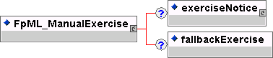
Contents:
exerciseNotice (zero or one occurrence; contains the sub-element(s) defined by exactly one occurrence of the entity FpML_ExerciseNotice)
- Definition of the party to whom notice of exercise should be given.
fallbackExercise (zero or one occurrence; of type boolean)
- If fallback exercise is specified then the notional amount of the underlying swap, not previously exercised under the swaption, will be automatically exercised at the expiration time on the expiration date if at such time the buyer is in-the-money, provided that the difference between the settlement rate and the fixed rate under the relevant underlying swap is not less than one tenth of a percentage point (0.10% or 0.001). The term In-the-money is assumed to have the meaning defined in the 2000 ISDA Definitions, Section 17.4. In-the-money.
Used by:
manualExercise
DTD Fragment:
<!ENTITY % FpML_ManualExercise "exerciseNotice? , fallbackExercise?">

FpML_Money
Description:
An entity for defining a currency amount.
Figure:
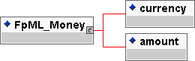
Contents:
currency (exactly one occurrence; of type string, an enumerated domain value defined by currencyScheme)
- The currency in which an amount is denominated.
amount (exactly one occurrence; of type decimal)
- The monetary quantity in currency units.
Used by:
notional
paymentAmount
stubAmount
DTD Fragment:
<!ENTITY % FpML_Money "currency , amount">

FpML_MultipleExercise
Description:
An entity to define multiple exercise. As defined in the 2000 ISDA Definitions, Section 12.4. Multiple Exercise, the buyer of the option has the right to exercise all or less than all the unexercised notional amount of the underlying swap on one or more days in the exercise period, but on any such day may not exercise less than the minimum notional amount or more than the maximum notional amount, and if an integral multiple amount is specified, the notional amount exercised must be equal to, or be an integral multiple of, the integral multiple amount.
Figure:
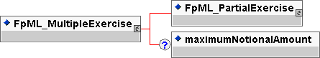
Contents:
inherited element(s) (this entity inherits the element(s) defined by exactly one occurrence of the entity FpML_PartialExercise)
- An entity to define partial exercise. As defined in the 2000 ISDA Definitions, Section 12.3 Partial Exercise, the buyer of the option may exercise all or less than all the notional amount of the underlying swap but may not be less than the minimum notional amount (if specified) and must be an integral multiple of the integral multiple amount if specified.
maximumNotionalAmount (zero or one occurrence; of type decimal)
- The maximum notional amount that can be exercised on a given exercise date.
Used by:
multipleExercise
DTD Fragment:
<!ENTITY % FpML_MultipleExercise "%FpML_PartialExercise; , maximumNotionalAmount?">

FpML_Notional
Description:
An entity for defining the notional amount or notional amount schedule associated with a swap stream. The notional schedule will be captured by explicitly specifying the dates that the notional changes and the outstanding notional amount that applies from that date. A parametric representation of the rules defining the notional step schedule can optionally be included.
Figure:
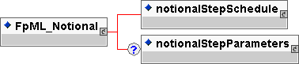
Contents:
notionalStepSchedule (exactly one occurrence; contains the sub-element(s) defined by exactly one occurrence of the entity FpML_AmountSchedule)
- The notional amount or notional amount schedule expressed as explicit outstanding notional amounts and dates. In the case of a schedule, the step dates may be subject to adjustment in accordance with any adjustments specified in calculationPeriodDatesAdjustments.
notionalStepParameters (zero or one occurrence; contains the sub-element(s) defined by exactly one occurrence of the entity FpML_NotionalStepRule)
- A parametric representation of the notional step schedule, i.e. parameters used to generate the notional schedule.
Used by:
notionalSchedule
DTD Fragment:
<!ENTITY % FpML_Notional "notionalStepSchedule , notionalStepParameters?">

FpML_NotionalStepRule
Description:
An entity for defining a parametric representation of the notional step schedule, i.e. parameters used to generate the notional balance on each step date. The step change in notional can be expressed in terms of either a fixed amount or as a percentage of either the initial notional or previous notional amount. This parametric representation is intended to cover the more common amortizing/accreting.
Figure:
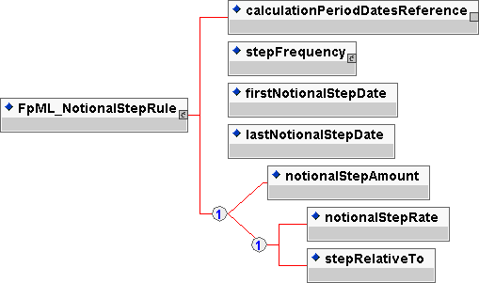
Contents:
calculationPeriodDatesReference (exactly one occurrence; an empty element containing an href attribute)
- A pointer style reference to the associated calculation period dates component defined elsewhere in the document.
stepFrequency (exactly one occurrence; contains the sub-element(s) defined by exactly one occurrence of the entity FpML_Interval)
- The frequency at which the step changes occur. This frequency must be a multiple of the stream calculation period frequency.
firstNotionalStepDate (exactly one occurrence; of type date)
- The unadjusted calculation period start date of the first change in notional. This day may be subject to adjustment in accordance with any adjustments specified in calculationPeriodDatesAdjustments.
lastNotionalStepDate (exactly one occurrence; of type date)
- The unadjusted calculation period end date of the last change in notional. This day may be subject to adjustment in accordance with any adjustments specified in calculationPeriodDatesAdjustments.
Either
notionalStepAmount (exactly one occurrence; of type decimal)
- The explicit amount that the notional changes on each step date. This can be a positive or negative amount.
Or
notionalStepRate (exactly one occurrence; of type decimal)
- The percentage amount by which the notional changes on each step date. The percentage is either a percentage applied to the initial notional amount or the previous outstanding notional, depending on the value of the element stepRelativeTo. The percentage can be either positive or negative. A percentage of 5% would be represented as 0.05.
Or
stepRelativeTo (exactly one occurrence; of type string, an enumerated domain value defined by stepRelativeToScheme)
- Specifies whether the notionalStepRate should be applied to the initial notional or the previous notional in order to calculate the notional step change amount.
Used by:
notionalStepParameters
DTD Fragment:
<!ENTITY % FpML_NotionalStepRule "calculationPeriodDatesReference , stepFrequency , firstNotionalStepDate , lastNotionalStepDate , (notionalStepAmount | (notionalStepRate , stepRelativeTo))">

FpML_Offset
Description:
An entity for defining an offset used in calculating a new date relative to a reference date. Currently, the only offsets defined are expected to be expressed as either calendar or business day offsets. This entity inherits from a base entity, FpML_Interval.
Figure:
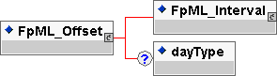
Contents:
inherited element(s) (this entity inherits the element(s) defined by exactly one occurrence of the entity FpML_Interval)
- An entity for defining a time interval or offset, e.g. one day, three months. Used for specifying frequencies at which events occur, the tenor of a floating rate or an offset relative to another date.
dayType (zero or one occurrence; of type string, an enumerated domain value defined by dayTypeScheme)
- In the case of an offset specified as a number of days, this element defines whether consideration is given as to whether a day is a good business day or not. If a day type of business days is specified then non-business days are ignored when calculating the offset. The financial business centers to use for determination of business days are implied by the context in which this element is used. This element must only be included when the offset is specified as a number of days. If the offset is zero days then the dayType element should not be included.
Used by:
FpML_RelativeDateOffset
paymentDaysOffset
rateCutOffDaysOffset
DTD Fragment:
<!ENTITY % FpML_Offset "(%FpML_Interval; , dayType?)">

FpML_OptionalEarlyTermination
Description:
An entity to define an early termination provision where either or both parties have the right to exercise.
Figure:
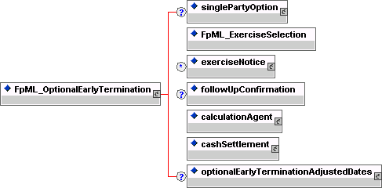
Contents:
singlePartyOption (zero or one occurrence; contains the sub-element(s) defined by exactly one occurrence of the entity FpML_SinglePartyOption)
- If optional early termination is not available to both parties then this component specifies the buyer and seller of the option.
inherited element(s) (this entity inherits the element(s) defined by exactly one occurrence of the entity FpML_ExerciseSelection)
- Entity to defined the types of exercise. The choice is european, bermuda or american exercise.
exerciseNotice (zero or more occurrences; contains the sub-element(s) defined by exactly one occurrence of the entity FpML_ExerciseNotice)
- Definition of the party to whom notice of exercise should be given.
followUpConfirmation (zero or one occurrence; of type boolean)
- A flag to indicate whether follow-up confirmation of exercise (written or electronic) is required following telephonic notice by the buyer to the seller or seller's agent.
calculationAgent (exactly one occurrence; contains the sub-element(s) defined by exactly one occurrence of the entity FpML_CalculationAgent)
- The ISDA Calculation Agent responsible for performing duties associated with an optional early termination.
cashSettlement (exactly one occurrence; contains the sub-element(s) defined by exactly one occurrence of the entity FpML_CashSettlement)
- If specified, this means that cash settlement is applicable to the transaction and defines the parameters associated with the cash settlement procedure. If not specified, then physical settlement is applicable.
optionalEarlyTerminationAdjustedDates (zero or one occurrence; contains the sub-element(s) defined by exactly one occurrence of the entity FpML_OptionalEarlyTerminationAdjustedDates)
- An early termination provision to terminate the trade at fair value where one or both parties have the right to decide on termination.
Used by:
optionalEarlyTermination
DTD Fragment:
<!ENTITY % FpML_OptionalEarlyTermination "singlePartyOption? , (%FpML_ExerciseSelection;) , exerciseNotice* , followUpConfirmation? , calculationAgent , cashSettlement , optionalEarlyTerminationAdjustedDates?">

FpML_OptionalEarlyTerminationAdjustedDates
Description:
An entity to define the adjusted dates associated with an optional early termination provision.
Figure:
Contents:
earlyTerminationEvent (one or more occurrences; contains the sub-element(s) defined by exactly one occurrence of the entity FpML_EarlyTerminationEvent)
- The adjusted dates associated with an individual early termination date.
Used by:
optionalEarlyTerminationAdjustedDates
DTD Fragment:
<!ENTITY % FpML_OptionalEarlyTerminationAdjustedDates "earlyTerminationEvent+">

FpML_PartialExercise
Description:
An entity to define partial exercise. As defined in the 2000 ISDA Definitions, Section 12.3 Partial Exercise, the buyer of the option may exercise all or less than all the notional amount of the underlying swap but may not be less than the minimum notional amount (if specified) and must be an integral multiple of the integral multiple amount if specified.
Figure:
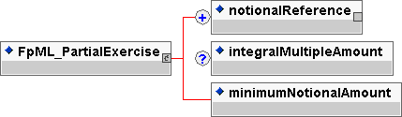
Contents:
notionalReference (one or more occurrences; an empty element containing an href attribute)
- A pointer style reference to the associated notional schedule defined elsewhere in the document.
integralMultipleAmount (zero or one occurrence; of type decimal)
- A notional amount which restricts the amount of notional that can be exercised when partial exercise or multiple exercise is applicable. The integral multiple amount defines a lower limit of notional that can be exercised and also defines a unit multiple of notional that can be exercised, i.e. only integer multiples of this amount can be exercised.
minimumNotionalAmount (exactly one occurrence; of type decimal)
- The minimum notional amount that can be exercised on a given exercise date. See multipleExercise.
Used by:
FpML_MultipleExercise
partialExercise
DTD Fragment:
<!ENTITY % FpML_PartialExercise "notionalReference+ , integralMultipleAmount? , minimumNotionalAmount">

FpML_Party
Description:
An entity for defining party identifier information.
Figure:
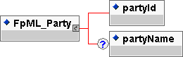
Contents:
partyId (exactly one occurrence; of type string, an enumerated domain value defined by partyIdScheme)
- A party identifier, e.g. a S.W.I.F.T. bank identifier code (BIC).
partyName (zero or one occurrence; of type string)
- The name of the party. A free format string. FpML does not define usage rules for this element
Used by:
party
DTD Fragment:
<!ENTITY % FpML_Party "partyId , partyName?">

FpML_PartyTradeIdentifier
Description:
An entity for defining one or more trade reference identifiers allocated to the trade by a party. A link identifier allows the trade to be associated with other related trades, e.g. trades forming part of a larger structured transaction. It is expected that for external communication of a trade there will be only one tradeId sent in the document per party.
Figure:
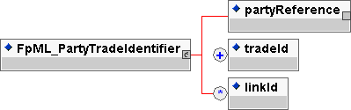
Contents:
partyReference (exactly one occurrence; an empty element containing an href attribute)
- A pointer style reference to a party identifier defined elsewhere in the document. The party referenced has allocated the trade identifier.
tradeId (one or more occurrences; of type string, an enumerated domain value defined by tradeIdScheme)
- A trade reference identifier allocated by a party. FpML does not define the domain values associated with this element. Note that the domain values for this element are not strictly an enumerated list.
linkId (zero or more occurrences; of type string, an enumerated domain value defined by linkIdScheme)
- A link identifier allowing the trade to be associated with other related trades, e.g. the linkId may contain a tradeId for an associated trade or several related trades may be given the same linkId. FpML does not define the domain values associated with this element. Note that the domain values for this element are not strictly an enumerated list.
Used by:
partyTradeIdentifier
DTD Fragment:
<!ENTITY % FpML_PartyTradeIdentifier "partyReference , tradeId+ , linkId*">

FpML_Payment
Description:
An entity for defining payments.
Figure:
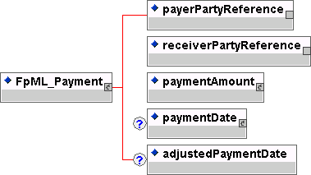
Contents:
payerPartyReference (exactly one occurrence; an empty element containing an href attribute)
- A pointer style reference to a party identifier defined elsewhere in the document.
receiverPartyReference (exactly one occurrence; an empty element containing an href attribute)
- A pointer style reference to a party identifier defined elsewhere in the document.
paymentAmount (exactly one occurrence; contains the sub-element(s) defined by exactly one occurrence of the entity FpML_Money)
- The currency amount of the payment.
paymentDate (zero or one occurrence; contains the sub-element(s) defined by exactly one occurrence of the entity FpML_AdjustableDate)
- The payment date. This date is subject to adjustment in accordance with any applicable business day convention. This element is optional to allow the fee component to be used to capture commission amounts that might not have a known payment date associated with them, e.g. commissions may be invoiced and billed periodically.
adjustedPaymentDate (zero or one occurrence; of type date)
- The adjusted payment date. This date should already be adjusted for any applicable business day convention. This element is not intended for use in trade confirmation but may be specified to allow the fee structure to also serve as a cashflow type component (all dates in the FpML_Cashflows entity are adjusted payment dates).
Used by:
FpML_BulletPayment
payment
premium
DTD Fragment:
<!ENTITY % FpML_Payment "payerPartyReference , receiverPartyReference , paymentAmount , paymentDate? , adjustedPaymentDate?">

FpML_PaymentCalculationPeriod
Description:
An entity defining the adjusted and unadjusted payment date and associated calculation period parameters required to calculate the actual or projected payment amount. This entity forms part of the cashflows representation of a swap stream.
Figure:
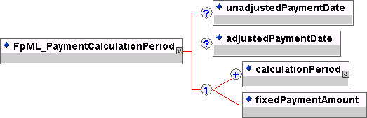
Contents:
unadjustedPaymentDate (zero or one occurrence; of type date)
- The unadjusted payment date.
adjustedPaymentDate (zero or one occurrence; of type date)
- The adjusted payment date. This date should already be adjusted for any applicable business day convention.
Either
calculationPeriod (one or more occurrences; contains the sub-element(s) defined by exactly one occurrence of the entity FpML_CalculationPeriod)
- The parameters used in the calculation of a fixed or floating rate calculation period amount. A list of calculation period elements may be ordered in the document by ascending adjusted start date. An FpML document which contains an unordered list of calculation periods is still regarded as a conformant document.
Or
fixedPaymentAmount (exactly one occurrence; of type decimal)
- A known fixed payment amount.
Used by:
paymentCalculationPeriod
DTD Fragment:
<!ENTITY % FpML_PaymentCalculationPeriod "unadjustedPaymentDate?, adjustedPaymentDate? , (calculationPeriod+ | fixedPaymentAmount)">

FpML_PaymentDates
Description:
An entity for defining the parameters used to generate the payment dates schedule, including the specification of early or delayed payments. Payment dates are determined relative to the calculation periods dates or the reset dates.
Figure:
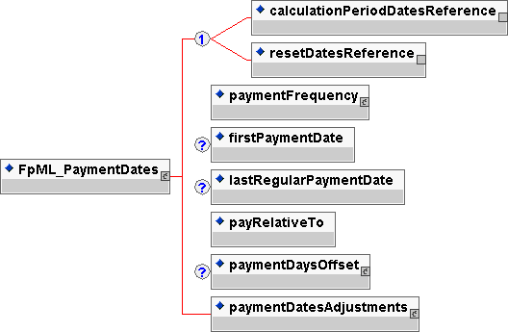
Contents:
Either
calculationPeriodDatesReference (exactly one occurrence; an empty element containing an href attribute)
- A pointer style reference to the associated calculation period dates component defined elsewhere in the document.
Or
resetDatesReference (exactly one occurrence; an empty element containing an href attribute)
- A pointer style reference to the associated reset dates component defined elsewhere in the document.
paymentFrequency (exactly one occurrence; contains the sub-element(s) defined by exactly one occurrence of the entity FpML_Interval)
- The frequency at which regular payment dates occur. If the payment frequency is equal to the frequency defined in the calculation period dates component then one calculation period contributes to each payment amount. If the payment frequency is less frequent than the frequency defined in the calculation period dates component then more than one calculation period will contribute to each payment amount. A payment frequency more frequent than the calculation period frequency or one that is not a multiple of the calculation period frequency is invalid.
firstPaymentDate (zero or one occurrence; of type date)
- The first unadjusted payment date. This day may be subject to adjustment in accordance with any business day convention specified in paymentDatesAdjustments. This element must only be included if there is an initial stub. This date will normally correspond to an unadjusted calculation period start or end date. This is true even if early or delayed payment is specified to be applicable since the actual first payment date will be the specified number of days before or after the applicable adjusted calculation period start or end date with the resulting payment date then being adjusted in accordance with any business day convention specified in paymentDatesAdjustments.
lastRegularPaymentDate (zero or one occurrence; of type date)
- The last regular unadjusted payment date. This day may be subject to adjustment in accordance with any business day convention specified in paymentDatesAdjustments. This element must only be included if there is a final stub. All calculation periods after this date contribute to the final payment. The final payment is made relative to the final set of calculation periods or the final reset date as the case may be. This date will normally correspond to an unadjusted calculation period start or end date. This is true even if early or delayed payment is specified to be applicable since the actual last regular payment date will be the specified number of days before or after the applicable adjusted calculation period start or end date with the resulting payment date then being adjusted in accordance with any business day convention specified in paymentDatesAdjustments.
payRelativeTo (exactly one occurrence; of type string, an enumerated domain value defined by payRelativeToScheme)
- Specifies whether the payments occur relative to each adjusted calculation period start date, adjusted calculation period end date or each reset date. The reset date is applicable in the case of certain euro (former French Franc) floating rate indices. Calculation period start date means relative to the start of the first calculation period contributing to a given payment. Similarly, calculation period end date means the end of the last calculation period contributing to a given payment.
paymentDaysOffset (zero or one occurrence; contains the sub-element(s) defined by exactly one occurrence of the entity FpML_Offset)
- If early payment or delayed payment is required, specifies the number of days offset that the payment occurs relative to what would otherwise be the unadjusted payment date. The offset can be specified in terms of either calendar or business days. Even in the case of a calendar days offset, the resulting payment date, adjusted for the specified calendar days offset, will still be adjusted in accordance with the specified payment dates adjustments. This element should only be included if early or delayed payment is applicable, i.e. if the periodMultiplier element value is not equal to zero. An early payment would be indicated by a negative periodMultiplier element value and a delayed payment (or payment lag) would be indicated by a positive periodMultiplier element value.
paymentDatesAdjustments (exactly one occurrence; contains the sub-element(s) defined by exactly one occurrence of the entity FpML_BusinessDayAdjustments)
- The business day convention to apply to each payment date if it would otherwise fall on a day that is not a business day in the specified financial business centers.
Used by:
paymentDates
DTD Fragment:
<!ENTITY % FpML_PaymentDates "((calculationPeriodDatesReference | resetDatesReference) , paymentFrequency , firstPaymentDate? , lastRegularPaymentDate? , payRelativeTo , paymentDaysOffset? , paymentDatesAdjustments)">

FpML_PrincipalExchange
Description:
An entity for defining a principal exchange amount and unadjusted and adjusted exchange date. This entity forms part of the cashflows representation of a swap stream.
Figure:
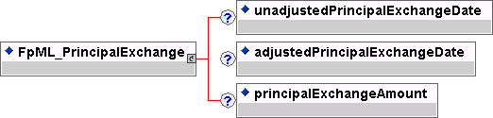
Contents:
unadjustedPrincipalExchangeDate (zero or one occurrence; of type date)
- The unadjusted principal exchange date.
adjustedPrincipalExchangeDate (zero or one occurrence; of type date)
- The principal exchange date. This date should already be adjusted for any applicable business day convention.
principalExchangeAmount (zero or one occurrence; of type decimal)
- The principal exchange amount. This amount should be positive if the stream payer is paying the exchange amount and signed negative if they are receiving it.
Used by:
principalExchange
DTD Fragment:
<!ENTITY % FpML_PrincipalExchange "unadjustedPrincipalExchangeDate?, adjustedPrincipalExchangeDate? , principalExchangeAmount?">

FpML_PrincipalExchanges
Description:
An entity for defining which principal exchanges occur for the stream.
Figure:
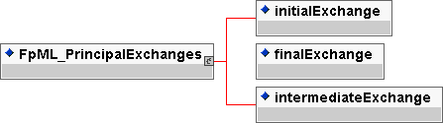
Contents:
initialExchange (exactly one occurrence; of type boolean)
- A true/false flag to indicate whether there is an initial exchange of principal on the effective date.
finalExchange (exactly one occurrence; of type boolean)
- A true/false flag to indicate whether there is a final exchange of principal on the termination date.
intermediateExchange (exactly one occurrence; of type boolean)
- A true/false flag to indicate whether there are intermediate or interim exchanges of principal during the term of the swap.
Used by:
principalExchanges
DTD Fragment:
<!ENTITY % FpML_PrincipalExchanges "initialExchange , finalExchange , intermediateExchange">

FpML_Product
Description:
The base entity which all FpML products extend.
Figure:
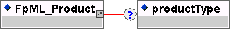
Contents:
productType (zero or one occurrence; of type string, an enumerated domain value defined by productTypeScheme)
- A classification of the type of product. FpML does not define domain values for this element.
Used by:
FpML_BulletPayment
FpML_CapFloor
FpML_Fra
FpML_Swap
FpML_Swaption
DTD Fragment:
<!ENTITY % FpML_Product "productType?">

FpML_ProductSelection
Description:
An entity defining the available product definitions.
Figure:
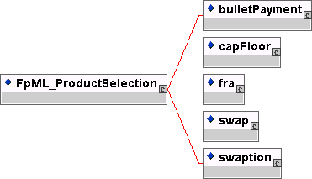
Contents:
Either
bulletPayment (exactly one occurrence; contains the sub-element(s) defined by exactly one occurrence of the entity FpML_BulletPayment)
- A product to represent one or more known payments.
Or
capFloor (exactly one occurrence; contains the sub-element(s) defined by exactly one occurrence of the entity FpML_CapFloor)
- A cap, floor or cap floor structures product definition.
Or
fra (exactly one occurrence; contains the sub-element(s) defined by exactly one occurrence of the entity FpML_Fra)
- A forward rate agreement product definition.
Or
swap (exactly one occurrence; contains the sub-element(s) defined by exactly one occurrence of the entity FpML_Swap)
- A swap product definition.
Or
swaption (exactly one occurrence; contains the sub-element(s) defined by exactly one occurrence of the entity FpML_Swaption)
- A swaption product definition.
Used by:
FpML_Trade
DTD Fragment:
<!ENTITY % FpML_ProductSelection "(bulletPayment | capFloor | fra | swap | swaption)">

FpML_RateObservation
Description:
An entity for defining parameters associated with an individual rate observation or fixing. This entity forms part of the cashflows representation of a stream.
Figure:
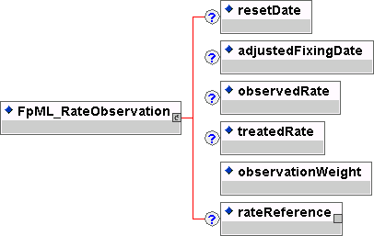
Contents:
resetDate (zero or one occurrence; of type date)
- The reset date.
adjustedFixingDate (zero or one occurrence; of type date)
- The adjusted fixing date, i.e. the actual date the rate is observed. This date should already be adjusted for any applicable business day convention.
observedRate (zero or one occurrence; of type decimal)
- The actual observed rate before any required rate treatment is applied, e.g. before converting a rate quoted on a discount basis to an equivalent yield. An observed rate of 5% would be represented as 0.05.
treatedRate (zero or one occurrence; of type decimal)
- The observed rate after any required rate treatment is applied. A treated rate of 5% would be represented as 0.05.
observationWeight (exactly one occurrence; of type positiveInteger)
- The number of days weighting to be associated with the rate observation, i.e. the number of days such rate is in effect. This is applicable in the case of a weighted average method of calculation where more than one reset date is established for a single calculation period.
rateReference (zero or one occurrence; an empty element containing an href attribute)
- A pointer style reference to a floating rate component defined as part of a stub calculation period amount component. It is only required when it is necessary to distinguish two rate observations for the same fixing date which could occur when linear interpolation of two different rates occurs for a stub calculation period.
Used by:
rateObservation
DTD Fragment:
<!ENTITY % FpML_RateObservation "resetDate?, adjustedFixingDate? , observedRate? , treatedRate? , observationWeight , rateReference?">

FpML_ReferenceBank
Description:
An entity to describe institution (party) identified by means of a coding scheme and an optional name.
Figure:
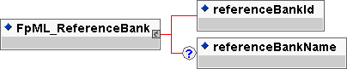
Contents:
referenceBankId (exactly one occurrence; of type string, an enumerated domain value defined by referenceBankIdScheme)
- An institution (party) identifier, e.g. a bank identifier code (BIC).
referenceBankName (zero or one occurrence; of type string)
- The name of the institution (party). A free format string. FpML does not define usage rules for the element.
Used by:
referenceBank
DTD Fragment:
<!ENTITY % FpML_ReferenceBank "referenceBankId , referenceBankName?">

FpML_RelativeDateOffset
Description:
An entity for defining a date (referred to as the derived date) as a relative offset from another date (referred to as the anchor date). If the anchor date is itself an adjustable date then the offset is assumed to be calculated from the adjusted anchor date. A number of different scenarios can be supported, namely; 1) the derived date may simply be a number of calendar periods (days, weeks, months or years) preceding or following the anchor date; 2) the unadjusted derived date may be a number of calendar periods (days, weeks, months, years) preceding or following the anchor date with the resulting unadjusted derived date subject to adjustment in accordance with a specified business day convention, i.e. the derived date must fall on a good business day; 3) the derived date may be a number of business days preceding or following the anchor date. Note that the businessDayConvention element specifies any required adjustment to the unadjusted derived date. A negative or positive value in the periodMultiplier element indicates whether the unadjusted derived date precedes or follows the anchor date. The businessDayConvention element should contain a value of NONE if the dayType element contains a value of Business (since specifying a negative or positive business days offset would already guarantee that the derived date would fall on a good business day in the specified business centers).
Figure:
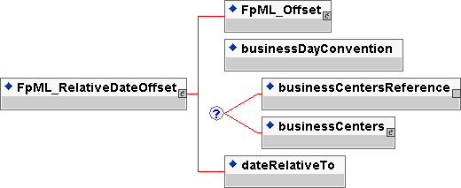
Contents:
inherited element(s) (this entity inherits the element(s) defined by exactly one occurrence of the entity FpML_Offset)
- An entity for defining an offset used in calculating a new date relative to a reference date. Currently, the only offsets defined are expected to be expressed as either calendar or business day offsets. This entity inherits from a base entity, FpML_Interval.
businessDayConvention (exactly one occurrence; of type string, an enumerated domain value defined by businessDayConventionScheme)
- The convention for adjusting a date if it would otherwise fall on a day that is not a business day. If the business day convention value is NONE then the businessCentersReference or businessCenters element should still be included if the dayType element contains a value of Business since the business centers defined are those used for determining good business days.
Zero or one occurrence of either
businessCentersReference (exactly one occurrence; an empty element containing an href attribute)
- A pointer style reference to a set of financial business centers defined elsewhere in the document. This set of business centers is used to determine whether a particular day is a business day or not.
Or
businessCenters (zero or one occurrence; contains the sub-element(s) defined by exactly one occurrence of the entity FpML_BusinessCenters)
- A container for a set of financial business centers. This set of business centers is used to determine whether a day is a business day or not.
dateRelativeTo (exactly one occurrence; of type string, an enumerated domain value defined by dateRelativeToScheme)
- Specifies the anchor date. This element also carries an href attribute. The href attribute value will be a pointer style reference to the element or component elsewhere in the document where the anchor date is defined.
Used by:
FpML_RelativeDates
cashSettlementValuationDate
feePaymentDate
fixingDateOffset
fixingDates
relativeDate
varyingNotionalFixingDates
varyingNotionalInterimExchangePaymentDates
DTD Fragment:
<!ENTITY % FpML_RelativeDateOffset "(%FpML_Offset; , businessDayConvention , (businessCentersReference | businessCenters)? , dateRelativeTo)">

FpML_RelativeDates
Description:
An entity to define a set of dates defined as relative to another set of dates.
Figure:
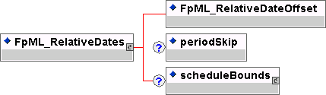
Contents:
inherited element(s) (this entity inherits the element(s) defined by exactly one occurrence of the entity FpML_RelativeDateOffset)
- An entity for defining a date (referred to as the derived date) as a relative offset from another date (referred to as the anchor date). If the anchor date is itself an adjustable date then the offset is assumed to be calculated from the adjusted anchor date. A number of different scenarios can be supported, namely; 1) the derived date may simply be a number of calendar periods (days, weeks, months or years) preceding or following the anchor date; 2) the unadjusted derived date may be a number of calendar periods (days, weeks, months, years) preceding or following the anchor date with the resulting unadjusted derived date subject to adjustment in accordance with a specified business day convention, i.e. the derived date must fall on a good business day; 3) the derived date may be a number of business days preceding or following the anchor date. Note that the businessDayConvention element specifies any required adjustment to the unadjusted derived date. A negative or positive value in the periodMultiplier element indicates whether the unadjusted derived date precedes or follows the anchor date. The businessDayConvention element should contain a value of NONE if the dayType element contains a value of Business (since specifying a negative or positive business days offset would already guarantee that the derived date would fall on a good business day in the specified business centers).
periodSkip (zero or one occurrence; of type positiveInteger)
- The number of periods in the referenced date schedule that are between each date in the relative date schedule. Thus a skip of 2 would mean that dates are relative to every second date in the referenced schedule. If present this should have a value greater than 1.

scheduleBounds (zero or one occurrence; contains the sub-element(s) defined by exactly one occurrence of the entity FpML_DateRange)
- The first and last dates of a schedule. This can be used to restrict the range of values in a reference series of dates.

Used by:
relativeDates
DTD Fragment:
<!ENTITY % FpML_RelativeDates "(%FpML_RelativeDateOffset; , periodSkip? , scheduleBounds?)">

FpML_ResetDates
Description:
An entity for defining the parameters used to generate the reset dates schedule and associated fixing dates. The reset dates are determined relative to the calculation periods schedule dates.
Figure:
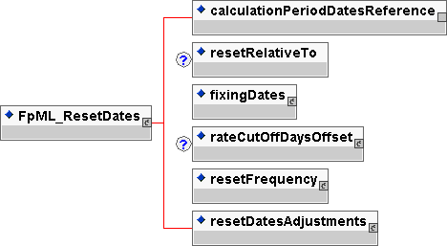
Contents:
calculationPeriodDatesReference (exactly one occurrence; an empty element containing an href attribute)
- A pointer style reference to the associated calculation period dates component defined elsewhere in the document.
resetRelativeTo (zero or one occurrence; of type string, an enumerated domain value defined by resetRelativeToScheme)
- Specifies whether the reset dates are determined with respect to each adjusted calculation period start date or adjusted calculation period end date. If the reset frequency is specified as daily this element must not be included.
fixingDates (exactly one occurrence; contains the sub-element(s) defined by exactly one occurrence of the entity FpML_RelativeDateOffset)
- Specifies the fixing date relative to each reset date in terms of a business days offset and an associated set of financial business centers. Normally these offset calculation rules will be those specified in the ISDA definition for the relevant floating rate index (ISDA's Floating Rate Option). However, non-standard offset calculation rules may apply for a trade if mutually agreed by the principal parties to the transaction. The href attribute on the dateRelativeTo element should reference the id attribute on the resetDates element.
rateCutOffDaysOffset (zero or one occurrence; contains the sub-element(s) defined by exactly one occurrence of the entity FpML_Offset)
- Specifies the number of business days before the period end date when the rate cut-off date is assumed to apply. The financial business centers associated with determining the rate cut-off date are those specified in the reset dates adjustments. The rate cut-off number of days must be a negative integer (a value of zero would imply no rate cut off applies in which case the rateCutOffDaysOffset element should not be included). The relevant rate for each reset date in the period from, and including, a rate cut-off date to, but excluding, the next applicable period end date (or, in the case of the last calculation period, the termination date) will (solely for purposes of calculating the floating amount payable on the next applicable payment date) be deemed to be the relevant rate in effect on that rate cut-off date. For example, if rate cut-off days for a daily averaging deal is -2 business days, then the refix rate applied on (period end date - 2 days) will also be applied as the reset on (period end date - 1 day), i.e. the actual number of reset dates remains the same but from the rate cut-off date until the period end date, the same refix rate is applied. Note that in the case of several calculation periods contributing to a single payment, the rate cut-off is assumed only to apply to the final calculation period contributing to that payment. The day type associated with the offset must imply a business days offset.
resetFrequency (exactly one occurrence; contains the sub-element(s) defined by exactly one occurrence of the entity FpML_ResetFrequency)
- The frequency at which reset dates occur. In the case of a weekly reset frequency, also specifies the day of the week that the reset occurs. If the reset frequency is greater than the calculation period frequency then this implies that more than one reset date is established for each calculation period and some form of rate averaging is applicable.
resetDatesAdjustments (exactly one occurrence; contains the sub-element(s) defined by exactly one occurrence of the entity FpML_BusinessDayAdjustments)
- The business day convention to apply to each reset date if it would otherwise fall on a day that is not a business day in the specified financial business centers.
Used by:
resetDates
DTD Fragment:
<!ENTITY % FpML_ResetDates "calculationPeriodDatesReference , resetRelativeTo? , fixingDates , rateCutOffDaysOffset? , resetFrequency , resetDatesAdjustments">

FpML_ResetFrequency
Description:
An entity for defining the reset frequency. In the case of a weekly reset, also specifies the day of the week that the reset occurs. This entity inherits from a base entity, FpML_Interval. If the reset frequency is greater than the calculation period frequency then this implies that more than one reset date is established for each calculation period and some form of rate averaging is applicable. The specific averaging method of calculation is specified in the entity FpML_FloatingRateCalculation.
Figure:
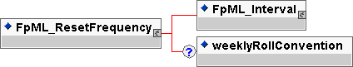
Contents:
inherited element(s) (this entity inherits the element(s) defined by exactly one occurrence of the entity FpML_Interval)
- An entity for defining a time interval or offset, e.g. one day, three months. Used for specifying frequencies at which events occur, the tenor of a floating rate or an offset relative to another date.
weeklyRollConvention (zero or one occurrence; of type string, an enumerated domain value defined by weeklyRollConventionScheme)
- The day of the week on which a weekly reset date occurs. This element must be included if the reset frequency is defined as weekly and not otherwise.
Used by:
resetFrequency
DTD Fragment:
<!ENTITY % FpML_ResetFrequency "(%FpML_Interval; , weeklyRollConvention?)">

FpML_Rounding
Description:
An entity for defining a rounding direction and precision to be used in the rounding of a rate.
Figure:
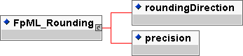
Contents:
roundingDirection (exactly one occurrence; of type string, an enumerated domain value defined by roundingDirectionScheme)
- Specifies the rounding direction.
precision (exactly one occurrence; of type nonNegativeInteger)
- Specifies the rounding precision in terms of a number of decimal places. Note how a percentage rate rounding of 5 decimal places is expressed as a rounding precision of 7 in the FpML document since the percentage is expressed as a decimal, e.g. 9.876543% (or 0.09876543) being rounded to the nearest 5 decimal places is 9.87654% (or 0.0987654).
Used by:
finalRateRounding
DTD Fragment:
<!ENTITY % FpML_Rounding "roundingDirection , precision">

FpML_Schedule
Description:
An entity for defining a schedule of rate or amounts in terms of an initial value and then a series of step date and value pairs. On each step date the rate or amount changes to the new step value. The series of step date and value pairs are optional. If not specified, this implies that the initial value remains unchanged over time.
Figure:
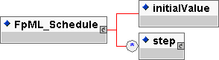
Contents:
initialValue (exactly one occurrence; of type decimal)
- The initial rate or amount, as the case may be. An initial rate of 5% would be represented as 0.05.
step (zero or more occurrences; contains the sub-element(s) defined by exactly one occurrence of the entity FpML_Step)
- The schedule of step date and value pairs. On each step date the associated step value becomes effective A list of steps may be ordered in the document by ascending step date. An FpML document containing an unordered list of steps is still regarded as a conformant document.
Used by:
FpML_AmountSchedule
FpML_StrikeSchedule
feeAmountSchedule
feeRateSchedule
fixedRateSchedule
floatingRateMultiplierSchedule
spreadSchedule
DTD Fragment:
<!ENTITY % FpML_Schedule "initialValue , step*">

FpML_SettlementRateSource
Description:
An entity to describe the method for obtaining a settlement rate.
Figure:
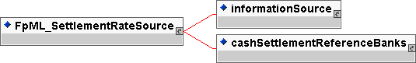
Contents:
Either
informationSource (exactly one occurrence; contains the sub-element(s) defined by exactly one occurrence of the entity FpML_InformationSource)
- The information source where a published or displayed market rate will be obtained, e.g. Telerate Page 3750.
Or
cashSettlementReferenceBanks (exactly one occurrence; contains the sub-element(s) defined by exactly one occurrence of the entity FpML_CashSettlementReferenceBanks)
- A container for a set of reference institutions. These reference institutions may be called upon to provide rate quotations as part of the method to determine the applicable cash settlement amount. If institutions are not specified, it is assumed that reference institutions will be agreed between the parties on the exercise date, or in the case of swap transaction to which mandatory early termination is applicable, the cash settlement valuation date.
Used by:
settlementRateSource
DTD Fragment:
<!ENTITY % FpML_SettlementRateSource "informationSource | cashSettlementReferenceBanks">

FpML_SinglePartyOption
Description:
An entity to describe the buyer and seller of a n option.
Figure:
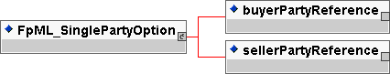
Contents:
buyerPartyReference (exactly one occurrence; an empty element containing an href attribute)
- A pointer style reference to a party identifier defined elsewhere in the document. The party referenced is the buyer of the instrument.
sellerPartyReference (exactly one occurrence; an empty element containing an href attribute)
- A pointer style reference to a party identifier defined elsewhere in the document. The party referenced is the seller of the instrument.
Used by:
singlePartyOption
DTD Fragment:
<!ENTITY % FpML_SinglePartyOption "buyerPartyReference , sellerPartyReference">

FpML_Step
Description:
An entity for defining a step date and step value pair. These step definitions are used to define varying rate or amount schedules, e.g. a notional amortization or a step-up coupon schedule.
Figure:
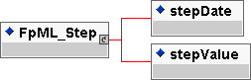
Contents:
stepDate (exactly one occurrence; of type date)
- The date on which the associated stepValue becomes effective. This day may be subject to adjustment in accordance with a business day convention.
stepValue (exactly one occurrence; of type decimal)
- The rate or amount which becomes effective on the associated stepDate. A rate of 5% would be represented as 0.05.
Used by:
step
DTD Fragment:
<!ENTITY % FpML_Step "stepDate , stepValue">

FpML_Strike
Description:
An entity to describe a single cap or floor rate.
Figure:
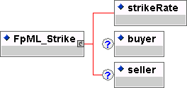
Contents:
strikeRate (exactly one occurrence; of type decimal)
- The rate for a cap or floor.
buyer (zero or one occurrence; of type string, an enumerated domain value defined by payerReceiverScheme)
- The buyer of the option
seller (zero or one occurrence; of type string, an enumerated domain value defined by payerReceiverScheme)
- The party that has sold.
Used by:
capRate
floorRate
DTD Fragment:
<!ENTITY % FpML_Strike "strikeRate , buyer? , seller?">

FpML_StrikeSchedule
Description:
An entity to describe a schedule of cap or floor rates.
Figure:
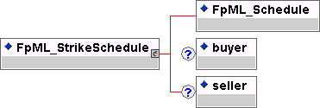
Contents:
inherited element(s) (this entity inherits the element(s) defined by exactly one occurrence of the entity FpML_Schedule)
- An entity for defining a schedule of rate or amounts in terms of an initial value and then a series of step date and value pairs. On each step date the rate or amount changes to the new step value. The series of step date and value pairs are optional. If not specified, this implies that the initial value remains unchanged over time.
buyer (zero or one occurrence; of type string, an enumerated domain value defined by payerReceiverScheme)
- The buyer of the option
seller (zero or one occurrence; of type string, an enumerated domain value defined by payerReceiverScheme)
- The party that has sold.
Used by:
capRateSchedule
floorRateSchedule
DTD Fragment:
<!ENTITY % FpML_StrikeSchedule "(%FpML_Schedule; , buyer? , seller?)">

FpML_Stub
Description:
An entity for defining how a stub calculation period amount is calculated. A single floating rate tenor different to that used for the regular part of the calculation periods schedule may be specified, or two floating rate tenors may be specified. If two floating rate tenors are specified then Linear Interpolation (in accordance with the 2000 ISDA Definitions, Section 8.3. Interpolation) is assumed to apply. Alternatively, an actual known stub rate or stub amount may be specified.
Figure:
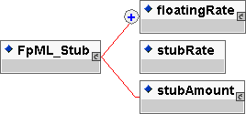
Contents:
Either
floatingRate (one or more occurrences; contains the sub-element(s) defined by exactly one occurrence of the entity FpML_FloatingRate)
- The rates to be applied to the initial or final stub may be the linear interpolation of two different rates. While the majority of the time, the rate indices will be the same as that specified in the stream and only the tenor itself will be different, it is possible to specify two different rates. For example, a 2 month stub period may use the linear interpolation of a 1 month and 3 month rate. The different rates would be specified in this component. Note that a maximum of two rates can be specified. If a stub period uses the same floating rate index, including tenor, as the regular calculation periods then this should not be specified again within this component, i.e. the stub calculation period amount component may not need to be specified even if there is an initial or final stub period. If a stub period uses a different floating rate index compared to the regular calculation periods then this should be specified within this component. If specified here, they are likely to have id attributes, allowing them to be referenced from within the cashflows component.
Or
stubRate (exactly one occurrence; of type decimal)
- An actual rate to apply for the initial or final stub period may have been agreed between the principal parties (in a similar way to how an initial rate may have been agreed for the first regular period). If an actual stub rate has been agreed then it would be included in this component. It will be a per annum rate, expressed as a decimal. A stub rate of 5% would be represented as 0.05.
Or
stubAmount (exactly one occurrence; contains the sub-element(s) defined by exactly one occurrence of the entity FpML_Money)
- An actual amount to apply for the initial or final stub period may have been agreed between the two parties. If an actual stub amount has been agreed then it would be included in this component.
Used by:
finalStub
initialStub
DTD Fragment:
<!ENTITY % FpML_Stub "(floatingRate+ | stubRate | stubAmount)">

FpML_StubCalculationPeriodAmount
Description:
An entity for defining how the initial or final stub calculation period amounts is calculated. For example, the rate to be applied to the initial or final stub calculation period may be the linear interpolation of two different tenors for the floating rate index specified in the calculation period amount component, e.g. A two month stub period may use the linear interpolation of a one month and three month floating rate. The different rate tenors would be specified in this component. Note that a maximum of two rate tenors can be specified. If a stub period uses a single index tenor and this is the same as that specified in the calculation period amount component then the initial stub or final stub element, as the case may be, must not be included.
Figure:
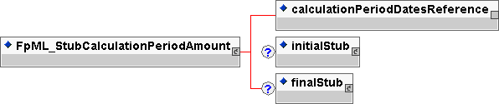
Contents:
calculationPeriodDatesReference (exactly one occurrence; an empty element containing an href attribute)
- A pointer style reference to the associated calculation period dates component defined elsewhere in the document.
initialStub (zero or one occurrence; contains the sub-element(s) defined by exactly one occurrence of the entity FpML_Stub)
- Specifies how the initial stub amount is calculated. A single floating rate tenor different to that used for the regular part of the calculation periods schedule may be specified, or two floating tenors may be specified. If two floating rate tenors are specified then Linear Interpolation (in accordance with the 2000 ISDA Definitions, Section 8.3. Interpolation) is assumed to apply. Alternatively, an actual known stub rate or stub amount may be specified.
finalStub (zero or one occurrence; contains the sub-element(s) defined by exactly one occurrence of the entity FpML_Stub)
- Specifies how the final stub amount is calculated. A single floating rate tenor different to that used for the regular part of the calculation periods schedule may be specified, or two floating tenors may be specified. If two floating rate tenors are specified then Linear Interpolation (in accordance with the 2000 ISDA Definitions, Section 8.3. Interpolation) is assumed to apply. Alternatively, an actual known stub rate or stub amount may be specified.
Used by:
stubCalculationPeriodAmount
DTD Fragment:
<!ENTITY % FpML_StubCalculationPeriodAmount "calculationPeriodDatesReference , initialStub? , finalStub?">

FpML_Swap
Description:
An entity for defining swap streams and additional payments between the principal parties involved in the swap.
Figure:
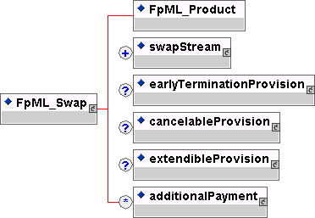
Contents:

inherited element(s) (this entity inherits the element(s) defined by exactly one occurrence of the entity FpML_Product)
- The base entity which all FpML products extend.
swapStream (one or more occurrences; contains the sub-element(s) defined by exactly one occurrence of the entity FpML_InterestRateStream)
- The swap streams.
earlyTerminationProvision (zero or one occurrence; contains the sub-element(s) defined by exactly one occurrence of the entity FpML_EarlyTerminationProvision)
- Parameters specifying provisions relating to the optional and mandatory early termination of a swap transaction.
cancelableProvision (zero or one occurrence; contains the sub-element(s) defined by exactly one occurrence of the entity FpML_CancelableProvision)
- A provision that allows the specification of an embedded option within a swap giving the buyer of the option the right to terminate the swap, in whole or in part, on the early termination date.
extendibleProvision (zero or one occurrence; contains the sub-element(s) defined by exactly one occurrence of the entity FpML_ExtendibleProvision)
- A provision that allows the specification of an embedded option within a swap giving the buyer of the option the right to extend the swap, in whole or in part, to the extended termination date.
additionalPayment (zero or more occurrences; contains the sub-element(s) defined by exactly one occurrence of the entity FpML_Fee)
- Additional payments between the principal parties.
Used by:
swap
DTD Fragment:
<!ENTITY % FpML_Swap "%FpML_Product;,swapStream+ , earlyTerminationProvision? , cancelableProvision? , extendibleProvision? , additionalPayment*">

FpML_Swaption
Description:
An entity to define a option on a swap.
Figure:
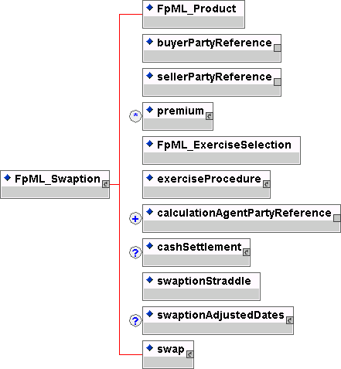
Contents:

inherited element(s) (this entity inherits the element(s) defined by exactly one occurrence of the entity FpML_Product)
- The base entity which all FpML products extend.
buyerPartyReference (exactly one occurrence; an empty element containing an href attribute)
- A pointer style reference to a party identifier defined elsewhere in the document. The party referenced is the buyer of the instrument.
sellerPartyReference (exactly one occurrence; an empty element containing an href attribute)
- A pointer style reference to a party identifier defined elsewhere in the document. The party referenced is the seller of the instrument.
premium (zero or more occurrences; contains the sub-element(s) defined by exactly one occurrence of the entity FpML_Payment)
- The option premium amount payable by buyer to seller on the specified payment date.
inherited element(s) (this entity inherits the element(s) defined by exactly one occurrence of the entity FpML_ExerciseSelection)
- Entity to defined the types of exercise. The choice is european, bermuda or american exercise.
exerciseProcedure (exactly one occurrence; contains the sub-element(s) defined by exactly one occurrence of the entity FpML_ExerciseProcedure)
- A set of parameters defining procedures associated with the exercise.
calculationAgentPartyReference (one or more occurrences; an empty element containing an href attribute)
- A pointer style reference to a party identifier defined elsewhere in the document. The party referenced is the ISDA Calculation Agent for the trade. If more than one party is referenced then the parties are assumed to be co-calculation agents, i.e. they have joint responsibility.
cashSettlement (zero or one occurrence; contains the sub-element(s) defined by exactly one occurrence of the entity FpML_CashSettlement)
- If specified, this means that cash settlement is applicable to the transaction and defines the parameters associated with the cash settlement procedure. If not specified, then physical settlement is applicable.
swaptionStraddle (exactly one occurrence; of type boolean)
- Whether the option is a swaption or a swaption straddle
swaptionAdjustedDates (zero or one occurrence; contains the sub-element(s) defined by exactly one occurrence of the entity FpML_SwaptionAdjustedDates)
- The adjusted dates associated with swaption exercise. These dates have been adjusted for any applicable business day convention.
swap (exactly one occurrence; contains the sub-element(s) defined by exactly one occurrence of the entity FpML_Swap)
- A swap product definition.
Used by:
swaption
DTD Fragment:
<!ENTITY % FpML_Swaption "%FpML_Product;,buyerPartyReference , sellerPartyReference , premium* , (%FpML_ExerciseSelection;) , exerciseProcedure , calculationAgentPartyReference+ , cashSettlement? , swaptionStraddle , swaptionAdjustedDates? , swap">

FpML_SwaptionAdjustedDates
Description:
An entity to describe the adjusted dates associated with swaption exercise and settlement.
Figure:
Contents:
exerciseEvent (one or more occurrences; contains the sub-element(s) defined by exactly one occurrence of the entity FpML_ExerciseEvent)
- The adjusted dates associated with an individual swaption exercise date.
Used by:
swaptionAdjustedDates
DTD Fragment:
<!ENTITY % FpML_SwaptionAdjustedDates "exerciseEvent+">

FpML_Trade
Description:
An entity for defining an FpML trade.
Figure:
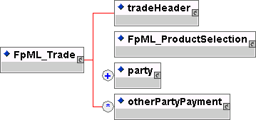
Contents:
tradeHeader (exactly one occurrence; contains the sub-element(s) defined by exactly one occurrence of the entity FpML_TradeHeader)
- The information on the trade which is not product specific, e.g. trade date.

inherited element(s) (this entity inherits the element(s) defined by exactly one occurrence of the entity FpML_ProductSelection)
- An entity defining the available product definitions.

party (one or more occurrences; contains the sub-element(s) defined by exactly one occurrence of the entity FpML_Party)
- The parties obligated to make payments from time to time during the term of the trade. This will include, at a minimum, the principal parties involved in the swap or forward rate agreement. Other parties paying or receiving fees, commissions etc. must also be specified if referenced in other party payments.
otherPartyPayment (zero or more occurrences; contains the sub-element(s) defined by exactly one occurrence of the entity FpML_Fee)
- Other fees or additional payments associated with the trade, e.g. broker commissions, where one or more of the parties involved are not principal parties involved in the trade.
Used by:
trade
DTD Fragment:
<!ENTITY % FpML_Trade "tradeHeader , %FpML_ProductSelection; , party+ , otherPartyPayment*">

FpML_TradeHeader
Description:
An entity for defining trade related information which is not product specific.
Figure:
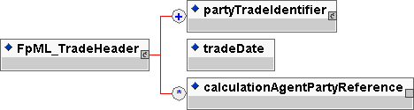
Contents:
partyTradeIdentifier (one or more occurrences; contains the sub-element(s) defined by exactly one occurrence of the entity FpML_PartyTradeIdentifier)
- The trade reference identifier(s) allocated to the trade by the parties involved.
tradeDate (exactly one occurrence; of type date)
- The trade date.
calculationAgentPartyReference (zero or more occurrences; an empty element containing an href attribute)
- A pointer style reference to a party identifier defined elsewhere in the document. The party referenced is the ISDA Calculation Agent for the trade. If more than one party is referenced then the parties are assumed to be co-calculation agents, i.e. they have joint responsibility.
Used by:
tradeHeader
DTD Fragment:
<!ENTITY % FpML_TradeHeader "partyTradeIdentifier+ , tradeDate , calculationAgentPartyReference*">

FpML_YieldCurveMethod
Description:
An entity to define the parameters required for each of the ISDA defined yield curve methods for cash settlement.
Figure:
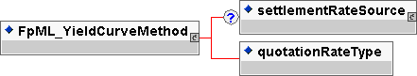
Contents:
settlementRateSource (zero or one occurrence; contains the sub-element(s) defined by exactly one occurrence of the entity FpML_SettlementRateSource)
- The method for obtaining a settlement rate. This may be from some information source (e.g. Reuters) or from a set of reference banks.
quotationRateType (exactly one occurrence; of type string, an enumerated domain value defined by quotationRateTypeScheme)
- Which rate quote is to be observed, either Bid, Mid, Offer or Exercising Party Pays. The meaning of Exercising Party Pays is defined in the 2000 ISDA Definitions, Section 17.2. Certain Definitions Relating to Cash Settlement, paragraph (j)
Used by:
parYieldCurveAdjustedMethod
parYieldCurveUnadjustedMethod
zeroCouponYieldAdjustedMethod
DTD Fragment:
<!ENTITY % FpML_YieldCurveMethod "settlementRateSource? , quotationRateType">

Document TYPE Definition (DTD)

fpml-dtd-2-0
<?xml version='1.0' encoding='UTF-8' ?>

<!--Generated by XML Authority-->

<!-- uri://www.fpml.org/spec/2002/fpml-dtd-2-0-2002-12-13 -->
<!ENTITY % FpML_Product "productType?">

<!ENTITY % FpML_AdjustableDate "unadjustedDate , dateAdjustments">

<!ENTITY % FpML_BusinessCenters "businessCenter+">

<!ENTITY % FpML_BusinessDayAdjustments "businessDayConvention , (businessCentersReference | businessCenters)?">

<!ENTITY % FpML_Calculation "((notionalSchedule | fxLinkedNotionalSchedule) , (fixedRateSchedule | floatingRateCalculation) , dayCountFraction , discounting? , compoundingMethod?)">

<!ENTITY % FpML_CalculationPeriod "unadjustedStartDate?, unadjustedEndDate?, adjustedStartDate? , adjustedEndDate?, calculationPeriodNumberOfDays? , (notionalAmount | fxLinkedNotionalAmount) , (floatingRateDefinition | fixedRate)">

<!ENTITY % FpML_CalculationPeriodAmount "calculation | knownAmountSchedule">

<!ENTITY % FpML_CalculationPeriodDates "effectiveDate , terminationDate , calculationPeriodDatesAdjustments , firstPeriodStartDate? , firstRegularPeriodStartDate? , lastRegularPeriodEndDate? , calculationPeriodFrequency">

<!ENTITY % FpML_Cashflows "cashflowsMatchParameters , principalExchange* , paymentCalculationPeriod*">

<!ENTITY % FpML_Discounting "discountingType , discountRate? , discountRateDayCountFraction?">

<!ENTITY % FpML_Payment "payerPartyReference , receiverPartyReference , paymentAmount , paymentDate? , adjustedPaymentDate?">

<!ENTITY % FpML_Fee "%FpML_Payment; , paymentType?">

<!ENTITY % FpML_FloatingRate "floatingRateIndex , indexTenor? , floatingRateMultiplierSchedule? , spreadSchedule? , rateTreatment? , capRateSchedule* , floorRateSchedule*">

<!ENTITY % FpML_FloatingRateCalculation "(%FpML_FloatingRate; , initialRate? , finalRateRounding? , averagingMethod? , negativeInterestRateTreatment?)">

<!ENTITY % FpML_FloatingRateDefinition "calculatedRate? , rateObservation* , floatingRateMultiplier? , spread? , capRate* , floorRate*">

<!ENTITY % FpML_Fra "%FpML_Product; , buyerPartyReference , sellerPartyReference , adjustedEffectiveDate , adjustedTerminationDate , paymentDate , fixingDateOffset , dayCountFraction , calculationPeriodNumberOfDays , notional , fixedRate , floatingRateIndex , indexTenor+ , fraDiscounting">

<!ENTITY % FpML_InterestRateStream "payerPartyReference , receiverPartyReference , calculationPeriodDates , paymentDates , resetDates? , calculationPeriodAmount , stubCalculationPeriodAmount? , principalExchanges? , cashflows?">

<!ENTITY % FpML_Interval "periodMultiplier , period">

<!ENTITY % FpML_CalculationPeriodFrequency "(%FpML_Interval; , rollConvention)">

<!ENTITY % FpML_Money "currency , amount">

<!ENTITY % FpML_Notional "notionalStepSchedule , notionalStepParameters?">

<!ENTITY % FpML_NotionalStepRule "calculationPeriodDatesReference , stepFrequency , firstNotionalStepDate , lastNotionalStepDate , (notionalStepAmount | (notionalStepRate , stepRelativeTo))">

<!ENTITY % FpML_Offset "(%FpML_Interval; , dayType?)">

<!ENTITY % FpML_Party "partyId , partyName?">

<!ENTITY % FpML_PartyTradeIdentifier "partyReference , tradeId+ , linkId*">

<!ENTITY % FpML_PaymentCalculationPeriod "unadjustedPaymentDate?, adjustedPaymentDate? , (calculationPeriod+ | fixedPaymentAmount)">

<!ENTITY % FpML_PaymentDates "((calculationPeriodDatesReference | resetDatesReference) , paymentFrequency , firstPaymentDate? , lastRegularPaymentDate? , payRelativeTo , paymentDaysOffset? , paymentDatesAdjustments)">

<!ENTITY % FpML_PrincipalExchange "unadjustedPrincipalExchangeDate?, adjustedPrincipalExchangeDate? , principalExchangeAmount?">

<!ENTITY % FpML_PrincipalExchanges "initialExchange , finalExchange , intermediateExchange">

<!ENTITY % FpML_ProductSelection "(bulletPayment | capFloor | fra | swap | swaption)">

<!ENTITY % FpML_RateObservation "resetDate?, adjustedFixingDate? , observedRate? , treatedRate? , observationWeight , rateReference?">

<!ENTITY % FpML_RelativeDateOffset "(%FpML_Offset; , businessDayConvention , (businessCentersReference | businessCenters)? , dateRelativeTo)">

<!ENTITY % FpML_ResetDates "calculationPeriodDatesReference , resetRelativeTo? , fixingDates , rateCutOffDaysOffset? , resetFrequency , resetDatesAdjustments">

<!ENTITY % FpML_ResetFrequency "(%FpML_Interval; , weeklyRollConvention?)">

<!ENTITY % FpML_Rounding "roundingDirection , precision">

<!ENTITY % FpML_Schedule "initialValue , step*">

<!ENTITY % FpML_AmountSchedule "(%FpML_Schedule; , currency)">

<!ENTITY % FpML_Step "stepDate , stepValue">

<!ENTITY % FpML_Stub "(floatingRate+ | stubRate | stubAmount)">

<!ENTITY % FpML_StubCalculationPeriodAmount "calculationPeriodDatesReference , initialStub? , finalStub?">

<!ENTITY % FpML_Swap "%FpML_Product; , swapStream+ , earlyTerminationProvision? , cancelableProvision? , extendibleProvision? , additionalPayment*">

<!ENTITY % FpML_Trade "tradeHeader , %FpML_ProductSelection; , party+ , otherPartyPayment*">

<!ENTITY % FpML_TradeHeader "partyTradeIdentifier+ , tradeDate , calculationAgentPartyReference*">

<!-- new version 2.0 entities required by FpML 1.0 elements below -->
<!ENTITY % FpML_Strike "strikeRate , buyer? , seller?">

<!ENTITY % FpML_StrikeSchedule "(%FpML_Schedule; , buyer? , seller?)">

<!ELEMENT FpML (trade)>

<!ATTLIST FpML version (2-0 ) #REQUIRED
averagingMethodSchemeDefault CDATA #IMPLIED
businessCenterSchemeDefault CDATA #IMPLIED
businessDayConventionSchemeDefault CDATA #IMPLIED
calculationAgentPartySchemeDefault CDATA #IMPLIED
compoundingMethodSchemeDefault CDATA #IMPLIED
currencySchemeDefault CDATA #IMPLIED
dateRelativeToSchemeDefault CDATA #IMPLIED
dayCountFractionSchemeDefault CDATA #IMPLIED
dayTypeSchemeDefault CDATA #IMPLIED
discountingTypeSchemeDefault CDATA #IMPLIED
floatingRateIndexSchemeDefault CDATA #IMPLIED
informationProviderSchemeDefault CDATA #IMPLIED
linkIdSchemeDefault CDATA #IMPLIED
negativeInterestRateTreatmentSchemeDefault CDATA #IMPLIED
partyIdSchemeDefault CDATA #IMPLIED
payerReceiverSchemeDefault CDATA #IMPLIED
paymentTypeSchemeDefault CDATA #IMPLIED
payRelativeToSchemeDefault CDATA #IMPLIED
periodSchemeDefault CDATA #IMPLIED
productTypeSchemeDefault CDATA #IMPLIED
quotationRateTypeSchemeDefault CDATA #IMPLIED
rateSourcePageSchemeDefault CDATA #IMPLIED
rateTreatmentSchemeDefault CDATA #IMPLIED
referenceBankIdSchemeDefault CDATA #IMPLIED
resetRelativeToSchemeDefault CDATA #IMPLIED
rollConventionSchemeDefault CDATA #IMPLIED
roundingDirectionSchemeDefault CDATA #IMPLIED
stepRelativeToSchemeDefault CDATA #IMPLIED
tradeIdSchemeDefault CDATA #IMPLIED
weeklyRollConventionSchemeDefault CDATA #IMPLIED >
<!ELEMENT additionalPayment (%FpML_Fee;)>

<!ATTLIST additionalPayment type NMTOKEN #FIXED 'Fee'
base NMTOKEN #FIXED 'Payment'
id ID #IMPLIED >
<!ELEMENT adjustedEffectiveDate (#PCDATA)>

<!ATTLIST adjustedEffectiveDate type NMTOKEN #FIXED 'date'
id ID #REQUIRED >
<!ELEMENT adjustedEndDate (#PCDATA)>

<!ATTLIST adjustedEndDate type NMTOKEN #FIXED 'date' >
<!ELEMENT adjustedFixingDate (#PCDATA)>

<!ATTLIST adjustedFixingDate type NMTOKEN #FIXED 'date' >
<!ELEMENT adjustedPaymentDate (#PCDATA)>

<!ATTLIST adjustedPaymentDate type NMTOKEN #FIXED 'date' >
<!ELEMENT adjustedPrincipalExchangeDate (#PCDATA)>

<!ATTLIST adjustedPrincipalExchangeDate type NMTOKEN #FIXED 'date' >
<!ELEMENT adjustedStartDate (#PCDATA)>

<!ATTLIST adjustedStartDate type NMTOKEN #FIXED 'date' >
<!ELEMENT adjustedTerminationDate (#PCDATA)>

<!ATTLIST adjustedTerminationDate type NMTOKEN #FIXED 'date' >
<!ELEMENT amount (#PCDATA)>

<!ATTLIST amount type NMTOKEN #FIXED 'decimal' >
<!ELEMENT averagingMethod (#PCDATA)>

<!ATTLIST averagingMethod type NMTOKEN #FIXED 'string'
averagingMethodScheme CDATA #IMPLIED >
<!ELEMENT businessCenter (#PCDATA)>

<!ATTLIST businessCenter type NMTOKEN #FIXED 'string'
id ID #IMPLIED
businessCenterScheme CDATA #IMPLIED >
<!ELEMENT businessCenters (%FpML_BusinessCenters;)>

<!ATTLIST businessCenters type NMTOKEN #FIXED 'BusinessCenters'
id ID #IMPLIED >
<!ELEMENT businessCentersReference EMPTY>

<!ATTLIST businessCentersReference href CDATA #REQUIRED >
<!ELEMENT businessDayConvention (#PCDATA)>

<!ATTLIST businessDayConvention type NMTOKEN #FIXED 'string'
businessDayConventionScheme CDATA #IMPLIED >
<!ELEMENT buyerPartyReference EMPTY>

<!ATTLIST buyerPartyReference href CDATA #REQUIRED >
<!ELEMENT calculatedRate (#PCDATA)>

<!ATTLIST calculatedRate type NMTOKEN #FIXED 'decimal' >
<!ELEMENT calculation (%FpML_Calculation;)>

<!ATTLIST calculation type NMTOKEN #FIXED 'Calculation' >
<!ELEMENT calculationAgentPartyReference EMPTY>

<!ATTLIST calculationAgentPartyReference href CDATA #REQUIRED >
<!ELEMENT calculationPeriod (%FpML_CalculationPeriod;)>

<!ATTLIST calculationPeriod type NMTOKEN #FIXED 'CalculationPeriod'
id ID #IMPLIED >
<!ELEMENT calculationPeriodAmount (%FpML_CalculationPeriodAmount;)>

<!ATTLIST calculationPeriodAmount type NMTOKEN #FIXED 'CalculationPeriodAmount' >
<!ELEMENT calculationPeriodDates (%FpML_CalculationPeriodDates;)>

<!ATTLIST calculationPeriodDates type NMTOKEN #FIXED 'CalculationPeriodDates'
id ID #REQUIRED >
<!ELEMENT calculationPeriodDatesAdjustments (%FpML_BusinessDayAdjustments;)>

<!ATTLIST calculationPeriodDatesAdjustments type NMTOKEN #FIXED 'BusinessDayAdjustments' >
<!ELEMENT calculationPeriodDatesReference EMPTY>

<!ATTLIST calculationPeriodDatesReference href CDATA #REQUIRED >
<!ELEMENT calculationPeriodFrequency (%FpML_CalculationPeriodFrequency;)>

<!ATTLIST calculationPeriodFrequency type NMTOKEN #FIXED 'CalculationPeriodFrequency'
base NMTOKEN #FIXED 'Interval' >
<!ELEMENT calculationPeriodNumberOfDays (#PCDATA)>

<!ATTLIST calculationPeriodNumberOfDays type NMTOKEN #FIXED 'positiveInteger' >
<!ELEMENT capRate (%FpML_Strike;)>

<!ATTLIST capRate type NMTOKEN #FIXED 'Strike'
id ID #IMPLIED >
<!ELEMENT capRateSchedule (%FpML_StrikeSchedule;)>

<!ATTLIST capRateSchedule type NMTOKEN #FIXED 'StrikeSchedule'
base NMTOKEN #FIXED 'Schedule'
id ID #IMPLIED >
<!ELEMENT cashflows (%FpML_Cashflows;)>

<!ATTLIST cashflows type NMTOKEN #FIXED 'Cashflows' >
<!ELEMENT cashflowsMatchParameters (#PCDATA)>

<!ATTLIST cashflowsMatchParameters type NMTOKEN #FIXED 'boolean' >
<!ELEMENT compoundingMethod (#PCDATA)>

<!ATTLIST compoundingMethod type NMTOKEN #FIXED 'string'
compoundingMethodScheme CDATA #IMPLIED >
<!ELEMENT currency (#PCDATA)>

<!ATTLIST currency type NMTOKEN #FIXED 'string'
currencyScheme CDATA #IMPLIED >
<!ELEMENT dateAdjustments (%FpML_BusinessDayAdjustments;)>

<!ATTLIST dateAdjustments type NMTOKEN #FIXED 'BusinessDayAdjustments' >
<!ELEMENT dateRelativeTo (#PCDATA)>

<!ATTLIST dateRelativeTo type NMTOKEN #FIXED 'string'
href CDATA #REQUIRED
dateRelativeToScheme CDATA #IMPLIED >
<!ELEMENT dayCountFraction (#PCDATA)>

<!ATTLIST dayCountFraction type NMTOKEN #FIXED 'string'
dayCountFractionScheme CDATA #IMPLIED >
<!ELEMENT dayType (#PCDATA)>

<!ATTLIST dayType type NMTOKEN #FIXED 'string'
dayTypeScheme CDATA #IMPLIED >
<!ELEMENT discounting (%FpML_Discounting;)>

<!ATTLIST discounting type NMTOKEN #FIXED 'Discounting' >
<!ELEMENT discountingType (#PCDATA)>

<!ATTLIST discountingType type NMTOKEN #FIXED 'string'
discountingTypeScheme CDATA #IMPLIED >
<!ELEMENT discountRate (#PCDATA)>

<!ATTLIST discountRate type NMTOKEN #FIXED 'decimal' >
<!ELEMENT discountRateDayCountFraction (#PCDATA)>

<!ATTLIST discountRateDayCountFraction type NMTOKEN #FIXED 'string'
dayCountFractionScheme CDATA #IMPLIED >
<!ELEMENT effectiveDate (%FpML_AdjustableDate;)>

<!ATTLIST effectiveDate type NMTOKEN #FIXED 'AdjustableDate' >
<!ELEMENT finalExchange (#PCDATA)>

<!ATTLIST finalExchange type NMTOKEN #FIXED 'boolean' >
<!ELEMENT finalRateRounding (%FpML_Rounding;)>

<!ATTLIST finalRateRounding type NMTOKEN #FIXED 'Rounding' >
<!ELEMENT finalStub (%FpML_Stub;)>

<!ATTLIST finalStub type NMTOKEN #FIXED 'Stub' >
<!ELEMENT firstNotionalStepDate (#PCDATA)>

<!ATTLIST firstNotionalStepDate type NMTOKEN #FIXED 'date' >
<!ELEMENT firstPaymentDate (#PCDATA)>

<!ATTLIST firstPaymentDate type NMTOKEN #FIXED 'date' >
<!ELEMENT firstPeriodStartDate (%FpML_AdjustableDate;)>

<!ATTLIST firstPeriodStartDate type NMTOKEN #FIXED 'AdjustableDate' >
<!ELEMENT firstRegularPeriodStartDate (#PCDATA)>

<!ATTLIST firstRegularPeriodStartDate type NMTOKEN #FIXED 'date' >
<!ELEMENT fixedPaymentAmount (#PCDATA)>

<!ATTLIST fixedPaymentAmount type NMTOKEN #FIXED 'decimal' >
<!ELEMENT fixedRate (#PCDATA)>

<!ATTLIST fixedRate type NMTOKEN #FIXED 'decimal' >
<!ELEMENT fixedRateSchedule (%FpML_Schedule;)>

<!ATTLIST fixedRateSchedule type NMTOKEN #FIXED 'Schedule' >
<!ELEMENT fixingDateOffset (%FpML_RelativeDateOffset;)>

<!ATTLIST fixingDateOffset type NMTOKEN #FIXED 'RelativeDateOffset'
base NMTOKEN #FIXED 'Offset' >
<!ELEMENT fixingDates (%FpML_RelativeDateOffset;)>

<!ATTLIST fixingDates type NMTOKEN #FIXED 'RelativeDateOffset'
base NMTOKEN #FIXED 'Offset' >
<!ELEMENT floatingRate (%FpML_FloatingRate;)>

<!ATTLIST floatingRate type NMTOKEN #FIXED 'FloatingRate'
id ID #IMPLIED >
<!ELEMENT floatingRateCalculation (%FpML_FloatingRateCalculation;)>

<!ATTLIST floatingRateCalculation type NMTOKEN #FIXED 'FloatingRateCalculation'
base NMTOKEN #FIXED 'FloatingRate' >
<!ELEMENT floatingRateDefinition (%FpML_FloatingRateDefinition;)>

<!ATTLIST floatingRateDefinition type NMTOKEN #FIXED 'FloatingRateDefinition' >
<!ELEMENT floatingRateIndex (#PCDATA)>

<!ATTLIST floatingRateIndex type NMTOKEN #FIXED 'string'
floatingRateIndexScheme CDATA #IMPLIED >
<!ELEMENT floorRate (%FpML_Strike;)>

<!ATTLIST floorRate type NMTOKEN #FIXED 'Strike'
id ID #IMPLIED >
<!ELEMENT floorRateSchedule (%FpML_StrikeSchedule;)>

<!ATTLIST floorRateSchedule type NMTOKEN #FIXED 'StrikeSchedule'
base NMTOKEN #FIXED 'Schedule'
id ID #IMPLIED >
<!ELEMENT fra (%FpML_Fra;)>

<!ATTLIST fra type NMTOKEN #FIXED 'Fra'
base NMTOKEN #FIXED 'Product'
id ID #IMPLIED >
<!ELEMENT fraDiscounting (#PCDATA)>

<!ATTLIST fraDiscounting type NMTOKEN #FIXED 'boolean' >
<!ELEMENT indexTenor (%FpML_Interval;)>

<!ATTLIST indexTenor type NMTOKEN #FIXED 'Interval'
id ID #IMPLIED >
<!ELEMENT initialExchange (#PCDATA)>

<!ATTLIST initialExchange type NMTOKEN #FIXED 'boolean' >
<!ELEMENT initialRate (#PCDATA)>

<!ATTLIST initialRate type NMTOKEN #FIXED 'decimal' >
<!ELEMENT initialStub (%FpML_Stub;)>

<!ATTLIST initialStub type NMTOKEN #FIXED 'Stub' >
<!ELEMENT initialValue (#PCDATA)>

<!ATTLIST initialValue type NMTOKEN #FIXED 'decimal' >
<!ELEMENT intermediateExchange (#PCDATA)>

<!ATTLIST intermediateExchange type NMTOKEN #FIXED 'boolean' >
<!ELEMENT knownAmountSchedule (%FpML_AmountSchedule;)>

<!ATTLIST knownAmountSchedule type NMTOKEN #FIXED 'AmountSchedule'
base NMTOKEN #FIXED 'Schedule' >
<!ELEMENT lastNotionalStepDate (#PCDATA)>

<!ATTLIST lastNotionalStepDate type NMTOKEN #FIXED 'date' >
<!ELEMENT lastRegularPaymentDate (#PCDATA)>

<!ATTLIST lastRegularPaymentDate type NMTOKEN #FIXED 'date' >
<!ELEMENT lastRegularPeriodEndDate (#PCDATA)>

<!ATTLIST lastRegularPeriodEndDate type NMTOKEN #FIXED 'date' >
<!ELEMENT linkId (#PCDATA)>

<!ATTLIST linkId type NMTOKEN #FIXED 'string'
id ID #IMPLIED
linkIdScheme CDATA #IMPLIED >
<!ELEMENT negativeInterestRateTreatment (#PCDATA)>

<!ATTLIST negativeInterestRateTreatment type NMTOKEN #FIXED 'string'
negativeInterestRateTreatmentScheme CDATA #IMPLIED >
<!ELEMENT notional (%FpML_Money;)>

<!ATTLIST notional type NMTOKEN #FIXED 'Money' >
<!ELEMENT notionalAmount (#PCDATA)>

<!ATTLIST notionalAmount type NMTOKEN #FIXED 'decimal' >
<!ELEMENT notionalSchedule (%FpML_Notional;)>

<!ATTLIST notionalSchedule type NMTOKEN #FIXED 'Notional'
id ID #IMPLIED >
<!ELEMENT notionalStepAmount (#PCDATA)>

<!ATTLIST notionalStepAmount type NMTOKEN #FIXED 'decimal' >
<!ELEMENT notionalStepParameters (%FpML_NotionalStepRule;)>

<!ATTLIST notionalStepParameters type NMTOKEN #FIXED 'NotionalStepRule' >
<!ELEMENT notionalStepRate (#PCDATA)>

<!ATTLIST notionalStepRate type NMTOKEN #FIXED 'decimal' >
<!ELEMENT notionalStepSchedule (%FpML_AmountSchedule;)>

<!ATTLIST notionalStepSchedule type NMTOKEN #FIXED 'AmountSchedule'
base NMTOKEN #FIXED 'Schedule' >
<!ELEMENT observationWeight (#PCDATA)>

<!ATTLIST observationWeight type NMTOKEN #FIXED 'positiveInteger' >
<!ELEMENT observedRate (#PCDATA)>

<!ATTLIST observedRate type NMTOKEN #FIXED 'decimal' >
<!ELEMENT otherPartyPayment (%FpML_Fee;)>

<!ATTLIST otherPartyPayment type NMTOKEN #FIXED 'Fee'
base NMTOKEN #FIXED 'Payment'
id ID #IMPLIED >
<!ELEMENT party (%FpML_Party;)>

<!ATTLIST party type NMTOKEN #FIXED 'Party'
id ID #REQUIRED >
<!ELEMENT partyId (#PCDATA)>

<!ATTLIST partyId type NMTOKEN #FIXED 'string'
partyIdScheme CDATA #IMPLIED >
<!ELEMENT partyName (#PCDATA)>

<!ATTLIST partyName type NMTOKEN #FIXED 'string' >
<!ELEMENT partyReference EMPTY>

<!ATTLIST partyReference href CDATA #REQUIRED >
<!ELEMENT partyTradeIdentifier (%FpML_PartyTradeIdentifier;)>

<!ATTLIST partyTradeIdentifier type NMTOKEN #FIXED 'PartyTradeIdentifier'
id ID #IMPLIED >
<!ELEMENT payerPartyReference EMPTY>

<!ATTLIST payerPartyReference href CDATA #REQUIRED >
<!ELEMENT paymentAmount (%FpML_Money;)>

<!ATTLIST paymentAmount type NMTOKEN #FIXED 'Money' >
<!ELEMENT paymentCalculationPeriod (%FpML_PaymentCalculationPeriod;)>

<!ATTLIST paymentCalculationPeriod type NMTOKEN #FIXED 'PaymentCalculationPeriod'
id ID #IMPLIED >
<!ELEMENT paymentDate (%FpML_AdjustableDate;)>

<!ATTLIST paymentDate type NMTOKEN #FIXED 'AdjustableDate'
id ID #IMPLIED >
<!ELEMENT paymentDates (%FpML_PaymentDates;)>

<!ATTLIST paymentDates type NMTOKEN #FIXED 'PaymentDates'
id ID #IMPLIED >
<!ELEMENT paymentDatesAdjustments (%FpML_BusinessDayAdjustments;)>

<!ATTLIST paymentDatesAdjustments type NMTOKEN #FIXED 'BusinessDayAdjustments' >
<!ELEMENT paymentDaysOffset (%FpML_Offset;)>

<!ATTLIST paymentDaysOffset type NMTOKEN #FIXED 'Offset'
base NMTOKEN #FIXED 'Interval' >
<!ELEMENT paymentFrequency (%FpML_Interval;)>

<!ATTLIST paymentFrequency type NMTOKEN #FIXED 'Interval' >
<!ELEMENT paymentType (#PCDATA)>

<!ATTLIST paymentType type NMTOKEN #FIXED 'string'
paymentTypeScheme CDATA #IMPLIED >
<!ELEMENT payRelativeTo (#PCDATA)>

<!ATTLIST payRelativeTo type NMTOKEN #FIXED 'string'
payRelativeToScheme CDATA #IMPLIED >
<!ELEMENT period (#PCDATA)>

<!ATTLIST period type NMTOKEN #FIXED 'string'
periodScheme CDATA #IMPLIED >
<!ELEMENT periodMultiplier (#PCDATA)>

<!ATTLIST periodMultiplier type NMTOKEN #FIXED 'integer' >
<!ELEMENT precision (#PCDATA)>

<!ATTLIST precision type NMTOKEN #FIXED 'nonNegativeInteger' >
<!ELEMENT principalExchange (%FpML_PrincipalExchange;)>

<!ATTLIST principalExchange type NMTOKEN #FIXED 'PrincipalExchange'
id ID #IMPLIED >
<!ELEMENT principalExchangeAmount (#PCDATA)>

<!ATTLIST principalExchangeAmount type NMTOKEN #FIXED 'decimal' >
<!ELEMENT principalExchanges (%FpML_PrincipalExchanges;)>

<!ATTLIST principalExchanges type NMTOKEN #FIXED 'PrincipalExchanges' >
<!ELEMENT rateCutOffDaysOffset (%FpML_Offset;)>

<!ATTLIST rateCutOffDaysOffset type NMTOKEN #FIXED 'Offset'
base NMTOKEN #FIXED 'Interval' >
<!ELEMENT rateObservation (%FpML_RateObservation;)>

<!ATTLIST rateObservation type NMTOKEN #FIXED 'RateObservation'
id ID #IMPLIED >
<!ELEMENT rateReference EMPTY>

<!ATTLIST rateReference href CDATA #REQUIRED >
<!ELEMENT rateTreatment (#PCDATA)>

<!ATTLIST rateTreatment type NMTOKEN #FIXED 'string'
rateTreatmentScheme CDATA #IMPLIED >
<!ELEMENT receiverPartyReference EMPTY>

<!ATTLIST receiverPartyReference href CDATA #REQUIRED >
<!ELEMENT resetDates (%FpML_ResetDates;)>

<!ATTLIST resetDates type NMTOKEN #FIXED 'ResetDates'
id ID #REQUIRED >
<!ELEMENT resetDatesAdjustments (%FpML_BusinessDayAdjustments;)>

<!ATTLIST resetDatesAdjustments type NMTOKEN #FIXED 'BusinessDayAdjustments' >
<!ELEMENT resetDatesReference EMPTY>

<!ATTLIST resetDatesReference href CDATA #REQUIRED >
<!ELEMENT resetFrequency (%FpML_ResetFrequency;)>

<!ATTLIST resetFrequency type NMTOKEN #FIXED 'ResetFrequency'
base NMTOKEN #FIXED 'Interval' >
<!ELEMENT resetRelativeTo (#PCDATA)>

<!ATTLIST resetRelativeTo type NMTOKEN #FIXED 'string'
resetRelativeToScheme CDATA #IMPLIED >
<!ELEMENT rollConvention (#PCDATA)>

<!ATTLIST rollConvention type NMTOKEN #FIXED 'string'
rollConventionScheme CDATA #IMPLIED >
<!ELEMENT roundingDirection (#PCDATA)>

<!ATTLIST roundingDirection type NMTOKEN #FIXED 'string'
roundingDirectionScheme CDATA #IMPLIED >
<!ELEMENT sellerPartyReference EMPTY>

<!ATTLIST sellerPartyReference href CDATA #REQUIRED >
<!ELEMENT spread (#PCDATA)>

<!ATTLIST spread type NMTOKEN #FIXED 'decimal' >
<!ELEMENT spreadSchedule (%FpML_Schedule;)>

<!ATTLIST spreadSchedule type NMTOKEN #FIXED 'Schedule' >
<!ELEMENT step (%FpML_Step;)>

<!ATTLIST step type NMTOKEN #FIXED 'Step'
id ID #IMPLIED >
<!ELEMENT stepDate (#PCDATA)>

<!ATTLIST stepDate type NMTOKEN #FIXED 'date' >
<!ELEMENT stepFrequency (%FpML_Interval;)>

<!ATTLIST stepFrequency type NMTOKEN #FIXED 'Interval' >
<!ELEMENT stepRelativeTo (#PCDATA)>

<!ATTLIST stepRelativeTo type NMTOKEN #FIXED 'string'
stepRelativeToScheme CDATA #IMPLIED >
<!ELEMENT stepValue (#PCDATA)>

<!ATTLIST stepValue type NMTOKEN #FIXED 'decimal' >
<!ELEMENT stubAmount (%FpML_Money;)>

<!ATTLIST stubAmount type NMTOKEN #FIXED 'Money' >
<!ELEMENT stubCalculationPeriodAmount (%FpML_StubCalculationPeriodAmount;)>

<!ATTLIST stubCalculationPeriodAmount type NMTOKEN #FIXED 'StubCalculationPeriodAmount' >
<!ELEMENT stubRate (#PCDATA)>

<!ATTLIST stubRate type NMTOKEN #FIXED 'decimal' >
<!ELEMENT swap (%FpML_Swap;)>

<!ATTLIST swap type NMTOKEN #FIXED 'Swap'
base NMTOKEN #FIXED 'Product'
id ID #IMPLIED >
<!ELEMENT swapStream (%FpML_InterestRateStream;)>

<!ATTLIST swapStream type NMTOKEN #FIXED 'InterestRateStream'
id ID #IMPLIED >
<!ELEMENT terminationDate (%FpML_AdjustableDate;)>

<!ATTLIST terminationDate type NMTOKEN #FIXED 'AdjustableDate' >
<!ELEMENT trade (%FpML_Trade;)>

<!ATTLIST trade type NMTOKEN #FIXED 'Trade'
id ID #IMPLIED >
<!ELEMENT tradeDate (#PCDATA)>

<!ATTLIST tradeDate type NMTOKEN #FIXED 'date' >
<!ELEMENT tradeHeader (%FpML_TradeHeader;)>

<!ATTLIST tradeHeader type NMTOKEN #FIXED 'TradeHeader' >
<!ELEMENT tradeId (#PCDATA)>

<!ATTLIST tradeId type NMTOKEN #FIXED 'string'
id ID #IMPLIED
tradeIdScheme CDATA #IMPLIED >
<!ELEMENT treatedRate (#PCDATA)>

<!ATTLIST treatedRate type NMTOKEN #FIXED 'decimal' >
<!ELEMENT unadjustedDate (#PCDATA)>

<!ATTLIST unadjustedDate type NMTOKEN #FIXED 'date'
id ID #IMPLIED >
<!ELEMENT weeklyRollConvention (#PCDATA)>

<!ATTLIST weeklyRollConvention type NMTOKEN #FIXED 'string'
weeklyRollConventionScheme CDATA #IMPLIED >
<!-- new version 2.0 entities below -->
<!ENTITY % FpML_AdjustableDates "unadjustedDate+ , dateAdjustments">

<!ENTITY % FpML_AdjustableOrRelativeDate "adjustableDate | relativeDate">

<!ENTITY % FpML_AdjustableOrRelativeDates "adjustableDates | relativeDates">

<!ENTITY % FpML_AmericanExercise "commencementDate , expirationDate , relevantUnderlyingDate? , earliestExerciseTime , latestExerciseTime? , expirationTime , multipleExercise? , exerciseFeeSchedule?">

<!ENTITY % FpML_AutomaticExercise "thresholdRate">

<!ENTITY % FpML_BermudaExercise "bermudaExerciseDates , relevantUnderlyingDate? , earliestExerciseTime , latestExerciseTime? , expirationTime , multipleExercise? , exerciseFeeSchedule?">

<!ENTITY % FpML_BusinessCenterTime "hourMinuteTime , businessCenter">

<!ENTITY % FpML_CalculationAgent "calculationAgentPartyReference+ | calculationAgentParty">

<!ENTITY % FpML_ExerciseSelection "europeanExercise | bermudaExercise | americanExercise">

<!ENTITY % FpML_CancelableProvision "buyerPartyReference , sellerPartyReference , (%FpML_ExerciseSelection;) , exerciseNotice? , followUpConfirmation , cancelableProvisionAdjustedDates?">

<!ENTITY % FpML_CancelableProvisionAdjustedDates "cancellationEvent+">

<!ENTITY % FpML_CancellationEvent "adjustedExerciseDate , adjustedEarlyTerminationDate">

<!ENTITY % FpML_CapFloor "%FpML_Product; , capFloorStream , additionalPayment*">

<!ENTITY % FpML_CashPriceMethod "cashSettlementReferenceBanks? , cashSettlementCurrency , quotationRateType">

<!ENTITY % FpML_CashSettlement "cashSettlementValuationTime , cashSettlementValuationDate , cashSettlementPaymentDate? , (cashPriceMethod | cashPriceAlternateMethod | parYieldCurveAdjustedMethod | zeroCouponYieldAdjustedMethod | parYieldCurveUnadjustedMethod)">

<!ENTITY % FpML_CashSettlementPaymentDate "adjustableDates | relativeDate | businessDateRange">

<!ENTITY % FpML_CashSettlementReferenceBanks "referenceBank+">

<!ENTITY % FpML_DateRange "unadjustedFirstDate , unadjustedLastDate">

<!ENTITY % FpML_BusinessDateRange "(%FpML_DateRange; , businessDayConvention , (businessCentersReference | businessCenters)?)">

<!ENTITY % FpML_EarlyTerminationEvent "adjustedExerciseDate , adjustedEarlyTerminationDate , adjustedCashSettlementValuationDate , adjustedCashSettlementPaymentDate , adjustedExerciseFeePaymentDate?">

<!ENTITY % FpML_EarlyTerminationProvision "mandatoryEarlyTermination | optionalEarlyTermination">

<!ENTITY % FpML_EuropeanExercise "expirationDate , relevantUnderlyingDate? , earliestExerciseTime , expirationTime , partialExercise? , exerciseFee?">

<!ENTITY % FpML_ExerciseEvent "adjustedExerciseDate , adjustedRelevantSwapEffectiveDate , adjustedCashSettlementValuationDate? , adjustedCashSettlementPaymentDate? , adjustedExerciseFeePaymentDate?">

<!ENTITY % FpML_ExerciseFee "payerPartyReference , receiverPartyReference , notionalReference , (feeAmount | feeRate) , feePaymentDate">

<!ENTITY % FpML_ExerciseFeeSchedule "payerPartyReference , receiverPartyReference , notionalReference , (feeAmountSchedule | feeRateSchedule) , feePaymentDate">

<!ENTITY % FpML_ExerciseProcedure "(manualExercise | automaticExercise) , followUpConfirmation">

<!ENTITY % FpML_ExtendibleProvision "buyerPartyReference , sellerPartyReference , (%FpML_ExerciseSelection;) , exerciseNotice? , followUpConfirmation , extendibleProvisionAdjustedDates?">

<!ENTITY % FpML_ExtendibleProvisionAdjustedDates "extensionEvent+">

<!ENTITY % FpML_ExtensionEvent "adjustedExerciseDate , adjustedExtendedTerminationDate">

<!ENTITY % FpML_FxLinkedNotionalAmount "resetDate?, adjustedFxSpotFixingDate? , observedFxSpotRate? , notionalAmount?">

<!ENTITY % FpML_FxLinkedNotionalSchedule "constantNotionalScheduleReference, initialValue? , varyingNotionalCurrency , varyingNotionalFixingDates , fxSpotRateSource , varyingNotionalInterimExchangePaymentDates">

<!ENTITY % FpML_FxSpotRateSource "informationSource , fixingTime">

<!ENTITY % FpML_InformationSource "rateSource , rateSourcePage? , rateSourcePageHeading?">

<!ENTITY % FpML_MandatoryEarlyTermination "mandatoryEarlyTerminationDate , calculationAgent , cashSettlement , mandatoryEarlyTerminationAdjustedDates?">

<!ENTITY % FpML_MandatoryEarlyTerminationAdjustedDates "adjustedEarlyTerminationDate , adjustedCashSettlementValuationDate , adjustedCashSettlementPaymentDate">

<!ENTITY % FpML_ManualExercise "exerciseNotice? , fallbackExercise?">

<!ENTITY % FpML_OptionalEarlyTermination "singlePartyOption? , (%FpML_ExerciseSelection;) , exerciseNotice* , followUpConfirmation? , calculationAgent , cashSettlement , optionalEarlyTerminationAdjustedDates?">

<!ENTITY % FpML_OptionalEarlyTerminationAdjustedDates "earlyTerminationEvent+">

<!ENTITY % FpML_PartialExercise "notionalReference+ , integralMultipleAmount? , minimumNotionalAmount">

<!ENTITY % FpML_MultipleExercise "%FpML_PartialExercise; , maximumNotionalAmount?">

<!ENTITY % FpML_ReferenceBank "referenceBankId , referenceBankName?">

<!ENTITY % FpML_RelativeDates "(%FpML_RelativeDateOffset; , periodSkip? , scheduleBounds?)">

<!ENTITY % FpML_SettlementRateSource "informationSource | cashSettlementReferenceBanks">

<!ENTITY % FpML_SinglePartyOption "buyerPartyReference , sellerPartyReference">

<!ENTITY % FpML_Swaption "%FpML_Product; , buyerPartyReference , sellerPartyReference , premium* , (%FpML_ExerciseSelection;) , exerciseProcedure , calculationAgentPartyReference+ , cashSettlement? , swaptionStraddle , swaptionAdjustedDates? , swap">

<!ENTITY % FpML_BulletPayment "%FpML_Product; , payment">

<!ENTITY % FpML_SwaptionAdjustedDates "exerciseEvent+">

<!ENTITY % FpML_YieldCurveMethod "settlementRateSource? , quotationRateType">

<!ENTITY % FpML_ExerciseNotice "partyReference , exerciseNoticePartyReference? , businessCenter">

<!ELEMENT adjustableDate (%FpML_AdjustableDate;)>

<!ATTLIST adjustableDate type NMTOKEN #FIXED 'AdjustableDate' >
<!ELEMENT adjustableDates (%FpML_AdjustableDates;)>

<!ATTLIST adjustableDates type NMTOKEN #FIXED 'AdjustableDates' >
<!ELEMENT adjustedCashSettlementPaymentDate (#PCDATA)>

<!ATTLIST adjustedCashSettlementPaymentDate type NMTOKEN #FIXED 'date' >
<!ELEMENT adjustedCashSettlementValuationDate (#PCDATA)>

<!ATTLIST adjustedCashSettlementValuationDate type NMTOKEN #FIXED 'date' >
<!ELEMENT adjustedEarlyTerminationDate (#PCDATA)>

<!ATTLIST adjustedEarlyTerminationDate type NMTOKEN #FIXED 'date' >
<!ELEMENT adjustedExerciseDate (#PCDATA)>

<!ATTLIST adjustedExerciseDate type NMTOKEN #FIXED 'date' >
<!ELEMENT adjustedExerciseFeePaymentDate (#PCDATA)>

<!ATTLIST adjustedExerciseFeePaymentDate type NMTOKEN #FIXED 'date' >
<!ELEMENT adjustedExtendedTerminationDate (#PCDATA)>

<!ATTLIST adjustedExtendedTerminationDate type NMTOKEN #FIXED 'date' >
<!ELEMENT adjustedFxSpotFixingDate (#PCDATA)>

<!ATTLIST adjustedFxSpotFixingDate type NMTOKEN #FIXED 'date' >
<!ELEMENT adjustedRelevantSwapEffectiveDate (#PCDATA)>

<!ATTLIST adjustedRelevantSwapEffectiveDate type NMTOKEN #FIXED 'date' >
<!ELEMENT americanExercise (%FpML_AmericanExercise;)>

<!ATTLIST americanExercise type NMTOKEN #FIXED 'AmericanExercise'
id ID #IMPLIED >
<!ELEMENT automaticExercise (%FpML_AutomaticExercise;)>

<!ATTLIST automaticExercise type NMTOKEN #FIXED 'AutomaticExercise' >
<!ELEMENT bermudaExercise (%FpML_BermudaExercise;)>

<!ATTLIST bermudaExercise type NMTOKEN #FIXED 'BermudaExercise'
id ID #IMPLIED >
<!ELEMENT bermudaExerciseDates (%FpML_AdjustableOrRelativeDates;)>

<!ATTLIST bermudaExerciseDates type NMTOKEN #FIXED 'AdjustableOrRelativeDates' >
<!ELEMENT bulletPayment (%FpML_BulletPayment;)>

<!ATTLIST bulletPayment type NMTOKEN #FIXED 'BulletPayment'
base NMTOKEN #FIXED 'Product'
id ID #IMPLIED >
<!ELEMENT businessDateRange (%FpML_BusinessDateRange;)>

<!ATTLIST businessDateRange type NMTOKEN #FIXED 'BusinessDateRange'
base NMTOKEN #FIXED 'DateRange' >
<!ELEMENT buyer (#PCDATA)>

<!ATTLIST buyer type NMTOKEN #FIXED 'string'
id ID #IMPLIED
payerReceiverScheme CDATA #IMPLIED >
<!ELEMENT calculationAgent (%FpML_CalculationAgent;)>

<!ATTLIST calculationAgent type NMTOKEN #FIXED 'CalculationAgent' >
<!ELEMENT calculationAgentParty (#PCDATA)>

<!ATTLIST calculationAgentParty type NMTOKEN #FIXED 'string'
calculationAgentPartyScheme CDATA #IMPLIED >
<!ELEMENT cancelableProvision (%FpML_CancelableProvision;)>

<!ATTLIST cancelableProvision type NMTOKEN #FIXED 'CancelableProvision' >
<!ELEMENT cancelableProvisionAdjustedDates (%FpML_CancelableProvisionAdjustedDates;)>

<!ATTLIST cancelableProvisionAdjustedDates type NMTOKEN #FIXED 'CancelableProvisionAdjustedDates' >
<!ELEMENT cancellationEvent (%FpML_CancellationEvent;)>

<!ATTLIST cancellationEvent type NMTOKEN #FIXED 'CancellationEvent'
id ID #IMPLIED >
<!ELEMENT capFloor (%FpML_CapFloor;)>

<!ATTLIST capFloor type NMTOKEN #FIXED 'CapFloor'
base NMTOKEN #FIXED 'Product'
id ID #IMPLIED >
<!ELEMENT capFloorStream (%FpML_InterestRateStream;)>

<!ATTLIST capFloorStream type NMTOKEN #FIXED 'InterestRateStream'
id ID #IMPLIED >
<!ELEMENT cashPriceAlternateMethod (%FpML_CashPriceMethod;)>

<!ATTLIST cashPriceAlternateMethod type NMTOKEN #FIXED 'CashPriceMethod' >
<!ELEMENT cashPriceMethod (%FpML_CashPriceMethod;)>

<!ATTLIST cashPriceMethod type NMTOKEN #FIXED 'CashPriceMethod' >
<!ELEMENT cashSettlement (%FpML_CashSettlement;)>

<!ATTLIST cashSettlement type NMTOKEN #FIXED 'CashSettlement'
id ID #IMPLIED >
<!ELEMENT cashSettlementCurrency (#PCDATA)>

<!ATTLIST cashSettlementCurrency type NMTOKEN #FIXED 'string'
currencyScheme CDATA #IMPLIED >
<!ELEMENT cashSettlementPaymentDate (%FpML_CashSettlementPaymentDate;)>

<!ATTLIST cashSettlementPaymentDate type NMTOKEN #FIXED 'CashSettlementPaymentDate' >
<!ELEMENT cashSettlementReferenceBanks (%FpML_CashSettlementReferenceBanks;)>

<!ATTLIST cashSettlementReferenceBanks type NMTOKEN #FIXED 'CashSettlementReferenceBanks'
id ID #IMPLIED >
<!ELEMENT cashSettlementValuationDate (%FpML_RelativeDateOffset;)>

<!ATTLIST cashSettlementValuationDate type NMTOKEN #FIXED 'RelativeDateOffset'
base NMTOKEN #FIXED 'Offset' >
<!ELEMENT cashSettlementValuationTime (%FpML_BusinessCenterTime;)>

<!ATTLIST cashSettlementValuationTime type NMTOKEN #FIXED 'BusinessCenterTime' >
<!ELEMENT commencementDate (%FpML_AdjustableOrRelativeDate;)>

<!ATTLIST commencementDate type NMTOKEN #FIXED 'AdjustableOrRelativeDate' >
<!ELEMENT constantNotionalScheduleReference EMPTY>

<!ATTLIST constantNotionalScheduleReference href CDATA #REQUIRED >
<!ELEMENT earliestExerciseTime (%FpML_BusinessCenterTime;)>

<!ATTLIST earliestExerciseTime type NMTOKEN #FIXED 'BusinessCenterTime' >
<!ELEMENT earlyTerminationEvent (%FpML_EarlyTerminationEvent;)>

<!ATTLIST earlyTerminationEvent type NMTOKEN #FIXED 'EarlyTerminationEvent'
id ID #IMPLIED >
<!ELEMENT earlyTerminationProvision (%FpML_EarlyTerminationProvision;)>

<!ATTLIST earlyTerminationProvision type NMTOKEN #FIXED 'EarlyTerminationProvision'
id ID #IMPLIED >
<!ELEMENT europeanExercise (%FpML_EuropeanExercise;)>

<!ATTLIST europeanExercise type NMTOKEN #FIXED 'EuropeanExercise'
id ID #IMPLIED >
<!ELEMENT exerciseEvent (%FpML_ExerciseEvent;)>

<!ATTLIST exerciseEvent type NMTOKEN #FIXED 'ExerciseEvent'
id ID #IMPLIED >
<!ELEMENT exerciseFee (%FpML_ExerciseFee;)>

<!ATTLIST exerciseFee type NMTOKEN #FIXED 'ExerciseFee' >
<!ELEMENT exerciseFeeSchedule (%FpML_ExerciseFeeSchedule;)>

<!ATTLIST exerciseFeeSchedule type NMTOKEN #FIXED 'ExerciseFeeSchedule' >
<!ELEMENT exerciseNotice (%FpML_ExerciseNotice;)>

<!ATTLIST exerciseNotice type NMTOKEN #FIXED 'ExerciseNotice'
id ID #IMPLIED >
<!ELEMENT exerciseNoticePartyReference EMPTY>

<!ATTLIST exerciseNoticePartyReference href CDATA #REQUIRED >
<!ELEMENT exerciseProcedure (%FpML_ExerciseProcedure;)>

<!ATTLIST exerciseProcedure type NMTOKEN #FIXED 'ExerciseProcedure' >
<!ELEMENT expirationDate (%FpML_AdjustableOrRelativeDate;)>

<!ATTLIST expirationDate type NMTOKEN #FIXED 'AdjustableOrRelativeDate' >
<!ELEMENT expirationTime (%FpML_BusinessCenterTime;)>

<!ATTLIST expirationTime type NMTOKEN #FIXED 'BusinessCenterTime' >
<!ELEMENT extendibleProvision (%FpML_ExtendibleProvision;)>

<!ATTLIST extendibleProvision type NMTOKEN #FIXED 'ExtendibleProvision' >
<!ELEMENT extendibleProvisionAdjustedDates (%FpML_ExtendibleProvisionAdjustedDates;)>

<!ATTLIST extendibleProvisionAdjustedDates type NMTOKEN #FIXED 'ExtendibleProvisionAdjustedDates' >
<!ELEMENT extensionEvent (%FpML_ExtensionEvent;)>

<!ATTLIST extensionEvent type NMTOKEN #FIXED 'ExtensionEvent'
id ID #IMPLIED >
<!ELEMENT fallbackExercise (#PCDATA)>

<!ATTLIST fallbackExercise type NMTOKEN #FIXED 'boolean' >
<!ELEMENT feeAmount (#PCDATA)>

<!ATTLIST feeAmount type NMTOKEN #FIXED 'decimal' >
<!ELEMENT feeAmountSchedule (%FpML_Schedule;)>

<!ATTLIST feeAmountSchedule type NMTOKEN #FIXED 'Schedule' >
<!ELEMENT feePaymentDate (%FpML_RelativeDateOffset;)>

<!ATTLIST feePaymentDate type NMTOKEN #FIXED 'RelativeDateOffset'
base NMTOKEN #FIXED 'Offset' >
<!ELEMENT feeRate (#PCDATA)>

<!ATTLIST feeRate type NMTOKEN #FIXED 'decimal' >
<!ELEMENT feeRateSchedule (%FpML_Schedule;)>

<!ATTLIST feeRateSchedule type NMTOKEN #FIXED 'Schedule' >
<!ELEMENT fixingTime (%FpML_BusinessCenterTime;)>

<!ATTLIST fixingTime type NMTOKEN #FIXED 'BusinessCenterTime' >
<!ELEMENT floatingRateMultiplier (#PCDATA)>

<!ATTLIST floatingRateMultiplier type NMTOKEN #FIXED 'decimal' >
<!ELEMENT floatingRateMultiplierSchedule (%FpML_Schedule;)>

<!ATTLIST floatingRateMultiplierSchedule type NMTOKEN #FIXED 'Schedule' >
<!ELEMENT followUpConfirmation (#PCDATA)>

<!ATTLIST followUpConfirmation type NMTOKEN #FIXED 'boolean' >
<!ELEMENT fxLinkedNotionalAmount (%FpML_FxLinkedNotionalAmount;)>

<!ATTLIST fxLinkedNotionalAmount type NMTOKEN #FIXED 'FxLinkedNotionalAmount' >
<!ELEMENT fxLinkedNotionalSchedule (%FpML_FxLinkedNotionalSchedule;)>

<!ATTLIST fxLinkedNotionalSchedule type NMTOKEN #FIXED 'FxLinkedNotionalSchedule' >
<!ELEMENT fxSpotRateSource (%FpML_FxSpotRateSource;)>

<!ATTLIST fxSpotRateSource type NMTOKEN #FIXED 'FxSpotRateSource' >
<!ELEMENT hourMinuteTime (#PCDATA)>

<!ATTLIST hourMinuteTime type NMTOKEN #FIXED 'time' >
<!ELEMENT informationSource (%FpML_InformationSource;)>

<!ATTLIST informationSource type NMTOKEN #FIXED 'InformationSource' >
<!ELEMENT integralMultipleAmount (#PCDATA)>

<!ATTLIST integralMultipleAmount type NMTOKEN #FIXED 'decimal' >
<!ELEMENT latestExerciseTime (%FpML_BusinessCenterTime;)>

<!ATTLIST latestExerciseTime type NMTOKEN #FIXED 'BusinessCenterTime' >
<!ELEMENT mandatoryEarlyTermination (%FpML_MandatoryEarlyTermination;)>

<!ATTLIST mandatoryEarlyTermination type NMTOKEN #FIXED 'MandatoryEarlyTermination'
id ID #IMPLIED >
<!ELEMENT mandatoryEarlyTerminationAdjustedDates (%FpML_MandatoryEarlyTerminationAdjustedDates;)>

<!ATTLIST mandatoryEarlyTerminationAdjustedDates type NMTOKEN #FIXED 'MandatoryEarlyTerminationAdjustedDates' >
<!ELEMENT mandatoryEarlyTerminationDate (%FpML_AdjustableDate;)>

<!ATTLIST mandatoryEarlyTerminationDate type NMTOKEN #FIXED 'AdjustableDate' >
<!ELEMENT manualExercise (%FpML_ManualExercise;)>

<!ATTLIST manualExercise type NMTOKEN #FIXED 'ManualExercise' >
<!ELEMENT maximumNotionalAmount (#PCDATA)>

<!ATTLIST maximumNotionalAmount type NMTOKEN #FIXED 'decimal' >
<!ELEMENT minimumNotionalAmount (#PCDATA)>

<!ATTLIST minimumNotionalAmount type NMTOKEN #FIXED 'decimal' >
<!ELEMENT multipleExercise (%FpML_MultipleExercise;)>

<!ATTLIST multipleExercise type NMTOKEN #FIXED 'MultipleExercise'
base NMTOKEN #FIXED 'PartialExercise' >
<!ELEMENT notionalReference EMPTY>

<!ATTLIST notionalReference href CDATA #REQUIRED >
<!ELEMENT observedFxSpotRate (#PCDATA)>

<!ATTLIST observedFxSpotRate type NMTOKEN #FIXED 'decimal' >
<!ELEMENT optionalEarlyTermination (%FpML_OptionalEarlyTermination;)>

<!ATTLIST optionalEarlyTermination type NMTOKEN #FIXED 'OptionalEarlyTermination' >
<!ELEMENT optionalEarlyTerminationAdjustedDates (%FpML_OptionalEarlyTerminationAdjustedDates;)>

<!ATTLIST optionalEarlyTerminationAdjustedDates type NMTOKEN #FIXED 'OptionalEarlyTerminationAdjustedDates' >
<!ELEMENT partialExercise (%FpML_PartialExercise;)>

<!ATTLIST partialExercise type NMTOKEN #FIXED 'PartialExercise' >
<!ELEMENT parYieldCurveAdjustedMethod (%FpML_YieldCurveMethod;)>

<!ATTLIST parYieldCurveAdjustedMethod type NMTOKEN #FIXED 'YieldCurveMethod' >
<!ELEMENT parYieldCurveUnadjustedMethod (%FpML_YieldCurveMethod;)>

<!ATTLIST parYieldCurveUnadjustedMethod type NMTOKEN #FIXED 'YieldCurveMethod' >
<!ELEMENT payment (%FpML_Payment;)>

<!ATTLIST payment type NMTOKEN #FIXED 'Payment' >
<!ELEMENT periodSkip (#PCDATA)>

<!ATTLIST periodSkip type NMTOKEN #FIXED 'positiveInteger' >
<!ELEMENT premium (%FpML_Payment;)>

<!ATTLIST premium type NMTOKEN #FIXED 'Payment'
id ID #IMPLIED >
<!ELEMENT productType (#PCDATA)>

<!ATTLIST productType type NMTOKEN #FIXED 'string'
productTypeScheme CDATA #IMPLIED >
<!ELEMENT quotationRateType (#PCDATA)>

<!ATTLIST quotationRateType type NMTOKEN #FIXED 'string'
quotationRateTypeScheme CDATA #IMPLIED >
<!ELEMENT rateSource (#PCDATA)>

<!ATTLIST rateSource type NMTOKEN #FIXED 'string'
informationProviderScheme CDATA #IMPLIED >
<!ELEMENT rateSourcePage (#PCDATA)>

<!ATTLIST rateSourcePage type NMTOKEN #FIXED 'string'
rateSourcePageScheme CDATA #IMPLIED >
<!ELEMENT rateSourcePageHeading (#PCDATA)>

<!ATTLIST rateSourcePageHeading type NMTOKEN #FIXED 'string' >
<!ELEMENT referenceBank (%FpML_ReferenceBank;)>

<!ATTLIST referenceBank type NMTOKEN #FIXED 'ReferenceBank'
id ID #IMPLIED >
<!ELEMENT referenceBankId (#PCDATA)>

<!ATTLIST referenceBankId type NMTOKEN #FIXED 'string'
referenceBankIdScheme CDATA #IMPLIED >
<!ELEMENT referenceBankName (#PCDATA)>

<!ATTLIST referenceBankName type NMTOKEN #FIXED 'string' >
<!ELEMENT relativeDate (%FpML_RelativeDateOffset;)>

<!ATTLIST relativeDate type NMTOKEN #FIXED 'RelativeDateOffset'
base NMTOKEN #FIXED 'Offset' >
<!ELEMENT relativeDates (%FpML_RelativeDates;)>

<!ATTLIST relativeDates type NMTOKEN #FIXED 'RelativeDates'
base NMTOKEN #FIXED 'RelativeDateOffset' >
<!ELEMENT relevantUnderlyingDate (%FpML_AdjustableOrRelativeDates;)>

<!ATTLIST relevantUnderlyingDate type NMTOKEN #FIXED 'AdjustableOrRelativeDates' >
<!ELEMENT resetDate (#PCDATA)>

<!ATTLIST resetDate type NMTOKEN #FIXED 'date' >
<!ELEMENT scheduleBounds (%FpML_DateRange;)>

<!ATTLIST scheduleBounds type NMTOKEN #FIXED 'DateRange' >
<!ELEMENT seller (#PCDATA)>

<!ATTLIST seller type NMTOKEN #FIXED 'string'
id ID #IMPLIED
payerReceiverScheme CDATA #IMPLIED >
<!ELEMENT settlementRateSource (%FpML_SettlementRateSource;)>

<!ATTLIST settlementRateSource type NMTOKEN #FIXED 'SettlementRateSource' >
<!ELEMENT singlePartyOption (%FpML_SinglePartyOption;)>

<!ATTLIST singlePartyOption type NMTOKEN #FIXED 'SinglePartyOption' >
<!ELEMENT strikeRate (#PCDATA)>

<!ATTLIST strikeRate type NMTOKEN #FIXED 'decimal' >
<!ELEMENT swaption (%FpML_Swaption;)>

<!ATTLIST swaption type NMTOKEN #FIXED 'Swaption'
base NMTOKEN #FIXED 'Product'
id ID #IMPLIED >
<!ELEMENT swaptionAdjustedDates (%FpML_SwaptionAdjustedDates;)>

<!ATTLIST swaptionAdjustedDates type NMTOKEN #FIXED 'SwaptionAdjustedDates' >
<!ELEMENT swaptionStraddle (#PCDATA)>

<!ATTLIST swaptionStraddle type NMTOKEN #FIXED 'boolean' >
<!ELEMENT thresholdRate (#PCDATA)>

<!ATTLIST thresholdRate type NMTOKEN #FIXED 'decimal' >
<!ELEMENT unadjustedEndDate (#PCDATA)>

<!ATTLIST unadjustedEndDate type NMTOKEN #FIXED 'date' >
<!ELEMENT unadjustedFirstDate (#PCDATA)>

<!ATTLIST unadjustedFirstDate type NMTOKEN #FIXED 'date' >
<!ELEMENT unadjustedLastDate (#PCDATA)>

<!ATTLIST unadjustedLastDate type NMTOKEN #FIXED 'date' >
<!ELEMENT unadjustedPaymentDate (#PCDATA)>

<!ATTLIST unadjustedPaymentDate type NMTOKEN #FIXED 'date' >
<!ELEMENT unadjustedPrincipalExchangeDate (#PCDATA)>

<!ATTLIST unadjustedPrincipalExchangeDate type NMTOKEN #FIXED 'date' >
<!ELEMENT unadjustedStartDate (#PCDATA)>

<!ATTLIST unadjustedStartDate type NMTOKEN #FIXED 'date' >
<!ELEMENT varyingNotionalCurrency (#PCDATA)>

<!ATTLIST varyingNotionalCurrency type NMTOKEN #FIXED 'string'
currencyScheme CDATA #IMPLIED >
<!ELEMENT varyingNotionalFixingDates (%FpML_RelativeDateOffset;)>

<!ATTLIST varyingNotionalFixingDates type NMTOKEN #FIXED 'RelativeDateOffset'
base NMTOKEN #FIXED 'Offset' >
<!ELEMENT varyingNotionalInterimExchangePaymentDates (%FpML_RelativeDateOffset;)>

<!ATTLIST varyingNotionalInterimExchangePaymentDates type NMTOKEN #FIXED 'RelativeDateOffset'
base NMTOKEN #FIXED 'Offset' >
<!ELEMENT zeroCouponYieldAdjustedMethod (%FpML_YieldCurveMethod;)>

<!ATTLIST zeroCouponYieldAdjustedMethod type NMTOKEN #FIXED 'YieldCurveMethod' >

dATA dICTIONARY

Element Definitions

Element/Description | Used By
additionalPayment ; entity type: FpML_Fee  Additional payments between the principal parties. | FpML_Swap  FpML_CapFloor
adjustableDate ; entity type: FpML_AdjustableDate  A date that shall be subject to adjustment if it would otherwise fall on a day that is not a business day in the specified business centers, together with the convention for adjusting the date. | FpML_AdjustableOrRelativeDate
adjustableDates ; entity type: FpML_AdjustableDates  A series of dates that shall be subject to adjustment if they would otherwise fall on a day that is not a business day in the specified business centers, together with the convention for adjusting the date. | FpML_AdjustableOrRelativeDates  FpML_CashSettlementPaymentDate
adjustedCashSettlementPaymentDate ; built-in datatype: date  The date on which the cash settlement amount is paid. This date should already be adjusted for any applicable business day convention. | FpML_EarlyTerminationEvent  FpML_ExerciseEvent  FpML_MandatoryEarlyTerminationAdjustedDates
adjustedCashSettlementValuationDate ; built-in datatype: date  The date by which the cash settlement amount must be agreed. This date should already be adjusted for any applicable business day convention. | FpML_EarlyTerminationEvent  FpML_ExerciseEvent  FpML_MandatoryEarlyTerminationAdjustedDates
adjustedEarlyTerminationDate ; built-in datatype: date  The early termination date that is applicable if an early termination provision is exercised. This date should already be adjusted for any applicable business day convention. | FpML_CancellationEvent  FpML_EarlyTerminationEvent  FpML_MandatoryEarlyTerminationAdjustedDates
adjustedEffectiveDate ; built-in datatype: date  The start date of the calculation period. This date should already be adjusted for any applicable business day convention. This is also the date when the observed rate is applied, the reset date. | FpML_Fra
adjustedEndDate ; built-in datatype: date  The calculation period end date, adjusted according to any relevant business day convention. | FpML_CalculationPeriod
adjustedExerciseDate ; built-in datatype: date  The date on which option exercise takes place. This date should already be adjusted for any applicable business day convention. | FpML_CancellationEvent  FpML_EarlyTerminationEvent  FpML_ExerciseEvent  FpML_ExtensionEvent
adjustedExerciseFeePaymentDate ; built-in datatype: date  The date on which the exercise fee amount is paid. This date should already be adjusted for any applicable business day convention. | FpML_EarlyTerminationEvent  FpML_ExerciseEvent
adjustedExtendedTerminationDate ; built-in datatype: date  The termination date if an extendible provision is exercised. This date should already be adjusted for any applicable business day convention. | FpML_ExtensionEvent
adjustedFixingDate ; built-in datatype: date  The adjusted fixing date, i.e. the actual date the rate is observed. This date should already be adjusted for any applicable business day convention. | FpML_RateObservation
adjustedFxSpotFixingDate ; built-in datatype: date  The date on which the fx spot rate is observed. This date should already be adjusted for any applicable business day convention. | FpML_FxLinkedNotionalAmount
adjustedPaymentDate ; built-in datatype: date  The adjusted payment date. This date should already be adjusted for any applicable business day convention.  (FpML_Fee usage) This element is not intended for use in trade confirmation but may be specified to allow the fee structure to also serve as a cashflow type component (all dates in the FpML_Cashflows entity are adjusted payment dates). | FpML_Fee  FpML_PaymentCalculationPeriod
adjustedPrincipalExchangeDate ; built-in datatype: date  The principal exchange date. This date should already be adjusted for any applicable business day convention. | FpML_PrincipalExchange
adjustedRelevantSwapEffectiveDate ; built-in datatype: date  The effective date of the underlying swap associated with a given exercise date. This date should already be adjusted for any applicable business day convention. | FpML_ExerciseEvent
adjustedStartDate ; built-in datatype: date  The calculation period start date, adjusted according to any relevant business day convention. | FpML_CalculationPeriod
adjustedTerminationDate ; built-in datatype: date  The end date of the calculation period. This date should already be adjusted for any applicable business day convention. | FpML_Fra
americanExercise ; entity type: FpML_AmericanExercise  The parameters for defining the exercise period for an American style option together with any rules governing the notional amount of the underlying which can be exercised on any given exercise date and any associated exercise fees. | FpML_CancelableProvision  FpML_ExtendibleProvision  FpML_OptionalEarlyTermination  FpML_Swaption
amount ; built-in datatype: decimal  The monetary quantity in currency units. | FpML_Money
automaticExercise ; entity type: FpML_AutomaticExercise  If automatic exercise is specified then the notional amount of the underlying swap, not previously exercised under the swaption, will be automatically exercised at the expiration time on the expiration date if at such time the buyer is in-the-money, provided that the difference between the settlement rate and the fixed rate under the relevant underlying swap is not less than the specified thresholdRate. The term In-the-money is assumed to have the meaning defined in the 2000 ISDA Definitions, Section 17.4. In-the-money. | FpML_ExerciseProcedure
averagingMethod ; built-in datatype: string ; coding scheme: averagingMethodScheme  If averaging is applicable, this element specifies whether a weighted or unweighted average method of calculation is to be used. The element must only be included when averaging applies. | FpML_FloatingRateCalculation
bermudaExercise ; entity type: FpML_BermudaExercise  The parameters for defining the exercise period for a Bermuda style option together with any rules governing the notional amount of the underlying which can be exercised on any given exercise date and any associated exercise fees. | FpML_CancelableProvision  FpML_ExtendibleProvision  FpML_OptionalEarlyTermination  FpML_Swaption
bermudaExerciseDates ; entity type: FpML_AdjustableOrRelativeDates  The dates that define the bermuda option exercise dates and the expiration date. The last specified exercise date is assumed to be the expiration date. The dates can either be specified as a series of explicit dates and associated adjustments or as a series of dates defined relative to another schedule of dates, for example, the calculation period start dates. Where a relative series of dates are defined the first and last possible exercise dates can be separately specified. | FpML_BermudaExercise
bulletPayment ; entity type: FpML_BulletPayment  A product to represent one or more known payments. | FpML_ProductSelection
businessCenter ; built-in datatype: string ; coding scheme: businessCenterScheme  A code identifying a financial business center location. A list of business centers may be ordered in the document alphabetically based on business center code. An FpML document containing an unordered business center list is still regarded as a conformant document. | FpML_BusinessCenters  FpML_BusinessCenterTime
businessCenters ; entity type: FpML_BusinessCenters  A container for a set of financial business centers. This set of business centers is used to determine whether a day is a business day or not. | FpML_BusinessDayAdjustments  FpML_RelativeDateOffset  FpML_BusinessDateRange
businessCentersReference ; empty element  A pointer style reference to a set of financial business centers defined elsewhere in the document. This set of business centers is used to determine whether a particular day is a business day or not. | FpML_BusinessDayAdjustments  FpML_RelativeDateOffset  FpML_BusinessDateRange
businessDateRange ; entity type: FpML_BusinessDateRange  A range of contiguous business days. | FpML_CashSettlementPaymentDate
businessDayConvention ; built-in datatype: string ; coding scheme: businessDayConventionScheme  The convention for adjusting a date if it would otherwise fall on a day that is not a business day.  (FpML_BusinessDayAdjustments usage) If the business day convention value is NONE then neither the businessCentersReference or businessCenters element should be included  (FpML_RelativeDateOffset usage) If the business day convention value is NONE then the businessCentersReference or businessCenters element should still be included if the dayType element contains a value of Business since the business centers defined are those used for determining good business days. | FpML_BusinessDayAdjustments  FpML_RelativeDateOffset  FpML_BusinessDateRange
buyer ; built-in datatype: string ; coding scheme: payerReceiverScheme  The buyer of the option | FpML_Strike  FpML_StrikeSchedule
buyerPartyReference ; empty element  A pointer style reference to a party identifier defined elsewhere in the document. The party referenced is the buyer of the instrument.  (FpML_SinglePartyOption usage) The ISDA defined Buyer. The party referenced holds the right, upon exercise, to terminate the Swap Transaction in whole or in part (depending on whether partial exercise is applicable). | FpML_Fra  FpML_CancelableProvision  FpML_ExtendibleProvision  FpML_SinglePartyOption  FpML_Swaption
calculatedRate ; built-in datatype: decimal  The final calculated rate for a calculation period after any required averaging of rates. A calculated rate of 5% would be represented as 0.05. | FpML_FloatingRateDefinition
calculation ; entity type: FpML_Calculation  The parameters used in the calculation of fixed or floating rate calculation period amounts. | FpML_CalculationPeriodAmount
calculationAgent ; entity type: FpML_CalculationAgent  The ISDA Calculation Agent responsible for performing duties associated with an optional early termination. | FpML_MandatoryEarlyTermination  FpML_OptionalEarlyTermination
calculationAgentParty ; built-in datatype: string ; coding scheme: calculationAgentPartyScheme  The ISDA Calculation Agent where the actual party responsible for performing the duties associated with a mandatory or optional early termination provision on a Swap Transaction will be determined at exercise, or in the case of mandatory early termination on the Cash Settlement Valuation Date. For example, the Calculation Agent in an optional early termination may be defined as being the Non-Exercising Party. Alternatively, the party responsible may be determined by reference to the relevant master agreement. | FpML_CalculationAgent
calculationAgentPartyReference ; empty element  A pointer style reference to a party identifier defined elsewhere in the document. The party referenced is the ISDA Calculation Agent for the trade. If more than one party is referenced then the parties are assumed to be co-calculation agents, i.e. they have joint responsibility. | FpML_TradeHeader  FpML_CalculationAgent  FpML_Swaption
calculationPeriod ; entity type: FpML_CalculationPeriod  The parameters used in the calculation of a fixed or floating rate calculation period amount. A list of calculation period elements may be ordered in the document by ascending adjusted start date. An FpML document which contains an unordered list of calculation periods is still regarded as a conformant document. | FpML_PaymentCalculationPeriod
calculationPeriodAmount ; entity type: FpML_CalculationPeriodAmount  The calculation period amount parameters. | FpML_InterestRateStream
calculationPeriodDates ; entity type: FpML_CalculationPeriodDates  The calculation periods dates schedule. | FpML_InterestRateStream
calculationPeriodDatesAdjustments ; entity type: FpML_BusinessDayAdjustments  The business day convention to apply to each calculation period end date if it would otherwise fall on a day that is not a business day in the specified financial business centers. | FpML_CalculationPeriodDates
calculationPeriodDatesReference ; empty element  A pointer style reference to the associated calculation period dates component defined elsewhere in the document. | FpML_NotionalStepRule  FpML_PaymentDates  FpML_ResetDates  FpML_StubCalculationPeriodAmount
calculationPeriodFrequency ; entity type: FpML_CalculationPeriodFrequency  The frequency at which calculation period end dates occur within the regular part of the calculation period schedule and their roll date convention. | FpML_CalculationPeriodDates
calculationPeriodNumberOfDays ; type: positiveInteger  The number of days from the adjusted effective / start date to the adjusted termination / end date calculated in accordance with the applicable day count fraction. | FpML_Fra  FpML_CalculationPeriod
cancelableProvision ; entity type: FpML_CancelableProvision  A provision that allows the specification of an embedded option within a swap giving the buyer of the option the right to terminate the swap, in whole or in part, on the early termination date. | FpML_Swap
cancelableProvisionAdjustedDates ; entity type: FpML_CancelableProvisionAdjustedDates  The adjusted dates associated with a cancelable provision. These dates have been adjusted for any applicable business day convention. | FpML_CancelableProvision
cancellationEvent ; entity type: FpML_CancellationEvent  The adjusted dates for an individual cancellation date. | FpML_CancelableProvisionAdjustedDates
capFloor ; entity type: FpML_CapFloor  A cap, floor or cap floor structures product definition. | FpML_Product
capFloorStream ; entity type: FpML_InterestRateStream  A cap, floor or cap floor structure stream. | FpML_CapFloor
capRate ; entity type: FpML_Strike  The cap rate, if any, which applies to the floating rate for the calculation period. The cap rate (strike) is only required where the floating rate on a swap stream is capped at a certain strike level. The cap rate is assumed to be exclusive of any spread and is a per annum rate, expressed as a decimal. A cap rate of 5% would be represented as 0.05. | FpML_FloatingRateDefinition
capRateSchedule ; entity type: FpML_StrikeSchedule  The cap rate or cap rate schedule, if any, which applies to the floating rate. The cap rate (strike) is only required where the floating rate on a swap stream is capped at a certain strike level. A cap rate schedule is expressed as explicit cap rates and dates and the step dates may be subject to adjustment in accordance with any adjustments specified in calculationPeriodDatesAdjustments. The cap rate is assumed to be exclusive of any spread and is a per annum rate, expressed as a decimal. A cap rate of 5% would be represented as 0.05. | FpML_FloatingRate
cashflows ; entity type: FpML_Cashflows  The cashflows representation of the swap stream. | FpML_InterestRateStream
cashflowsMatchParameters ; built-in datatype: boolean  A true/false flag to indicate whether the cashflows match the parametric definition of the stream, i.e. whether the cashflows could be regenerated from the parameters without loss of information. | FpML_Cashflows
cashPriceAlternateMethod ; entity type: FpML_CashPriceMethod  An ISDA defined cash settlement method used for the determination of the applicable cash settlement amount. The method is defined in the 2000 ISDA Definitions, Section 17.3. Cash Settlement Methods, paragraph (b). | FpML_CashSettlement
cashPriceMethod ; entity type: FpML_CashPriceMethod  An ISDA defined cash settlement method used for the determination of the applicable cash settlement amount. The method is defined in the 2000 ISDA Definitions, Section 17.3. Cash Settlement Methods, paragraph (a). | FpML_CashSettlement
cashSettlement ; entity type: FpML_CashSettlement  If specified, this means that cash settlement is applicable to the transaction and defines the parameters associated with the cash settlement procedure. If not specified, then physical settlement is applicable. | FpML_MandatoryEarlyTermination  FpML_OptionalEarlyTermination  FpML_Swaption
cashSettlementCurrency ; built-in datatype: string ; coding scheme: currencyScheme  The currency in which the cash settlement amount will be calculated and settled. | FpML_CashPriceMethod
cashSettlementPaymentDate ; entity type: FpML_CashSettlementPaymentDate  The date on which the cash settlement amount will be paid, subject to adjustment in accordance with any applicable business day convention.This element would not be present for a mandatory early termination provision where the cash settlement payment date is the mandatory early termination date. | FpML_CashSettlement
cashSettlementReferenceBanks ; entity type: FpML_CashSettlementReferenceBanks  A container for a set of reference institutions. These reference institutions may be called upon to provide rate quotations as part of the method to determine the applicable cash settlement amount. If institutions are not specified, it is assumed that reference institutions will be agreed between the parties on the exercise date, or in the case of swap transaction to which mandatory early termination is applicable, the cash settlement valuation date. | FpML_CashPriceMethod  FpML_SettlementRateSource
cashSettlementValuationDate ; entity type: FpML_RelativeDateOffset  The date on which the cash settlement amount will be determined according to the cash settlement method if the parties have not otherwise been able to agree the cash settlement amount. | FpML_CashSettlement
cashSettlementValuationTime ; entity type: FpML_BusinessCenterTime  The time on the cash settlement valuation date when the cash settlement amount will be determined according to the cash settlement method if the parties have not otherwise been able to agree the cash settlement amount. | FpML_CashSettlement
commencementDate ; entity type: FpML_AdjustableOrRelativeDate  The first day of the exercise period for an American style option. | FpML_AmericanExercise
compoundingMethod ; built-in datatype: string ; coding scheme: compoundingMethodScheme  If more than one calculation period contributes to a single payment amount this element specifies whether compounding is applicable, and if so, what compounding method is to be used. This element must only be included when more than one calculation period contributes to a single payment amount. | FpML_Calculation
constantNotionalScheduleReference ; empty element  A pointer style reference to the associated constant notional schedule defined elsewhere in the document which contains the currency amounts which will be converted into the varying notional currency amounts using the spot currency exchange rate. | FpML_FxLinkedNotionalSchedule
currency ; built-in datatype: string ; coding scheme: currencyScheme  The currency in which an amount is denominated. | FpML_Money  FpML_AmountSchedule
dateAdjustments ; entity type: FpML_BusinessDayAdjustments  The business day convention and financial business centers used for adjusting the date if it would otherwise fall on a day that is not a business day in the specified business centers. | FpML_AdjustableDate  FpML_AdjustableDates
dateRelativeTo ; built-in datatype: string ; coding scheme: dateRelativeToScheme  Specifies the anchor date. This element also carries an href attribute. The href attribute value will be a pointer style reference to the element or component elsewhere in the document where the anchor date is defined. | FpML_RelativeDateOffset
dayCountFraction ; built-in datatype: string ; coding scheme: dayCountFractionScheme  The day count fraction. | FpML_Calculation  FpML_Fra
dayType ; built-in datatype: string ; coding scheme: dayTypeScheme  In the case of an offset specified as a number of days, this element defines whether consideration is given as to whether a day is a good business day or not. If a day type of business days is specified then non-business days are ignored when calculating the offset. The financial business centers to use for determination of business days are implied by the context in which this element is used. This element must only be included when the offset is specified as a number of days. If the offset is zero days then the dayType element should not be included. | FpML_Offset
discounting ; entity type: FpML_Discounting  The parameters specifying any discounting conventions that may apply. This element must only be included if discounting applies. | FpML_Calculation
discountingType ; built-in datatype: string ; coding scheme: discountingTypeScheme  The discounting method that is applicable. | FpML_Discounting
discountRate ; built-in datatype: decimal  A discount rate, expressed as a decimal, to be used in the calculation of a discounted amount. A discount rate of 5% would be represented as 0.05. | FpML_Discounting
discountRateDayCountFraction ; built-in datatype: string ; coding scheme: dayCountFractionScheme  A discount day count fraction to be used in the calculation of a discounted amount. | FpML_Discounting
earliestExerciseTime ; entity type: FpML_BusinessCenterTime  The earliest time at which notice of exercise can be given by the buyer to the seller (or seller's agent) i) on the expiration date, in the case of a European style option, (ii) on each bermuda option exercise date and the expiration date, in the case of a Bermuda style option and (iii) all days that are exercise business days from and including the commencement date to, and including, the expiration date, in the case of an American style option. | FpML_AmericanExercise  FpML_BermudaExercise  FpML_EuropeanExercise
earlyTerminationEvent ; entity type: FpML_EarlyTerminationEvent  The adjusted dates associated with an individual early termination date. | FpML_OptionalEarlyTerminationAdjustedDates
earlyTerminationProvision ; entity type: FpML_EarlyTerminationProvision  Parameters specifying provisions relating to the optional and mandatory early termination of a swap transaction. | FpML_Swap
effectiveDate ; entity type: FpML_AdjustableDate  The first day of the term of the trade. This day may be subject to adjustment in accordance with a business day convention. | FpML_CalculationPeriodDates
europeanExercise ; entity type: FpML_EuropeanExercise  The parameters for defining the exercise period for a European style option together with any rules governing the notional amount of the underlying which can be exercised on any given exercise date and any associated exercise fees. | FpML_CancelableProvision  FpML_ExtendibleProvision  FpML_OptionalEarlyTermination  FpML_Swaption
exerciseEvent ; entity type: FpML_ExerciseEvent  The adjusted dates associated with an individual swaption exercise date. | FpML_SwaptionAdjustedDates
exerciseFee ; entity type: FpML_ExerciseFee  A fee to be paid on exercise. This could be represented as an amount or a rate and notional reference on which to apply the rate. | FpML_EuropeanExercise
exerciseFeeSchedule ; entity type: FpML_ExerciseFeeSchedule  The fees associated with an exercise date. The fees are conditional on the exercise occurring. The fees can be specified as actual currency amounts or as percentages of the notional amount being exercised. | FpML_AmericanExercise  FpML_BermudaExercise
exerciseNotice ; entity type: FpML_ExerciseNotice  Definition of the party to whom notice of exercise should be given. | FpML_CancelableProvision  FpML_ExtendibleProvision  FpML_ManualExercise  FpML_OptionalEarlyTermination
exerciseNoticePartyReference ; empty element  A pointer style reference to a party identifier defined elsewhere in the document. The party referenced is the party to which notice of exercise should be given by the buyer. | FpML_CancelableProvision  FpML_ExtendibleProvision  FpML_ManualExercise  FpML_OptionalEarlyTermination
exerciseProcedure ; entity type: FpML_ExerciseProcedure  A set of parameters defining procedures associated with the exercise. | FpML_Swaption
expirationDate ; entity type: FpML_AdjustableOrRelativeDate  The last day within an exercise period for an American style option. For a European style option it is the only day within the exercise period. | FpML_AmericanExercise  FpML_EuropeanExercise
expirationTime ; entity type: FpML_BusinessCenterTime  The latest time for exercise on expirationDate. | FpML_AmericanExercise  FpML_BermudaExercise  FpML_EuropeanExercise
extendibleProvision ; entity type: FpML_ExtendibleProvision  A provision that allows the specification of an embedded option within a swap giving the buyer of the option the right to extend the swap, in whole or in part, to the extended termination date. | FpML_Swap
extendibleProvisionAdjustedDates ; entity type: FpML_ExtendibleProvisionAdjustedDates  The adjusted dates associated with a extendible provision. These dates have been adjusted for any applicable business day convention. | FpML_ExtendibleProvision
extensionEvent ; entity type: FpML_ExtensionEvent  The adjusted dates associated with a single extendible exercise date. | FpML_ExtendibleProvisionAdjustedDates
fallbackExercise ; built-in datatype: boolean  If fallback exercise is specified then the notional amount of the underlying swap, not previously exercised under the swaption, will be automatically exercised at the expiration time on the expiration date if at such time the buyer is in-the-money, provided that the difference between the settlement rate and the fixed rate under the relevant underlying swap is not less than one tenth of a percentage point (0.10% or 0.001). The term In-the-money is assumed to have the meaning defined in the 2000 ISDA Definitions, Section 17.4. In-the-money. | FpML_ManualExercise
feeAmount ; type: decimal  The amount of fee to be paid on exercise. The fee currency is that of the referenced notional | FpML_ExerciseFee
feeAmountSchedule ; entity type: FpML_Schedule  The exercise fee amount schedule. The fees are expressed as currency amounts. The currency of the fee is assumed to be that of the notional schedule referenced. | FpML_ExerciseFeeSchedule
feePaymentDate ; entity type: FpML_RelativeDateOffset  The date on which exercise fee(s) will be paid. It is specified as a relative date. | FpML_ExerciseFee  FpML_ExerciseFeeSchedule
feeRate ; type: decimal  A fee represented as a percentage of some referenced notional. A percentage of 5% would be represented as 0.05. | FpML_ExerciseFee
feeRateSchedule ; entity type: FpML_Schedule  The exercise fee rate schedule. The fees are expressed as percentage rates of the notional being exercised. The currency of the fee is assumed to be that of the notional schedule referenced. | FpML_ExerciseFeeSchedule
finalExchange ; built-in datatype: boolean  A true/false flag to indicate whether there is a final exchange of principal on the termination date. | FpML_PrincipalExchanges
finalRateRounding ; entity type: FpML_Rounding  The rounding convention to apply to the final rate used in determination of a calculation period amount. | FpML_FloatingRateCalculation
finalStub ; entity type: FpML_Stub  Specifies how the final stub amount is calculated. A single floating rate tenor different to that used for the regular part of the calculation periods schedule may be specified, or two floating tenors may be specified. If two floating rate tenors are specified then Linear Interpolation (in accordance with the 2000 ISDA Definitions, Section 8.3. Interpolation) is assumed to apply. Alternatively, an actual known stub rate or stub amount may be specified. | FpML_StubCalculationPeriodAmount
firstNotionalStepDate ; built-in datatype: date  The unadjusted calculation period start date of the first change in notional. This day may be subject to adjustment in accordance with any adjustments specified in calculationPeriodDatesAdjustments. | FpML_NotionalStepRule
firstPaymentDate ; built-in datatype: date  The first unadjusted payment date. This day may be subject to adjustment in accordance with any business day convention specified in paymentDatesAdjustments. This element must only be included if there is an initial stub. This date will normally correspond to an unadjusted calculation period start or end date. This is true even if early or delayed payment is specified to be applicable since the actual first payment date will be the specified number of days before or after the applicable adjusted calculation period start or end date with the resulting payment date then being adjusted in accordance with any business day convention specified in paymentDatesAdjustments. | FpML_PaymentDates
firstPeriodStartDate ; entity type: FpML_AdjustableDate  The start date of the first calculation period if the date falls before the effective date. It must only be specified if it is not equal to the effective date. This day may be subject to adjustment in accordance with a business day convention. | FpML_CalculationPeriodDates
firstRegularPeriodStartDate ; built-in datatype: date  The start date of the regular part of the calculation period schedule. It must only be specified if there is an initial stub calculation period. This day may be subject to adjustment in accordance with any adjustments specified in calculationPeriodDatesAdjustments. | FpML_CalculationPeriodDates
fixedPaymentAmount ; built-in datatype: decimal  A known fixed payment amount. | FpML_PaymentCalculationPeriod
fixedRate ; built-in datatype: decimal  The calculation period fixed rate. A per annum rate, expressed as a decimal. A fixed rate of 5% would be represented as 0.05. | FpML_CalculationPeriod  FpML_Fra
fixedRateSchedule ; entity type: FpML_Schedule  The fixed rate or fixed rate schedule expressed as explicit fixed rates and dates. In the case of a schedule, the step dates may be subject to adjustment in accordance with any adjustments specified in calculationPeriodDatesAdjustments. | FpML_Calculation
fixingDateOffset ; entity type: FpML_RelativeDateOffset  Specifies the fixing date relative to the reset date in terms of a business days offset and an associated set of financial business centers. Normally these offset calculation rules will be those specified in the ISDA definition for the relevant floating rate index (ISDA's Floating Rate Option). However, non-standard offset calculation rules may apply for a trade if mutually agreed by the principal parties to the transaction. The href attribute on the dateRelativeTo element should reference the id attribute on the adjustedEffectiveDate element. | FpML_Fra
fixingDates ; entity type: FpML_RelativeDateOffset  Specifies the fixing date relative to each reset date in terms of a business days offset and an associated set of financial business centers. Normally these offset calculation rules will be those specified in the ISDA definition for the relevant floating rate index (ISDA's Floating Rate Option). However, non-standard offset calculation rules may apply for a trade if mutually agreed by the principal parties to the transaction. The href attribute on the dateRelativeTo element should reference the id attribute on the resetDates element. | FpML_ResetDates
fixingTime ; entity type: FpML_BusinessCenterTime  The time at which the spot currency exchange rate will be observed. It is specified as a time in a specific business center, e.g. 11:00 am London time. | FpML_FxSpotRateSource
floatingRate ; entity type: FpML_FloatingRate  The rates to be applied to the initial or final stub may be the linear interpolation of two different rates. While the majority of the time, the rate indices will be the same as that specified in the stream and only the tenor itself will be different, it is possible to specify two different rates. For example, a 2 month stub period may use the linear interpolation of a 1 month and 3 month rate. The different rates would be specified in this component. Note that a maximum of two rates can be specified. If a stub period uses the same floating rate index, including tenor, as the regular calculation periods then this should not be specified again within this component, i.e. the stub calculation period amount component may not need to be specified even if there is an initial or final stub period. If a stub period uses a different floating rate index compared to the regular calculation periods then this should be specified within this component. If specified here, they are likely to have id attributes, allowing them to be referenced from within the cashflows component. | FpML_Stub
floatingRateCalculation ; entity type: FpML_FloatingRateCalculation  The floating rate calculation definitions. | FpML_Calculation
floatingRateDefinition ; entity type: FpML_FloatingRateDefinition  The floating rate reset information for the calculation period. | FpML_CalculationPeriod
floatingRateIndex ; built-in datatype: string ; coding scheme: floatingRateIndexScheme  The ISDA Floating Rate Option, i.e. the floating rate index. | FpML_FloatingRate  FpML_Fra
floatingRateMultiplier ; built-in datatype: decimal  A rate multiplier to apply to the floating rate. The multiplier can be a positive or negative decimal. This element should only be included if the multiplier is not equal to 1 (one). | FpML_FloatingRateDefinition
floatingRateMultiplierSchedule ; entity type: FpML_Schedule  A rate mutliplier or multiplier scheduel to apply to the floating rate. A multiplier schedule is expressed as explicit multipliers and dates. In the case of a schedule, the step dates may be subject to adjustment in accordance with any adjustments specified in the calculationPeriodDatesAdjustments. The multiplier can be a positive or negative decimal. This element should only be included if the multiplier is not equal to 1 (one) for the term of the stream. | FpML_FloatingRate
floorRate ; entity type: FpML_Strike  The floor rate, if any, which applies to the floating rate for the calculation period. The floor rate (strike) is only required where the floating rate on a swap stream is floored at a certain strike level. The floor rate is assumed to be exclusive of any spread and is a per annum rate, expressed as a decimal. A floor rate of 5% would be represented as 0.05. | FpML_FloatingRateDefinition
floorRateSchedule ; entity type: FpML_StrikeSchedule  The floor rate or floor rate schedule, if any, which applies to the floating rate. The floor rate (strike) is only required where the floating rate on a swap stream is floored at a certain strike level. A floor rate schedule is expressed as explicit floor rates and dates and the step dates may be subject to adjustment in accordance with any adjustments specified in calculationPeriodDatesAdjustments. The floor rate is assumed to be exclusive of any spread and is a per annum rate, expressed as a decimal. A floor rate of 5% would be represented as 0.05. | FpML_FloatingRate
followUpConfirmation ; built-in datatype: boolean  A flag to indicate whether follow-up confirmation of exercise (written or electronic) is required following telephonic notice by the buyer to the seller or seller's agent. | FpML_CancelableProvision  FpML_ExerciseProcedure  FpML_ExtendibleProvision  FpML_OptionalEarlyTermination
fra ; entity type: FpML_Fra  A forward rate agreement product definition. | FpML_Product
fraDiscounting ; built-in datatype: boolean  A true/false flag to indicate whether ISDA FRA Discounting applies. If false, then the calculation will be based on a par value and no discounting will apply. | FpML_Fra
fxLinkedNotionalAmount ; entity type: FpML_FxLinkedNotionalAmount  The amount that a cashflow will accrue interest on. This is the calculated amount of the fx linked notional - ie the other currency notional amount multiplied by the appropriate fx spot rate. | FpML_CalculationPeriod
fxLinkedNotionalSchedule ; entity type: FpML_FxLinkedNotionalSchedule  A notional amount schedule where each notional that applies to a calculation period is calculated with reference to a notional amount or notional amount schedule in a different currency by means of a spot currency exchange rate which is normally observed at the beginning of each period. | FpML_Calculation
fxSpotRateSource ; entity type: FpML_FxSpotRateSource  The information source and time at which the spot currency exchange rate will be observed. | FpML_FxLinkedNotionalSchedule
hourMinuteTime ; built-in datatype: time  A time specified in hh:mm:ss format where the second component must be '00', e.g. 11am would be represented as 11:00:00. | FpML_BusinessCenterTime
indexTenor ; entity type: FpML_Interval  The ISDA Designated Maturity, i.e. the tenor of the floating rate. | FpML_FloatingRate  FpML_Fra
informationSource ; entity type: FpML_InformationSource  The information source where a published or displayed market rate will be obtained, e.g. Telerate Page 3750. | FpML_FxSpotRateSource  FpML_SettlementRateSource
initialExchange ; built-in datatype: boolean  A true/false flag to indicate whether there is an initial exchange of principal on the effective date. | FpML_PrincipalExchanges
initialRate ; built-in datatype: decimal  The initial floating rate reset agreed between the principal parties involved in the trade. This is assumed to be the first required reset rate for the first regular calculation period. It should only be included when the rate is not equal to the rate published on the source implied by the floating rate index. An initial rate of 5% would be represented as 0.05. | FpML_FloatingRateCalculation
initialStub ; entity type: FpML_Stub  Specifies how the initial stub amount is calculated. A single floating rate tenor different to that used for the regular part of the calculation periods schedule may be specified, or two floating tenors may be specified. If two floating rate tenors are specified then Linear Interpolation (in accordance with the 2000 ISDA Definitions, Section 8.3. Interpolation) is assumed to apply. Alternatively, an actual known stub rate or stub amount may be specified. | FpML_StubCalculationPeriodAmount
initialValue ; built-in datatype: decimal  The initial rate or amount, as the case may be. An initial rate of 5% would be represented as 0.05. | FpML_Schedule  FpML_FxLinkedNotionalSchedule
integralMultipleAmount ; built-in datatype: decimal  A notional amount which restricts the amount of notional that can be exercised when partial exercise or multiple exercise is applicable. The integral multiple amount defines a lower limit of notional that can be exercised and also defines a unit multiple of notional that can be exercised, i.e. only integer multiples of this amount can be exercised. | FpML_PartialExercise
intermediateExchange ; built-in datatype: boolean  A true/false flag to indicate whether there are intermediate or interim exchanges of principal during the term of the swap. | FpML_PrincipalExchanges
knownAmountSchedule ; entity type: FpML_AmountSchedule  The known calculation period amount or a known amount schedule expressed as explicit known amounts and dates. In the case of a schedule, the step dates may be subject to adjustment in accordance with any adjustments specified in calculationPeriodDatesAdjustments. | FpML_CalculationPeriodAmount
lastNotionalStepDate ; built-in datatype: date  The unadjusted calculation period end date of the last change in notional. This day may be subject to adjustment in accordance with any adjustments specified in calculationPeriodDatesAdjustments. | FpML_NotionalStepRule
lastRegularPaymentDate ; built-in datatype: date  The last regular unadjusted payment date. This day may be subject to adjustment in accordance with any business day convention specified in paymentDatesAdjustments. This element must only be included if there is a final stub. All calculation periods after this date contribute to the final payment. The final payment is made relative to the final set of calculation periods or the final reset date as the case may be. This date will normally correspond to an unadjusted calculation period start or end date. This is true even if early or delayed payment is specified to be applicable since the actual last regular payment date will be the specified number of days before or after the applicable adjusted calculation period start or end date with the resulting payment date then being adjusted in accordance with any business day convention specified in paymentDatesAdjustments. | FpML_PaymentDates
lastRegularPeriodEndDate ; built-in datatype: date  The end date of the regular part of the calculation period schedule. It must only be specified if there is a final stub calculation period. This day may be subject to adjustment in accordance with any adjustments specified in calculationPeriodDatesAdjustments. | FpML_CalculationPeriodDates
latestExerciseTime ; entity type: FpML_BusinessCenterTime  For a Bermuda or American style options, the latest time on an exercise business day (excluding the expiration date) within the exercise period that notice of exercise can be given by buyer to the seller or seller's agent. Notice of exercise given after this time will be deemed to have been given on the next exercise business day. | FpML_AmericanExercise  FpML_BermudaExercise
linkId ; built-in datatype: string ; coding scheme: linkIdScheme  A link identifier allowing the trade to be associated with other related trades, e.g. the linkId may contain a tradeId for an associated trade or several related trades may be given the same linkId. FpML does not define the domain values associated with this element. Note that the domain values for this element are not strictly an enumerated list. | FpML_PartyTradeIdentifier
mandatoryEarlyTermination ; entity type: FpML_MandatoryEarlyTermination  A mandatory early termination provision to terminate the swap at fair value. | FpML_EarlyTerminationProvision
mandatoryEarlyTerminationAdjustedDates ; entity type: FpML_MandatoryEarlyTerminationAdjustedDates  The adjusted dates associated with a mandatory early termination provision. These dates have been adjusted for any applicable business day convention. | FpML_MandatoryEarlyTermination
mandatoryEarlyTerminationDate ; entity type: FpML_AdjustableDate  The early termination date associated with a mandatory early termination of a swap. | FpML_MandatoryEarlyTermination
manualExercise ; entity type: FpML_ManualExercise  Specifies that the notice of exercise must be given by the buyer to the seller or seller's agent. | FpML_ExerciseProcedure
maximumNotionalAmount ; built-in datatype: decimal  The maximum notional amount that can be exercised on a given exercise date. | FpML_MultipleExercise
minimumNotionalAmount ; built-in datatype: decimal  The minimum notional amount that can be exercised on a given exercise date. See multipleExercise. | FpML_PartialExercise
multipleExercise ; entity type: FpML_MultipleExercise  As defined in the 2000 ISDA Definitions, Section 12.4. Multiple Exercise, the buyer of the option has the right to exercise all or less than all the unexercised notional amount of the underlying swap on one or more days in the exercise period, but on any such day may not exercise less than the minimum notional amount or more than the maximum notional amount, and if an integral multiple amount is specified, the notional amount exercised must be equal to, or be an integral multiple of, the integral multiple amount. | FpML_AmericanExercise  FpML_BermudaExercise
negativeInterestRateTreatment ; built-in datatype: string ; coding scheme: negativeInterestRateTreatmentScheme  The specification of any provisions for calculating payment obligations when a floating rate is negative (either due to a quoted negative floating rate or by operation of a spread that is subtracted from the floating rate). | FpML_FloatingRateCalculation
notional ; entity type: FpML_Money  The notional amount. | FpML_Fra
notionalAmount ; built-in datatype: decimal  The calculation period notional amount.  (FpML_FxLinkedNotionalAmount usage) The notional in the currency of the stream. This notional can be calculated once the FX Spot rate is known. It is optional since it should not be present prior to the fx spot reset date. | FpML_CalculationPeriod  FpML_FxLinkedNotionalAmount
notionalReference ; empty element  A pointer style reference to the associated notional schedule defined elsewhere in the document. | FpML_ExerciseFee  FpML_ExerciseFeeSchedule  FpML_PartialExercise
notionalSchedule ; entity type: FpML_Notional  The notional amount or notional amount schedule. | FpML_Calculation
notionalStepAmount ; built-in datatype: decimal  The explicit amount that the notional changes on each step date. This can be a positive or negative amount. | FpML_NotionalStepRule
notionalStepParameters ; entity type: FpML_NotionalStepRule  A parametric representation of the notional step schedule, i.e. parameters used to generate the notional schedule. | FpML_Notional
notionalStepRate ; built-in datatype: decimal  The percentage amount by which the notional changes on each step date. The percentage is either a percentage applied to the initial notional amount or the previous outstanding notional, depending on the value of the element stepRelativeTo. The percentage can be either positive or negative. A percentage of 5% would be represented as 0.05. | FpML_NotionalStepRule
notionalStepSchedule ; entity type: FpML_AmountSchedule  The notional amount or notional amount schedule expressed as explicit outstanding notional amounts and dates. In the case of a schedule, the step dates may be subject to adjustment in accordance with any adjustments specified in calculationPeriodDatesAdjustments. | FpML_Notional
observationWeight ; type: positiveInteger  The number of days weighting to be associated with the rate observation, i.e. the number of days such rate is in effect. This is applicable in the case of a weighted average method of calculation where more than one reset date is established for a single calculation period. | FpML_RateObservation
observedFxSpotRate ; built-in datatype: decimal  The actual observed fx spot rate. | FpML_FxLinkedNotionalAmount
observedRate ; built-in datatype: decimal  The actual observed rate before any required rate treatment is applied, e.g. before converting a rate quoted on a discount basis to an equivalent yield. An observed rate of 5% would be represented as 0.05. | FpML_RateObservation
optionalEarlyTermination ; entity type: FpML_OptionalEarlyTermination  An option for either or both parties to terminate the swap at fair value. | FpML_EarlyTerminationProvision
optionalEarlyTerminationAdjustedDates ; entity type: FpML_OptionalEarlyTerminationAdjustedDates  An early termination provision to terminate the trade at fair value where one or both parties have the right to decide on termination. | FpML_OptionalEarlyTermination
otherPartyPayment ; entity type: FpML_Fee  Other fees or additional payments associated with the trade, e.g. broker commissions, where one or more of the parties involved are not principal parties involved in the trade. | FpML_Trade
partialExercise ; entity type: FpML_PartialExercise  As defined in the 2000 ISDA Definitions, Section 12.3. Partial Exercise, the buyer of the option has the right to exercise all or less than all the notional amount of the underlying swap on the expiration date, but may not exercise less than the minimum notional amount, and if an integral multiple amount is specified, the notional amount exercised must be equal to, or be an integral multiple of, the integral multiple amount. | FpML_EuropeanExercise
party ; entity type: FpML_Party  The parties obligated to make payments from time to time during the term of the trade. This will include, at a minimum, the principal parties involved in the swap or forward rate agreement. Other parties paying or receiving fees, commissions etc. must also be specified if referenced in other party payments. | FpML_Trade
partyId ; built-in datatype: string ; coding scheme: partyIdScheme  A party identifier, e.g. a S.W.I.F.T. bank identifier code (BIC). | FpML_Party
partyName ; built-in datatype: string  The name of the party. A free format string. FpML does not define usage rules for this element | FpML_Party
partyReference ; empty element  A pointer style reference to a party identifier defined elsewhere in the document. The party referenced has allocated the trade identifier. | FpML_PartyTradeIdentifier
partyTradeIdentifier ; entity type: FpML_PartyTradeIdentifier  The trade reference identifier(s) allocated to the trade by the parties involved. | FpML_TradeHeader
parYieldCurveAdjustedMethod ; entity type: FpML_YieldCurveMethod  An ISDA defined cash settlement method used for the determination of the applicable cash settlement amount. The method is defined in the 2000 ISDA Definitions, Section 17.3. Cash Settlement Methods, paragraph (c). | FpML_CashSettlement
parYieldCurveUnadjustedMethod ; entity type: FpML_YieldCurveMethod  An ISDA defined cash settlement method used for the determination of the applicable cash settlement amount. The method is defined in the 2000 ISDA Definitions, Section 17.3. Cash Settlement Methods, paragraph (e). | FpML_CashSettlement
payerPartyReference ; empty element  A pointer style reference to a party identifier defined elsewhere in the document. | FpML_Fee  FpML_InterestRateStream
payment ; entity type: FpML_Payment  A known payment between two parties. | FpML_BulletPayment
paymentAmount ; entity type: FpML_Money  The currency amount of the payment. | FpML_Fee
paymentCalculationPeriod ; entity type: FpML_PaymentCalculationPeriod  The adjusted payment date and associated calculation period parameters required to calculate the actual or projected payment amount. A list of payment calculation period elements may be ordered in the document by ascending adjusted payment date. An FpML document containing an unordered list of payment calculation periods is still regarded as a conformant document. | FpML_Cashflows
paymentDate ; entity type: FpML_AdjustableDate  The payment date. This date is subject to adjustment in accordance with any applicable business day convention.  (FpML_Fee usage) This element is optional to allow the fee component to be used to capture commission amounts that might not have a known payment date associated with them, e.g. commissions may be invoiced and billed periodically. | FpML_Fee  FpML_Fra
paymentDates ; entity type: FpML_PaymentDates  The payment dates schedule. | FpML_InterestRateStream
paymentDatesAdjustments ; entity type: FpML_BusinessDayAdjustments  The business day convention to apply to each payment date if it would otherwise fall on a day that is not a business day in the specified financial business centers. | FpML_PaymentDates
paymentDaysOffset ; entity type: FpML_Offset  If early payment or delayed payment is required, specifies the number of days offset that the payment occurs relative to what would otherwise be the unadjusted payment date. The offset can be specified in terms of either calendar or business days. Even in the case of a calendar days offset, the resulting payment date, adjusted for the specified calendar days offset, will still be adjusted in accordance with the specified payment dates adjustments. This element should only be included if early or delayed payment is applicable, i.e. if the periodMultiplier element value is not equal to zero. An early payment would be indicated by a negative periodMultiplier element value and a delayed payment (or payment lag) would be indicated by a positive periodMultiplier element value. | FpML_PaymentDates
paymentFrequency ; entity type: FpML_Interval  The frequency at which regular payment dates occur. If the payment frequency is equal to the frequency defined in the calculation period dates component then one calculation period contributes to each payment amount. If the payment frequency is less frequent than the frequency defined in the calculation period dates component then more than one calculation period will contribute to e payment amount. A payment frequency more frequent than the calculation period frequency or one that is not a multiple of the calculation period frequency is invalid. | FpML_PaymentDates
paymentType ; built-in datatype: string ; coding scheme: paymentTypeScheme  A classification of the type of fee or additional payment, e.g. brokerage, upfront fee etc. FpML does not define domain values for this element. | FpML_Fee
payRelativeTo ; built-in datatype: string ; coding scheme: payRelativeToScheme  Specifies whether the payments occur relative to each adjusted calculation period start date, adjusted calculation period end date or each reset date. The reset date is applicable in the case of certain euro (former French Franc) floating rate indices. Calculation period start date means relative to the start of the first calculation period contributing to a given payment. Similarly, calculation period end date means the end of the last calculation period contributing to a given payment. | FpML_PaymentDates
period ; built-in datatype: string ; coding scheme: periodScheme  A time period, e.g. a day, week, month, year or term of the stream. If the periodMultiplier value is 0 (zero) then period must contain the value D (day). | FpML_Interval
periodMultiplier ; built-in datatype: integer  A time period multiplier, e.g. 1, 2 or 3 etc. A negative value can be used when specifying an offset relative to another date, e.g. -2 days. If the period value is T (Term) then periodMultiplier must contain the value 1. | FpML_Interval
periodSkip ; built-in datatype: integer  The number of periods in the referenced date schedule that are between each date in the relative date schedule. Thus a skip of 2 would mean that dates are relative to every second date in the referenced schedule. If present this should have a value greater than 1. | FpML_RelativeDates
precision ; type: nonNegativeInteger  Specifies the rounding precision in terms of a number of decimal places. Note how a percentage rate rounding of 5 decimal places is expressed as a rounding precision of 7 in the FpML document since the percentage is expressed as a decimal, e.g. 9.876543% (or 0.09876543) being rounded to the nearest 5 decimal places is 9.87654% (or 0.0987654). | FpML_Rounding
premium ; entity type: FpML_Payment  The option premium amount payable by buyer to seller on the specified payment date. | FpML_Swaption
principalExchange ; entity type: FpML_PrincipalExchange  The initial, intermediate and final principal exchange amounts. Typically required on cross currency interest rate swaps where actual exchanges of principal occur. A list of principal exchange elements may be ordered in the document by ascending adjusted principal exchange date. An FpML document containing an unordered principal exchange list is still regarded as a conformant document. | FpML_Cashflows
principalExchangeAmount ; built-in datatype: decimal  The principal exchange amount. This amount should be positive if the stream payer is paying the exchange amount and signed negative if they are receiving it. | FpML_PrincipalExchange
principalExchanges ; entity type: FpML_PrincipalExchanges  The true/false flags indicating whether initial, intermediate or final exchanges of principal should occur. | FpML_InterestRateStream
productType ; built-in datatype: string ; coding scheme: productTypeScheme  A classification of the type of product. FpML does not define domain values for this element. | FpML_Product
quotationRateType ; built-in datatype: string ; coding scheme: quotationRateTypeScheme  Which rate quote is to be observed, either Bid, Mid, Offer or Exercising Party Pays. The meaning of Exercising Party Pays is defined in the 2000 ISDA Definitions, Section 17.2. Certain Definitions Relating to Cash Settlement, paragraph (j) | FpML_CashPriceMethod  FpML_YieldCurveMethod
rateCutOffDaysOffset ; entity type: FpML_Offset  Specifies the number of business days before the period end date when the rate cut-off date is assumed to apply. The financial business centers associated with determining the rate cut-off date are those specified in the reset dates adjustments. The rate cut-off number of days must be a negative integer (a value of zero would imply no rate cut off applies in which case the rateCutOffDaysOffset element should not be included). The relevant rate for each reset date in the period from, and including, a rate cut-off date to, but excluding, the next applicable period end date (or, in the case of the last calculation period, the termination date) will (solely for purposes of calculating the floating amount payable on the next applicable payment date) be deemed to be the relevant rate in effect on that rate cut-off date. For example, if rate cut-off days for a daily averaging deal is -2 business days, then the refix rate applied on (period end date - 2 days) will also be applied as the reset on (period end date - 1 day), i.e. the actual number of reset dates remains the same but from the rate cut-off date until the period end date, the same refix rate is applied. Note that in the case of several calculation periods contributing to a single payment, the rate cut-off is assumed only to apply to the final calculation period contributing to that payment. The day type associated with the offset must imply a business days offset. | FpML_ResetDates
rateObservation ; entity type: FpML_RateObservation  The details of a particular rate observation, including the fixing date and observed rate. A list of rate observation elements may be ordered in the document by ascending adjusted fixing date. An FpML document containing an unordered list of rate observations is still regarded as a conformant document. | FpML_FloatingRateDefinition
rateReference ; empty element  A pointer style reference to a floating rate component defined as part of a stub calculation period amount component. It is only required when it is necessary to distinguish two rate observations for the same fixing date which could occur when linear interpolation of two different rates occurs for a stub calculation period. | FpML_RateObservation
rateSource ; built-in datatype: string ; coding scheme: informationProviderScheme  An information source for obtaining a market rate. For example Bloomberg, Reuters, Telerate etc. | FpML_InformationSource
rateSourcePage ; built-in datatype: string ; coding scheme: rateSourcePageScheme  The specific information source page for obtaining a market rate. For example, 3750 (Telerate), LIBO (Reuters) etc. | FpML_InformationSource
rateSourcePageHeading ; built-in datatype: string  The heading for the rate source on a given rate source page. | FpML_InformationSource
rateTreatment ; built-in datatype: string ; coding scheme: rateTreatmentScheme  The specification of any rate conversion which needs to be applied to the observed rate before being used in any calculations. The two common conversions are for securities quoted on a bank discount basis which will need to be converted to either a Money Market Yield or Bond Equivalent Yield. See the Annex to the 2000 ISDA Definitions, Section 7.3. Certain General Definitions Relating to Floating Rate Options, paragraphs (g) and (h) for definitions of these terms. | FpML_FloatingRate
receiverPartyReference ; empty element  A pointer style reference to a party identifier defined elsewhere in the document. | FpML_Fee  FpML_InterestRateStream
referenceBank ; entity type: FpML_ReferenceBank  An institution (party) identified by means of a coding scheme and an optional name. | FpML_CashSettlementReferenceBanks
referenceBankId ; built-in datatype: string ; coding scheme: referenceBankIdScheme  An institution (party) identifier, e.g. a bank identifier code (BIC). | FpML_ReferenceBank
referenceBankName ; built-in datatype: string  The name of the institution (party). A free format string. FpML does not define usage rules for the element. | FpML_ReferenceBank
relativeDate ; entity type: FpML_RelativeDateOffset  A date specified as some offset to another date (the anchor date). | FpML_AdjustableOrRelativeDate  FpML_CashSettlementPaymentDate
relativeDates ; entity type: FpML_RelativeDates  A series of dates specified as some offset to another series of dates. (the anchor dates). | FpML_AdjustableOrRelativeDates
relevantUnderlyingDate ; entity type: FpML_AdjustableOrRelativeDates  The date on the underlying set by the exercise of an option. What this date is depends on the option (eg in a swaption it is the effective date, in a extendible / cancelable provision is is the termination date). | FpML_AmericanExercise  FpML_BermudaExercise  FpML_EuropeanExercise
resetDate ; built-in datatype: date  The reset date | FpML_RateObservation
resetDates ; entity type: FpML_ResetDates  The reset dates schedule. The reset dates schedule only applies for a floating rate stream. | FpML_InterestRateStream
resetDatesAdjustments ; entity type: FpML_BusinessDayAdjustments  The business day convention to apply to each reset date if it would otherwise fall on a day that is not a business day in the specified financial business centers. | FpML_ResetDates
resetDatesReference ; empty element  A pointer style reference to the associated reset dates component defined elsewhere in the document. | FpML_PaymentDates
resetFrequency ; entity type: FpML_ResetFrequency  The frequency at which reset dates occur. In the case of a weekly reset frequency, also specifies the day of the week that the reset occurs. If the reset frequency is greater than the calculation period frequency then this implies that more than one reset date is established for each calculation period and some form of rate averaging is applicable. | FpML_ResetDates
resetRelativeTo ; built-in datatype: string ; coding scheme: resetRelativeToScheme  Specifies whether the reset dates are determined with respect to each adjusted calculation period start date or adjusted calculation period end date. If the reset frequency is specified as daily this element must not be included. | FpML_ResetDates
rollConvention ; built-in datatype: string ; coding scheme: rollConventionScheme  Used in conjunction with a frequency and the regular period start date of a calculation period, determines each calculation period end date within the regular part of a calculation period schedule. | FpML_CalculationPeriodFrequency
roundingDirection ; built-in datatype: string ; coding scheme: roundingDirectionScheme  Specifies the rounding direction. | FpML_Rounding
scheduleBounds ; entity type: FpML_DateRange  The first and last dates of a schedule. This can be used to restrict the range of values in a reference series of dates. | FpML_RelativeDates
seller ; built-in datatype: string ; coding scheme: payerReceiverScheme  The party that has sold. | FpML_Strike  FpML_StrikeSchedule
sellerPartyReference ; empty element  A pointer style reference to a party identifier defined elsewhere in the document. The party referenced is the seller of the instrument.  (FpML_SinglePartyOption usage) The ISDA defined Seller. The party referenced grants the party referenced by the element buyerPartyReference (i.e. the ISDA defined buyer) the right, upon exercise, to terminate the Swap Transaction in whole or in part (depending on whether partial exercise is applicable). | FpML_Fra  FpML_CancelableProvision  FpML_ExtendibleProvision  FpML_SinglePartyOption  FpML_Swaption
settlementRateSource ; entity type: FpML_SettlementRateSource  The method for obtaining a settlement rate. This may be from some information source (e.g. Reuters) or from a set of reference banks. | FpML_YieldCurveMethod
singlePartyOption ; entity type: FpML_SinglePartyOption  If optional early termination is not available to both parties then this component specifies the buyer and seller of the option. | FpML_OptionalEarlyTermination
spread ; built-in datatype: decimal  The ISDA Spread, if any, which applies for the calculation period. The spread is a per annum rate, expressed as a decimal. For purposes of determining a calculation period amount, if positive the spread will be added to the floating rate and if negative the spread will be subtracted from the floating rate. A positive 10 basis point (0.1%) spread would be represented as 0.001. | FpML_FloatingRateDefinition
spreadSchedule ; entity type: FpML_Schedule  The ISDA Spread or a Spread schedule expressed as explicit spreads and dates. In the case of a schedule, the step dates may be subject to adjustment in accordance with any adjustments specified in calculationPeriodDatesAdjustments. The spread is a per annum rate, expressed as a decimal. For purposes of determining a calculation period amount, if positive the spread will be added to the floating rate and if negative the spread will be subtracted from the floating rate. A positive 10 basis point (0.1%) spread would be represented as 0.001. | FpML_FloatingRate
step ; entity type: FpML_Step  The schedule of step date and value pairs. On each step date the associated step value becomes effective A list of steps may be ordered in the document by ascending step date. An FpML document containing an unordered list of steps is still regarded as a conformant document. | FpML_Schedule
stepDate ; built-in datatype: date  The date on which the associated stepValue becomes effective. This day may be subject to adjustment in accordance with a business day convention. | FpML_Step
stepFrequency ; entity type: FpML_Interval  The frequency at which the step changes occur. This frequency must be a multiple of the stream calculation period frequency. | FpML_NotionalStepRule
stepRelativeTo ; built-in datatype: string ; coding scheme: stepRelativeToScheme  Specifies whether the notionalStepRate should be applied to the initial notional or the previous notional in order to calculate the notional step change amount. | FpML_NotionalStepRule
stepValue ; built-in datatype: decimal  The rate or amount which becomes effective on the associated stepDate. A rate of 5% would be represented as 0.05. | FpML_Step
strikeRate ; built-in datatype: decimal  The rate for a cap or floor. | FpML_Strike
stubAmount ; entity type: FpML_Money  An actual amount to apply for the initial or final stub period may have been agreed between the two parties. If an actual stub amount has been agreed then it would be included in this component. | FpML_Stub
stubCalculationPeriodAmount ; entity type: FpML_StubCalculationPeriodAmount  The stub calculation period amount parameters. This element must only be included if there is an initial or final stub calculation period. Even then, it must only be included if either the stub references a different floating rate tenor to the regular calculation periods, or if the stub is calculated as a linear interpolation of two different floating rate tenors, or if a specific stub rate or stub amount has been negotiated. | FpML_InterestRateStream
stubRate ; built-in datatype: decimal  An actual rate to apply for the initial or final stub period may have been agreed between the principal parties (in a similar way to how an initial rate may have been agreed for the first regular period). If an actual stub rate has been agreed then it would be included in this component. It will be a per annum rate, expressed as a decimal. A stub rate of 5% would be represented as 0.05. | FpML_Stub
swap ; entity type: FpML_Swap  A swap product definition. | FpML_Product  FpML_Swaption
swapStream ; entity type: FpML_InterestRateStream  The swap streams. | FpML_Swap
swaption ; entity type: FpML_Swaption  A swaption product definition. | FpML_Product
swaptionAdjustedDates ; entity type: FpML_SwaptionAdjustedDates  The adjusted dates associated with swaption exercise. These dates have been adjusted for any applicable business day convention. | FpML_Swaption
swaptionStraddle ; built-in datatype: boolean  Whether the option is a swaption or a swaption straddle | FpML_Swaption
terminationDate ; entity type: FpML_AdjustableDate  The last day of the term of the trade. This day may be subject to adjustment in accordance with a business day convention. | FpML_CalculationPeriodDates
thresholdRate ; built-in datatype: decimal  A threshold rate. A threshold of 0.10% would be represented as 0.001. | FpML_AutomaticExercise
trade ; entity type: FpML_Trade  The FpML trade definition. | FpML
tradeDate ; built-in datatype: date  The trade date. | FpML_TradeHeader
tradeHeader ; entity type: FpML_TradeHeader  The information on the trade which is not product specific, e.g. trade date. | FpML_Trade
tradeId ; built-in datatype: string ; coding scheme: tradeIdScheme  A trade reference identifier allocated by a party. FpML does not define the domain values associated with this element. Note that the domain values for this element are not strictly an enumerated list. | FpML_PartyTradeIdentifier
treatedRate ; built-in datatype: decimal  The observed rate after any required rate treatment is applied. A treated rate of 5% would be represented as 0.05. | FpML_RateObservation
unadjustedDate ; built-in datatype: date  A date subject to adjustment. | FpML_AdjustableDate  FpML_AdjustableDates
unadjustedEndDate ; built-in datatype: date  The unadjusted calculation period end date. | FpML_CalculationPeriod
unadjustedFirstDate ; built-in datatype: date  The first date of a date range. | FpML_DateRange
unadjustedLastDate ; built-in datatype: date  The last date of a date range. | FpML_DateRange
unadjustedPaymentDate ; built-in datatype: date  The unadjusted payment date. | FpML_PaymentCalculationPeriod
unadjustedPrincipalExchangeDate ; built-in datatype: date  The unadjusted principal exchange date. | FpML_PrincipalExchange
unadjustedStartDate ; built-in datatype: date  The unadjusted calculation period start date | FpML_CalculationPeriod
varyingNotionalCurrency ; built-in datatype: string ; coding scheme: currencyScheme  The currency of the varying notional amount, i.e. the notional amount being determined periodically based on observation of a spot currency exchange rate. | FpML_FxLinkedNotionalSchedule
varyingNotionalFixingDates ; entity type: FpML_RelativeDateOffset  The dates on which spot currency exchange rates are observed for purposes of determining the varying notional currency amount that will apply to a calculation period. | FpML_FxLinkedNotionalSchedule
varyingNotionalInterimExchangePaymentDates ; entity type: FpML_RelativeDateOffset  The dates on which interim exchanges of notional are paid. Interim exchanges will arise as a result of changes in the spot currency exchange amount or changes in the constant notional schedule (e.g. amortization). | FpML_FxLinkedNotionalSchedule
weeklyRollConvention ; built-in datatype: string ; coding scheme: weeklyRollConventionScheme  The day of the week on which a weekly reset date occurs. This element must be included if the reset frequency is defined as weekly and not otherwise. | FpML_ResetFrequency
zeroCouponYieldAdjustedMethod ; entity type: FpML_YieldCurveMethod  An ISDA defined cash settlement method used for the determination of the applicable cash settlement amount. The method is defined in the 2000 ISDA Definitions, Section 17.3. Cash Settlement Methods, paragraph (d). | FpML_CashSettlement

Character encoding and character repertoire

Character Encoding

Producers of FpML documents intended for interchange with other parties must encode such documents using either UTF-8 or UTF-16. Consumers of FpML documents must be able to process documents encoded using UTF-8, as well as documents encoded using UTF-16. For more information, see http://www.w3.org/TR/REC-xml#charencoding.

Character Repertoire

FpML element content, as well as values of the FpML id and href attributes, may use any valid XML characters. For more information, see http://www.w3.org/TR/REC-xml#charsets.

dATATYPES and coding schemes

Datatypes

FpML 2.0 uses a subset of the built-in datatypes (both primitive and derived datatypes) as defined in XML Schema Part 2: Datatypes, W3C Recommendation 02 May 2001. The built-in datatypes are described at:

http://www.w3.org/TR/2001/REC-xmlschema-2-20010502/ - built-in-datatypes

The built-in datatypes used in FpML 2.0 are the following:

- boolean
- date
- decimal
- integer
- nonNegativeInteger
- positiveInteger
- string
- time.

The set of valid literals for each datatype are those defined in the XML Schema specification as being its lexical space. Additional constraints are imposed by FpML 2.0 on the date and time built-in datatypes as described below.

date

All elements of type date in FpML must contain date values with the format CCYY-MM-DD where “CC” represents the century, “YY” the year, “MM” the month and “DD” the day. The CCYY field must have at least four digits, the MM and DD fields exactly two digits each; leading zeroes must be used if the field would otherwise have too few digits. A following time zone qualifier is not allowed and year values must be in the range 0001 to 9999. For example, 25 May 2000 would be represented in FpML as 2000-05-25.

time

All elements of type time in FpML must represent daily recurring instant of time values with the format hh:mm:ss where “hh”, “mm” and “ss” represent hour, minute and second respectively. The hh, mm and ss fields must have exactly two digits each; leading zeroes must be used if the field would otherwise have too few digits. FpML imposes the further restriction that the second (ss) component must be ‘00’ and a time zero qualifier is not allowed. For example, 00:00:00 (midnight), 01:00:00 (1:00am), 12:00:00 (midday), 23:30:00 (11:30pm).

Coding Schemes

Introduction

A number of data elements defined in the FpML 2.0 DTD are restricted to holding one of a limited set of possible values, e.g. dayCountConvention, dayCountFraction, currency etc. Such restricted sets of values are frequently referred to as domains. XML 1.0 has some limited support for the concept of domains through the use of enumerated attributes.

FpML has adopted the principle of not using attributes to hold business data. As a consequence, XML enumerations are not used and an alternative strategy has been defined by the Architecture Working Group referred to as 'Schemes'. Each Scheme is associated with a URI. Coding Schemes can be categorized as one of the following:

- An external coding Scheme, which has a well-known URI. In this case the URI is assigned by an external body, and may or may not have its own versioning, date syntax and semantics. The external body may be an open standards organization, or it may be a market participant

- An external coding Scheme, which does not have a well-known URI. In this case FpML assigns a URI as a proxy to refer to the concept of the external Scheme, but this URI will not be versioned or dated

- An FpML-defined coding Scheme. In this case the Scheme is fully under FpML control and the URI will change reflecting newer versions and revisions as the scheme evolves and changes.

In this section, the FpML-controlled Schemes and their associated URIs are defined, as well as URIs assigned by FpML to external coding schemes. The URI construction follows the FpML Architecture Version 1.0 recommendation.

Note that FpML does not define a coding Scheme or URI for the following Schemes:

- Link Identifier (linkIdScheme)
- Payment Type (paymentTypeScheme)
- Product Type (productTypeScheme)
- Rate Source Page (rateSourcePageScheme)
- Trade Identifier (tradeIdScheme).

These are currently assumed to be specific to individual organizations or FpML based implementations.

Although the initial set of Schemes are defined in this document we expect that new versions of Schemes will be released from time to time and published separately. Key benefits of using Schemes are that they allow:

- enumerations to be revised without requiring a re-issue of the FpML DTDs
- alternate Schemes to be used without requiring changes to the FpML DTDs.

Averaging Method Scheme (averagingMethodScheme)

Definition
The method of calculation to be used when averaging rates. Per ISDA 2000 Definitions, Section 6.2. Certain Definitions Relating to Floating Amounts.

URI
http://www.fpml.org/spec/2000/averaging-method-1-0

Coding Scheme
Code | Meaning
Unweighted | The arithmetic mean of the relevant rates for each reset date.
Weighted | The arithmetic mean of the relevant rates in effect for each day in a calculation period calculated by multiplying each relevant rate by the number of days such relevant rate is in effect, determining the sum of such products and dividing such sum by the number of days in the calculation period.

Business Center Scheme (businessCenterScheme)

Definition
A financial business center location.

URI
http://www.fpml.org/spec/2000/business-center-1-0

Code Construction
In general, the codes are based on the ISO country code and the English name of the location.

Additional location codes can be built according to the following rules. The first two characters represent the ISO country code, the next two characters represent a) if the location name is one word, the first two letters of the location b) if the location name consists of at least two words, the first letter of the first word followed by the first letter of the second word .

There are exceptions to this rule. For example, the TARGET (Trans-European Automated Real-time Gross settlement Express Transfer system) business center for Euro settlement has a code of EUTA.

This coding scheme is currently consistent with the S.W.I.F.T. Financial Centre scheme used in the MT340/MT360/MT361 message definitions, although FpML controls the Business Center Scheme and it should not be assumed that both schemes will remain synchronized.

Coding Scheme
Code | Meaning
ARBA | Buenos Aires
ATVI | Vienna
AUME | Melbourne
AUSY | Sydney
BEBR | Brussels
BRSP | São Paulo
CAMO | Montreal
CATO | Toronto
CHGE | Geneva
CHZU | Zürich
CLSA | Santiago
CNBE | Beijing
CZPR | Prague
DEFR | Frankfurt
DKCO | Copenhagen
EETA | Tallinn
ESMA | Madrid
EUTA | TARGET (euro 'Business Center')
FIHE | Helsinki
FRPA | Paris
GBLO | London
GRAT | Athens
HKHK | Hong Kong
HUBU | Budapest
IDJA | Jakarta
ILTA | Tel Aviv
ITMI | Milan
ITRO | Rome
JPTO | Tokyo
KRSE | Seoul
LBBE | Beirut
LULU | Luxembourg
MXMC | Mexico City
MYKL | Kuala Lumpur
NLAM | Amsterdam
NOOS | Oslo
NZAU | Auckland
NZWE | Wellington
PAPC | Panama City
PHMA | Manila
PLWA | Warsaw
RUMO | Moscow
SARI | Riyadh
SEST | Stockholm
SGSI | Singapore
SKBR | Bratislava
THBA | Bangkok
TRAN | Ankara
TWTA | Taipei
USCH | Chicago
USLA | Los Angeles
USNY | New York
ZAJO | Johannesburg

Business Day Convention Scheme (businessDayConventionScheme)

Definition
The convention for adjusting any relevant date if it would otherwise fall on a day that is not a valid business day. Note that FRN is included here as a type of business day convention although it does not strictly fall within ISDA's definition of a Business Day Convention and does not conform to the simple definition given above.

URI
http://www.fpml.org/spec/2000/business-day-convention-1-0

Coding Scheme
Code | Meaning
FOLLOWING | The non-business date will be adjusted to the first following day that is a business day.
FRN | Per 2000 ISDA Definitions, Section 4.11. FRN Convention; Eurodollar Convention, i.e.  "FRN Convention" or "Eurodollar Convention" means, in respect of either Payment Dates or Period End Dates for a Swap Transaction and a party, that the Payment Dates or Period End Dates of that party will be each day during the term of the Swap Transaction that numerically corresponds to the preceding applicable Payment Date or Period End Date, as the case may be, of that party in the calendar month that is the specified number of months after the month in which the preceding applicable Payment Date or Period End Date occurred (or, in the case of the first applicable Payment Date or Period End Date, the day that numerically corresponds to the Effective Date in the calendar month that is the specified number of months after the month in which the Effective Date occurred), except that (a) if there is not any such numerically corresponding day in a calendar month in which a Payment Date or Period End Date, as the case may be, of that party should occur, then the Payment Date or Period End Date will be the last day that is a Business Day in that month, (b) if a Payment Date or Period End Date, as the case may be, of the party would otherwise fall on a day that is not a Business Day, then the Payment Date or Period End Date will be the first following day that is a Business Day unless that day falls in the next calendar month, in which case the Payment Date or Period End Date will be the first preceding day that is a Business Day, and (c) if the preceding applicable Payment Date or Period End Date, as the case may be, of that party occurred on the last day in a calendar month that was a Business Day, then all subsequent applicable Payment Dates or Period End Dates, as the case may be, of that party prior to the Termination Date will be the last day that is a Business Day in the month that is the specified number of months after the month in which the preceding applicable Payment Date or Period End Date occurred.
MODFOLLOWING | The non-business date will be adjusted to the first following day that is a business day unless that day falls in the next calendar month, in which case that date will be the first preceding day that is a business day.
PRECEDING | The non-business date will be adjusted to the first preceding day that is a business day
MODPRECEDING | The non-business date will be adjusted to the first preceding day that is a business day unless that day falls in the previous calendar month, in which case that date will be the first following day that is a business day.
NONE | The date will not be adjusted if it falls on a day that is not a business day.

Calculation Agent Party Scheme (calculationAgentPartyScheme)

Definition
The specification of how a calculation agent will be determined.

URI
http://www.fpml.org/spec/2001/calculation-agent-party-1-0

Coding Scheme
Code | Meaning
AsSpecifiedInMasterAgreement | The Calculation Agent is determined by reference to the relevant master agreement.
ExercisingParty | The party that gives notice of exercise. Per 2000 ISDA Definitions, Section 11.1. Parties, paragraph (d).
NonExercisingParty | The party that is given notice of exercise. Per 2000 ISDA Definitions, Section 11.1. Parties, paragraph (e).

Compounding Method Scheme (compoundingMethodScheme)

Definition
The compounding calculation method. Per 2000 ISDA Definitions, Section 6.3. Certain Definitions Relating to Compounding.

URI
http://www.fpml.org/spec/2000/compounding-method-1-0

Coding Scheme
Code | Meaning
Flat | Flat compounding.
None | No compounding is to be applied.
Straight | Straight compounding.

Currency Scheme (currencyScheme)

Definition
The code for representation of a currency.

URI
http://www.fpml.org/ext/iso4217

Coding Scheme
A valid currency code as defined by the ISO standard 4217 - Codes for representation of currencies and funds.

Date Relative To Scheme (dateRelativeToScheme)

Definition
The specification of the anchor date when calculating a derived date as a relative offset from this anchor date.

URI
http://www.fpml.org/spec/2001/date-relative-to-2-0

Coding Scheme
Code | Meaning
ResetDate | The derived date will be calculated as a relative offset from the reset date.
CashSettlementPaymentDate | The derived date will be calculated as a relative offset from the Cash Settlement Payment Date.
MandatoryEarlyTerminationDate | The derived date will be calculated as a relative offset from the Mandatory Early Termination Date.
ExerciseDate | The derived date will be calculated as a relative offset from the Exercise Date.
CalculationPeriodStartDate | The derived date will be calculated as a relative offset from the start date of a calculation period.
CalculationPeriodEndDate | The derived date will be calculated as a relative offset from the end date of a calculation period.
PaymentDate | The derived date will be calculated as a relative offset from the payment date.

Day Count Fraction Scheme (dayCountFractionScheme)

Definition
The specification for how the number of days between two dates is calculated for purposes of calculation of a fixed or floating payment amount and the basis for how many days are assumed to be in a year. Day Count Fraction is an ISDA term. The equivalent AFB (Association Française des Banques) term is Calculation Basis.

URI
http://www.fpml.org/spec/2000/day-count-fraction-1-0

Coding Scheme
Code | Meaning
1/1 | Per Annex to the 2000 ISDA Definitions (June 2000 Version), Section 4.16. Day Count Fraction, paragraph (a), i.e.  if "1/1" is specified, 1.
ACT/365.ISDA | Per Annex to the 2000 ISDA Definitions (June 2000 Version), Section 4.16. Day Count Fraction, paragraph (b), i.e.  If "Actual/365", "Act/365", "A/365", "Actual/Actual" or "Act/Act" is specified, the actual number of days in the Calculation Period or Compounding Period in respect of which the payment is being made divided by 365 (or, if any portion of that Calculation Period or Compounding Period falls in a leap year, the sum of (i) the actual number of days in that portion of the Calculation Period or Compounding Period falling in a leap year divided by 366 and (ii) the actual number of days in that portion of the Calculation Period or Compounding Period falling in a non-leap year divided by 365).
ACT/ACT.ISMA | The Fixed/Floating Amount will be calculated in accordance with Rule 251 of the statutes, by-laws, rules and recommendations of the International Securities Market Association, as published in April 1999, as applied to straight and convertible bonds issued after December 31, 1998, as though the Fixed/Floating Amount were the interest coupon on such a bond.
ACT/ACT.AFB | The Fixed/Floating Amount will be calculated in accordance with the "BASE EXACT/EXACT" day count fraction, as defined in the "Definitions Communes à plusieurs Additifs Techniques" published by the Association Française des Banques in September 1994.
ACT/365.FIXED | Per Annex to the 2000 ISDA Definitions (June 2000 Version), Section 4.16. Day Count Fraction, paragraph (c), i.e.  if "Actual/365 (Fixed)", "Act/365 (Fixed)", "A/365 (Fixed)" or "A/365F" is specified, the actual number of days in the Calculation Period or Compounding Period in respect of which payment is being made divided by 365.
ACT/360 | Per Annex to the 2000 ISDA Definitions (June 2000 Version), Section 4.16. Day Count Fraction, paragraph (d), i.e.  if "Actual/360", "Act/360" or "A/360" is specified, the actual number of days in the Calculation Period or Compounding Period in respect of which payment is being made divided by 360.
30/360 | Per Annex to the 2000 ISDA Definitions (June 2000 Version), Section 4.16. Day Count Fraction, paragraph (e), i.e.  if "30/360", "360/360" or "Bond Basis" is specified, the number of days in the Calculation Period or Compounding Period in respect of which payment is being made divided by 360 (the number of days to be calculated on the basis of a year of 360 days with 12 30-day months (unless (i) the last day of the Calculation Period or Compounding Period is the 31st day of a month but the first day of the Calculation Period or Compounding Period is a day other than the 30th or 31st day of a month, in which case the month that includes that last day shall not be considered to be shortened to a 30-day month, or (ii) the last day of the Calculation Period or Compounding Period is the last day of the month of February, in which case the month of February shall not be considered to be lengthened to a 30-day month)).
30E/360 | Per Annex to the 2000 ISDA Definitions (June 2000 Version), Section 4.16. Day Count Fraction, paragraph (f), i.e.  if "30E/360" or "Eurobond Basis" is specified, the number of days in the Calculation Period or Compounding Period in respect of which payment is being made divided by 360 (the number of days to be calculated on the basis of a year of 360 days with 12 30-day months, without regard to the date of the first day or last day of the Calculation Period or Compounding Period unless, in the case of the final Calculation Period or Compounding Period, the Termination Date is the last day of the month of February, in which case the month of February shall not be considered to be lengthened to a 30-day month).

Day Type Scheme (dayTypeScheme)

Definition
A day type classification used in counting the number of days between two dates.

URI
http://www.fpml.org/spec/2000/day-type-1-0

Coding Scheme
Code | Meaning
Business | When calculating the number of days between two dates the count includes only business days.
Calendar | When calculating the number of days between two dates the count includes all calendar days.

Discounting Type Scheme (discountingTypeScheme)

Definition
The method of calculating discounted payment amounts.

URI
http://www.fpml.org/spec/2000/discounting-type-1-0

Coding Scheme
Code | Meaning
Standard | Standard Discounting. Per 2000 ISDA Definitions, Section 8.4. Discounting, paragraph (a).
FRA | FRA Discounting. Per 2000 ISDA Definitions, Section 8.4. Discounting, paragraph (b).

Floating Rate Index Scheme (floatingRateIndexScheme)

Definition
The specification of an ISDA Rate Option for purposes of determining a relevant rate on a given reset date. Several URIs are defined to allow floating rate index code definitions to be associated with specific definitions and provisions published by ISDA.

URI
http://www.fpml.org/ext/isda-2000-definitions

Coding Scheme
Valid ISDA Rate Options as published by ISDA in the Annex to the 2000 ISDA Definitions, Section 7.1. Rate Options, and amended and supplemented through to the tradeDate of the trade. Amendments and supplements to the Annex will be deemed to have been made when published by ISDA.

URI
http://www.fpml.org/ext/isda-2000-definitions-june-2000-version-annex

Coding Scheme
Valid ISDA Rate Options as published by ISDA in the Annex to the 2000 ISDA Definitions (June 2000 Version), Section 7.1. Rate Options.

URI
http://www.fpml.org/ext/isda-euro-definitions

Coding Scheme
Valid ISDA Euro Rate Options as published by ISDA in the 1998 ISDA Euro Definitions, Section 3.1. Euro Rate Options.

URI
http://www.fpml.org/ext/isda-1998-supplement

Coding Scheme
Valid ISDA Rate Options as published by ISDA in the 1998 Supplement to the 1991 ISDA Definitions, Section 7.1. Rate Options.

URI
http://www.fpml.org/ext/isda-1991-definitions

Coding Scheme
Valid ISDA Rate Options as published by ISDA in the 1991 ISDA Definitions, Section 7.1. Rate Options.

Information Provider Scheme (informationProviderScheme)

Definition
The specification of a list of information providers and vendors who publish financial markets information. Their information sources will typically be used to determine a relevant market rate, price or index. Note that the current list has been compiled incorporating the Annex to the 2000 ISDA Definitions Section 7.2 – Certain Published and Displayed Sources.

URI
http://www.fpml.org/spec/2001/information-provider-1-0

Coding Scheme
Code | Meaning
BankOfCanada | The central bank of Canada
BankOfJapan | The central bank of Japan
Bloomberg | Bloomberg LP.
FederalReserve | The Federal Reserve, the central bank of the United States.
FHLBSF | The Federal Home Loan Bank of San Francisco, or its successor.
ISDA | International Swaps and Derivatives Association, Inc.
Reuters | Reuters Group Plc.
SAFEX | South African Futures Exchange, or its successor.
Telerate | Telerate, Inc.

Negative Interest Rate Treatment Scheme (negativeInterestRateTreatmentScheme)

Definition
The method of calculating payment obligations when a floating rate is negative (either due to a quoted negative floating rate or by operation of a spread that is subtracted from the floating rate).

URI
http://www.fpml.org/spec/2001/negative-interest-rate-treatment-1-0

Coding Scheme
Code | Meaning
NegativeInterestRateMethod | Negative Interest Rate Method. Per 2000 ISDA Definitions, Section 6.4. Negative Interest Rates, paragraphs (b) and (c).
ZeroInterestRateMethod | Zero Interest Rate Method. Per 2000 ISDA Definitions, Section 6.4. Negative Interest Rates, paragraphs (d) and (e).

Party Identifier Scheme (partyIdScheme)

Definition
The code for identification of parties involved in a trade. Valid bank identifier codes (BICs).

URI
http://www.fpml.org/ext/iso9362

Coding Scheme
Valid BIC codes as defined by the ISO standard 9362 - Bank identifier codes (BIC).

S.W.I.F.T. is the designated registration authority for the assignment of BIC codes. They maintain an online BIC directory at http://www.swift.com/.

Payer Receiver Scheme (payerReceiverScheme)

Definition
The specification of an interest rate stream payer or receiver party.

URI
http://www.fpml.org/spec/2001/payer-receiver-1-0

Coding Scheme
Code | Meaning
Payer | The party identified as the stream payer.
Receiver | The party identified as the stream receiver.

Pay Relative To Scheme (payRelativeToScheme)

Definition
The specification of whether payments occur relative to the calculation period start or end date, or the reset date.

URI
http://www.fpml.org/spec/2000/pay-relative-to-1-0

Coding Scheme
Code | Meaning
CalculationPeriodStartDate | Payments will occur relative to the first day of each calculation period.
CalculationPeriodEndDate | Payments will occur relative to the last day of each calculation period.
ResetDate | Payments will occur relative to the reset date.

Period Scheme (periodScheme)

Definition
The specification of a time period.

URI
http://www.fpml.org/spec/2000/period-1-0

Coding Scheme
Code | Meaning
D | Day
W | Week
M | Month
Y | Year
T | Term. The period commencing on the effective date of the stream and ending on the termination date of the stream.

Quotation Rate Type Scheme (quotationRateTypeScheme)

Definition
The specification of the type of the quotation rate to be obtained from each cash settlement reference bank.

URI
http://www.fpml.org/spec/2001/quotation-rate-type-1-0

Coding Scheme
Code | Meaning
Bid | A bid rate.
Ask | An ask rate.
Mid | A mid-market rate.
ExercisingPartyPays | If optional early termination is applicable to a swap transaction, the rate, which may be a bid or ask rate, which would result, if seller is in-the-money, in the higher absolute value of the cash settlement amount, or, is seller is out-of-the-money, in the lower absolute value of the cash settlement amount.

Rate Treatment Scheme (rateTreatmentScheme)

Definition
The specification of methods for converting rates from one basis to another.

URI
http://www.fpml.org/spec/2000/rate-treatment-1-0

Coding Scheme
Code | Meaning
BondEquivalentYield | Bond Equivalent Yield. Per Annex to the 2000 ISDA Definitions (June 2000 Version), Section 7.3. Certain General Definitions Relating to Floating Rate Options, paragraph (g).
MoneyMarketYield | Money Market Yield. Per Annex to the 2000 ISDA Definitions (June 2000 Version), Section 7.3. Certain General Definitions Relating to Floating Rate Options, paragraph (h).

Reference Bank Identifier Scheme (referenceBankIdScheme)

Definition
The code for identification of reference bank parties. Valid bank identifier codes (BICs).

URI
http://www.fpml.org/ext/iso9362

Coding Scheme
Valid BIC codes as defined by the ISO standard 9362 – Bank identifier codes (BIC).

S.W.I.F.T. is the designated registration authority for the assignment of BIC codes. They maintain an online BIC directory at http://www.swift.com

Reset Relative To Scheme (resetRelativeToScheme)

Definition
The specification of whether resets occur relative to the first or last day of a calculation period.

URI
http://www.fpml.org/spec/2000/reset-relative-to-1-0

Coding Scheme
Code | Meaning
CalculationPeriodStartDate | Resets will occur relative to the first day of each calculation period.
CalculationPeriodEndDate | Resets will occur relative to the last day of each calculation period.

Roll Convention Scheme (rollConventionScheme)

Definition
The convention for determining the sequence of calculation period end dates. It is used in conjunction with a specified frequency and the regular period start date of a calculation period, e.g. semi-annual IMM roll dates.

URI
http://www.fpml.org/spec/2000/roll-convention-1-0

Coding Scheme
Code | Meaning
EOM | Rolls on month end dates irrespective of the length of the month and the previous roll day.
FRN | Rolls days are determined according to the FRN Convention or Eurodollar Convention. Per 2000 ISDA Definitions, Section 4.11. FRN Convention; Eurodollar Convention.
IMM | IMM Settlement Dates. The third Wednesday of the (delivery) month. Per 2000 ISDA Definitions, Section 4.17. IMM Settlement Dates.
IMMCAD | The last trading day/expiration day of the Canadian Derivatives Exchange (Bourse de Montréal Inc) Three-month Canadian Bankers' Acceptance Futures (Ticker Symbol BAX). The second London banking day prior to the third Wednesday of the contract month. If the determined day is a Bourse or bank holiday in Montreal or Toronto, the last trading day shall be the previous bank business day. Per Canadian Derivatives Exchange BAX contract specification.
SFE | Sydney Futures Exchange 90-Day Bank Accepted Bill Futures Settlement Dates. The second Friday of the (delivery) month. Per Sydney Futures Exchange Contract Specification.
NONE | The roll convention is not required. For example, in the case of a daily calculation frequency.
TBILL | 13-week and 26-week U.S. Treasury Bill Auction Dates. Each Monday except for U.S. (New York) holidays when it will occur on a Tuesday.
1 | Rolls on the 1st day of the month.
2 | Rolls on the 2nd day of the month.
3 | Rolls on the 3rd day of the month.
4 | Rolls on the 4th day of the month.
5 | Rolls on the 5th day of the month.
6 | Rolls on the 6thday of the month.
7 | Rolls on the 7th day of the month.
8 | Rolls on the 8th day of the month.
9 | Rolls on the 9th day of the month.
10 | Rolls on the 10th day of the month.
11 | Rolls on the 11th day of the month.
12 | Rolls on the 12th day of the month.
13 | Rolls on the 13th day of the month.
14 | Rolls on the 14th day of the month.
15 | Rolls on the 15th day of the month.
16 | Rolls on the 16th day of the month.
17 | Rolls on the 17thday of the month.
18 | Rolls on the 18th day of the month.
19 | Rolls on the 19th day of the month.
20 | Rolls on the 20th day of the month.
21 | Rolls on the 21st day of the month.
22 | Rolls on the 22nd day of the month.
23 | Rolls on the 23rd day of the month.
24 | Rolls on the 24th day of the month.
25 | Rolls on the 25th day of the month.
26 | Rolls on the 26th day of the month.
27 | Rolls on the 27th day of the month.
28 | Rolls on the 28th day of the month.
29 | Rolls on the 29th day of the month.
30 | Rolls on the 30th day of the month.
MON | Rolls weekly on a Monday.
TUE | Rolls weekly on a Tuesday.
WED | Rolls weekly on a Wednesday.
THU | Rolls weekly on a Thursday.
FRI | Rolls weekly on a Friday.
SAT | Rolls weekly on a Saturday.
SUN | Rolls weekly on a Sunday.

Rounding Direction Scheme (roundingDirectionScheme)

Definition
The method of rounding a fractional number.

URI
http://www.fpml.org/spec/2000/rounding-direction-1-0

Coding Scheme
Code | Meaning
Up | A fractional number will be rounded up to the specified number of decimal places (the precision). For example, 5.21 and 5.25 rounded up to 1 decimal place are 5.3 and 5.3 respectively.
Down | A fractional number will be rounded down to the specified number of decimal places (the precision). For example, 5.29 and 5.25 rounded down to 1 decimal place are 5.2 and 5.2 respectively.
Nearest | A fractional number will be rounded either up or down to the specified number of decimal places (the precision) depending on its value. For example, 5.24 would be rounded down to 5.2 and 5.25 would be rounded up to 5.3 if a precision of 1 decimal place were specified.

Step Relative To Scheme (stepRelativeToScheme)

Definition
The specification of whether a percentage rate change, used to calculate a change in notional outstanding, is expressed as a percentage of the initial notional amount or the previously outstanding notional amount.

URI
http://www.fpml.org/spec/2000/step-relative-to-1-0

Coding Scheme
Code | Meaning
Initial | Change in notional to be applied is calculated by multiplying the percentage rate by the initial notional amount.
Previous | Change in notional to be applied is calculated by multiplying the percentage rate by the previously outstanding notional amount.

Weekly Roll Convention Scheme (weeklyRollConventionScheme)

Definition
The specification of a weekly roll day.

URI
http://www.fpml.org/spec/2000/weekly-roll-convention-1-0

Coding Scheme
Code | Meaning
MON | Monday
TUE | Tuesday
WED | Wednesday
THU | Thursday
FRI | Friday
SAT | Saturday
SUN | Sunday

Sample fPml

Introduction

This section contains twenty eight example FpML trades. Each example illustrates how different product features are modeled in FpML.

The twenty eight examples are the following:

- Fixed/floating single currency interest rate swap
- Fixed/floating single currency interest rate swap with initial stub period and notional amortization
- Fixed/floating single currency interest rate swap with compounding, payment delay and final rate rounding
- Fixed/floating single currency interest rate swap with arrears reset, step-up coupon and upfront fee
- Fixed/floating single currency interest rate swap with long initial stub and short final stub
- Fixed/floating cross currency interest rate swap
- Fixed/floating overnight interest rate swap (OIS)
- Forward rate agreement.
- European Swaption with physical settlement.
- European Swaption with physical settlement and relative underlying effective date.
- European Swaption with physical settlement, partial exercise and automatic exercise.
- European Swaption Straddle with cash settlement.
- European Swaption with cash settlement. Cashflows included.
- Bermuda Swaption with physical settlement.
- American Swaption with physical settlement.
- Fixed/Floating single currency interest rate swap with a mandatory early termination clause.
- Fixed/Floating single currency interest rate swap with a european style optional early termination clause.
- Fixed/Floating single currency interest rate swap with bermuda style optional early termination clause. Cashflows included.
- Fixed/Floating single currency interest rate swap with american style optional early termination clause.
- Fixed/Floating single currency interest rate swap with european cancelable provision.
- Fixed/Floating single currency interest rate swap with european extendible provision.
- Interest Rate Cap
- Interest Rate Floor
- Interest Rate Collar
- Fixed/Floating cross currency interest rate swap where the floating stream notional is reset based on the prevailing spot exchange rate. (FX Resetable Swap).
- Fixed/Floating cross currency interest rate swap where the floating stream notional is reset based on the prevailing spot exchange rate. (FX Resetable Swap). Cashflows included
- Inverse Floating single currency interest rate swap.
- Bullet Payments.

Example 5 shows the defaulted 'type' attributes as part of the sample document. This illustrates the additional content model information available to a validating parser when processing an FpML document.

The sample xml document are available for download at: http://www.fpml.org

Example 1 - Fixed/Floating Single Currency Interest Rate Swap

File: example_1.xml

On 12 December, 1994 Chase New York and Barclays Bank London enter into an ISDA swap agreement with each other. The terms of the contract are:

- Effective Date: 14 December, 1994

- Termination Date: 14 December, 1999

- Notional Amount: DEM 50,000,000

- Chase pays the floating rate every 6 months, based on 6-month DEM-LIBOR-BBA, on an ACT/360 basis

- Barclays pays the 6% fixed rate every year on a 30E/360 basis

- The swap is non compounding, non amortizing and there are no stub periods. There is no averaging of rates. The business day convention for adjusting the calculation dates is the same as that used for payment date adjustments.

Note the following:

- This example is identical to the MT360 Example 1 message in the S.W.I.F.T. User Handbook (Page 361, Category 3 - Treasury Markets - Foreign Exchange, Money Markets & Derivatives - October 1998 Standards Release - August 1998 Edition)

- Optional cashflows are not included in this example

- The floatingRateIndexScheme refers to the 1991 ISDA Definitions.

Example 2 - Fixed/Floating Single Currency Interest Rate Swap with Initial Stub Period and Notional Amortization

File: example_2.xml

The swap contract is identical to Example 1 except that there is an initial stub period and the notional amortizes.

The rate for the stub period is the linear interpolation between the 4-month and 5-month DEM-LIBOR-BBA rates.

The stub period on the floating stream runs from 16 January, 1995 to 14 June, 1995, and on the fixed stream from 16 January, 1995 to 14 December, 1995.

The notional amount is decreased by DEM 10,000,000 each year.

Note the following:

- This example is identical to the MT360 Example 2 message in the S.W.I.F.T. User Handbook (Page 364, Category 3 - Treasury Markets - Foreign Exchange, Money Markets & Derivatives - October 1998 Standards Release - August 1998 Edition)

- Optional cashflows are included. An assumption that all weekdays are good business days has been made in calculating the adjusted dates in the cashflows

- The floatingRateIndexScheme refers to the 1991 ISDA Definitions.

Example 3 - Fixed/Floating Single Currency Interest Rate Swap with Compounding, Payment Delay and Final Rate Rounding

File: example_3.xml

On 25 April, 2000 Morgan Stanley Dean Witter and JPMorgan enter into an ISDA swap agreement with each other. The terms of the contract are:

- Effective Date: 27 April, 2000

- Termination Date: 27 April, 2002

- Notional Amount: USD 100,000,000

- JPMorgan pays the 5.85% fixed rate semi-annually on a 30/360 basis.

- Morgan Stanley Dean Witter pays the floating rate semi-annually, based on 3-month USD-LIBOR-BBA reset and compounded flat quarterly, on an ACT/360 basis. The compounded rate to be used for calculating each floating payment amount will be rounded to the nearest 5 decimal places. Note how a percentage rate rounding of 5 decimal places is expressed as a rounding precision of 7 in the FpML document since the percentage is expressed as a decimal, e.g. 9.876543% (or 0.09876543) being rounded to the nearest 5 decimal places is 9.87654% (or 0.0987654)

- The business day convention for adjusting the calculation dates is the same as that used for payment date adjustments. There is a payment delay of 5 business days.

Note the following:

- Optional cashflows are included. An assumption that all weekdays are good business days has been made in calculating the adjusted dates in the cashflows

- The floatingRateIndexScheme refers to the 1998 Supplement to the 1991 ISDA Definitions.

Example 4 - Fixed/Floating Single Currency Interest Rate Swap with Arrears Reset, Step-Up Coupon and Upfront Fee

File: example_4.xml

On 25 April, 2000 Morgan Stanley Dean Witter and JPMorgan enter into an ISDA swap agreement with each other. The terms of the contract are:

- Effective Date: 27 April, 2000

- Termination Date: 27 April, 2002

- Notional amount: USD 100,000,000

- JPMorgan pays a 6.0% fixed rate semi-annually on a 30/360 basis for the first year and a fixed rate of 6.5% for the final year

- Morgan Stanley Dean Witter pays the floating rate quarterly, based on 3-month USD-LIBOR-BBA reset in arrears, on an ACT/360 basis

- There is no adjustment to period end dates on the fixed stream, i.e. the business day convention used for adjusting the payment dates does not apply for adjusting the calculation dates

- There is an upfront fee of USD 15,000 payable by Morgan Stanley Dean Witter to JPMorgan on the Effective Date.

Note the following:

- Optional cashflows are not included in this example

- The floatingRateIndexScheme refers to the 1998 Supplement to the 1991 ISDA Definitions.

Example 5 - Fixed/Floating Single Currency Interest Rate Swap with Long Initial Stub and Short Final Stub

File: example_5.xml

On 3 April, 2000 Chase and UBS Warburg enter into an ISDA swap agreement with each other. The terms of the contract are:

- Effective Date: 5 April, 2000

- Termination Date: 5 January, 2005

- Notional Amount: EUR 75,000,000

- Chase pays the floating rate every 6 months, based on 6-month EUR-EURIBOR-Telerate plus 10 basis points spread, on an ACT/360 basis

- UBS Warburg pays the 5.25% fixed rate every year on a 30/360 basis

- There is a long initial stub period of 7 months. The first period runs from 5 March, 2000 to 5 October, 2000 and an initial stub rate of 5.125% has been agreed for this period on the floating stream

- There is a short final stub period of 3 months. The final period runs from 5 October, 2004 to 5 January, 2005 and the 3-month EUR-EURIBOR-Telerate rate will be used for this period on the floating stream

- The business day convention for adjusting the calculation dates is the same as that used for payment date adjustments.

Note the following:

- The optional cashflows are not shown in this example

- This example shows the defaulted 'type' attributes to illustrate the additional content model information available to a validating parser. Whilst it is not invalid to include this information in the XML document instance, it is not recommended to do so, as any inconsistencies between the type information specified in the document and that in the DTD will result in a well formed but invalid FpML document

- The floatingRateIndexScheme refers to the 1998 ISDA Euro Definitions.

Example 6 - Fixed/Floating Cross Currency Interest Rate Swap

File: example_6.xml

On 12 December, 1994 Chase New York and Barclays Bank London enter into an ISDA cross-currency swap agreement with each other. The terms of the contract are:

- Effective Date: 14 December, 1994

- Termination Date: 14 December, 1999

- Chase pays the floating rate every 6 months, based on 6-month USD-LIBOR-BBA, on USD 10,000,000 and an ACT/360 basis

- Barclays pays the 6% fixed rate every year on JPY 1,000,000,000 and a 30E/360 basis

- The swap is non compounding, non amortizing and there are no stub periods. There is no averaging of rates. The business day convention for adjusting the calculation dates is the same as that used for payment date adjustments.

Note the following:

- This example is identical to the MT361 Example 1 message in the S.W.I.F.T. User Handbook (Page 477, Category 3 - Treasury Markets - Foreign Exchange, Money Markets & Derivatives - October 1998 Standards Release - August 1998 Edition)

- Optional cashflows are included. An assumption that all weekdays are good business days has been made in calculating the adjusted dates in the cashflows

- The floatingRateIndexScheme refers to the 1991 ISDA Definitions.

Example 7 – Fixed/Floating Overnight Interest Rate Swap (OIS)

File: example_7.xml

On 25 January, 2001 Citibank and Mizuho Capital enter into an ISDA swap agreement with each other. The terms of the contract are:

- Effective Date: 29 January, 2001

- Termination Date: 29 April, 2001

- Notional Amount: EUR 100,000,000

- Citibank makes a single floating rate payment at maturity based on the self-compounding floating rate index EUR-EONIA-OIS-COMPOUND, on an ACT/360 basis. The payment is delayed by one TARGET settlement day

- Mizuho Capital makes a single fixed rate payment at maturity based on a fixed rate of 5.1%, on an ACT/360 basis. The payment is delayed by one TARGET settlement day.

Note the following:

- Optional cashflows are not included in this example

- The floatingRateIndexScheme refers to the 2000 ISDA Definitions

- The calculationPeriodFrequency, paymentFrequency and resetFrequency are all specified as ‘Term’ since payments on the fixed and floating streams occur only at maturity and there is a single calculation period. The rollConvention is specified as ‘None’

- The floating rate reset date is the last day of the calculation period. The ISDA definition of the OIS floating rate index provides for the compounding of the overnight deposit rates to occur in the process of arriving at the floating rate. There is no need to specify compounding of the rate separately, i.e. calculationPeriodFrequency and paymentFrequency are the same and no compoundingMethod is specified

- The fixing date is equal to the reset date

- There is no indexTenor (designated maturity) specified for the OIS floating rate index

- The calculation agent is Citibank.

Example 8 - Forward Rate Agreement

File: example_8.xml

On 14 May, 1991 ABN AMRO Bank and Midland Bank enter a Forward Rate Agreement in which ABN AMRO is the seller of the notional contract amount and Midland the buyer. The terms of the contract are:

- Effective Date: 17 July, 1991

- Termination Date: 17 January, 1992

- Notional Amount: CHF 25,000,000

- Fixed Rate: 4.0%

- Day Count Fraction: Actual/360

Note the following:

- This example is identical to the MT340 Example message in the S.W.I.F.T. User Handbook (Page 243, Category 3 - Treasury Markets - Foreign Exchange, Money Markets & Derivatives - October 1998 Standards Release - August 1998 Edition).

- The floatingRateIndexScheme refers to the 1991 ISDA Definitions.

Example 9 – European Swaption, Physical Settlement, Explicit Underlying Effective Date

File: example_9.xml

On 30 August, 2000 Party buys from PartyB an option to exercise into an underlying ISDA swap. The terms of the contract are:

- PartyA pays to partyB a premium of EUR 100000, on 30 August, 2000.

- The Option Expires on 28th August, 2001.

- The Option should be exercised no earlier than 09:00 hours Brussels time, and no later than 11:00 hours Brussels time

- Follow-up confirmation of the exercise decision is required.

- Effective Date of the Underlying Swap: 30 August, 2001

- Termination Date of the Underlying Swap: 30 August, 2006

- Notional on the Underlying Swap Amount: EUR 100,000,000

- Should the option be exercised, PartyA makes semi-annual floating rate payments based on the floating rate index EUR-EURIBOR-Telerate, on an ACT/360 basis.

- Should the option be exercised, PartyB makes annual fixed rate payments based on a fixed rate of 5.0%, on an 30/360 basis.

Note the following:

- The Calculation agent is partyB

- The notification party is partyB, i.e. it is to partyB that notice of exercise must be given.

- The Swap is not specified with cashflows.

- The options settles physically.

- The effective date of the underlying swap is explicitly set as 30 August, 2001 by virtue of the fact that there is no relevantUnderlyingDate element set.

Example 10 – European Swaption, Physical Settlement, Relative Underlying Effective Date

File: example10.xml

On 30 August, 2000 Party buys from PartyB an option to exercise into an underlying ISDA swap. The terms of the contract are:

- PartyA pays to partyB a premium of EUR 100000, on 30 August, 2000.

- The Option Expires on 28th August, 2001.

- The Option should be exercised no earlier than 09:00 hours Brussels time, and no later than 11:00 hours Brussels time

- Follow-up confirmation of the exercise decision is required.

- Effective Date of the Underlying Swap is defined as being 2 days after the Exercise Date.

- Termination Date of the Underlying Swap: 30 August, 2006

- Notional on the Underlying Swap Amount: EUR 100,000,000

- Should the option be exercised, PartyA makes semi-annual floating rate payments based on the floating rate index EUR-EURIBOR-Telerate, on an ACT/360 basis.

- Should the option be exercised, PartyB makes annual fixed rate payments based on a fixed rate of 5.0%, on an 30/360 basis.

Example 11 – European Swaption, Physical Settlement, Partial Exercise, Automatic Exercise

File: example11.xml

On 30 August, 2000 Party buys from PartyB an option to exercise into an underlying ISDA swap. The terms of the contract are:

- PartyA pays to partyB a premium of EUR 100000, on 30 August, 2000.

- The Option Expires on 28th August, 2001.

- The option is exercised automatically where the threshold rate for exercise is set as 2 basis points.

- There is allowance for partial exercise, where the minimum notional amount is EUR 50,000,000 increasing in multiples of EUR 10,000,000.

- Effective Date of the Underlying Swap: 30 August 2001.

- Termination Date of the Underlying Swap: 30 August, 2006

- Notional on the Underlying Swap Amount: EUR 100,000,000

- Should the option be exercised, PartyA makes semi-annual floating rate payments based on the floating rate index EUR-EURIBOR-Telerate, on an ACT/360 basis.

- Should the option be exercised, PartyB makes annual fixed rate payments based on a fixed rate of 5.0%, on an 30/360 basis.

Example 12 – European Swaption, Cash Settlement, Swaption Straddle

File: example12.xml

On 30 August, 2000 Party buys from PartyB an option to exercise into an underlying ISDA swap. The terms of the contract are:

- PartyA pays to partyB a premium of EUR 100000, on 30 August, 2000.

- The Option Expires on 28th August, 2001.

- The Option should be exercised no earlier than 09:00 hours Brussels time, and no later than 11:00 hours Brussels time

- The exercise, settlement is made in cash with valuation being performed using the yield curve unadjusted method (rate source – ISDA, rate type – Mid).

- Follow-up confirmation of the exercise decision is required.

- Effective Date of the Underlying Swap: 30 August, 2001

- Termination Date of the Underlying Swap: 30 August, 2006

- Notional on the Underlying Swap Amount: EUR 100,000,000

- The Option held is a straddle, therefore, on exercise, PartyA will either

- Make semi-annual floating rate payments based on the floating rate index EUR-EURIBOR-Telerate, on an ACT/360 basis, and receive annual fixed rate payments based on a fixed rate of 5.0%, on an 30/360 basis.
or

- Make annual fixed rate payments based on a fixed rate of 5.0%, on an 30/360 basis and receive semi-annual floating rate payments based on the floating rate index EUR-EURIBOR-Telerate, on an ACT/360 basis.

Example 13 – European Swaption, Cash Settled, cashflows included

File: example13.xml

On 30 August, 2000 Party buys from PartyB an option to exercise into an underlying ISDA swap. The terms of the contract are:

- PartyA pays to partyB a premium of EUR 100000, on 30 August, 2000.

- The Option Expires on 28th August, 2001.

- The Option should be exercised no earlier than 09:00 hours Brussels time, and no later than 11:00 hours Brussels time

- The exercise, settlement is made in cash with valuation being performed using the yield curve unadjusted method (rate source – ISDA, rate type – Mid).

- Follow-up confirmation of the exercise decision is required.

- Effective Date of the Underlying Swap: 30 August, 2001

- Termination Date of the Underlying Swap: 30 August, 2006

- Notional on the Underlying Swap Amount: EUR 100,000,000

- Should the option be exercised, PartyA makes semi-annual floating rate payments based on the floating rate index EUR-EURIBOR-Telerate, on an ACT/360 basis.

- Should the option be exercised, PartyB makes annual fixed rate payments based on a fixed rate of 5.0%, on an 30/360 basis.

Note the following:

- The Calculation agent is partyB

- The swaption is specified with its adjusted exercise date..

- The Swap is specified with cashflows included

Example 14 – Bermuda Swaption, Physical Settlement.

File: example14.xml

On 30 August, 2000 Party buys from PartyB an option to exercise into an underlying ISDA swap. The terms of the contract are:

- PartyA pays to partyB a premium of EUR 100000, on 30 August, 2000.

- The Option can be exercised the following dates….
28 December, 2000
28 April, 2000
28 August, 2000

- The Option should be exercised on these dates no earlier than 09:00 hours Brussels time, and no later than 11:00 hours Brussels time

- Follow-up confirmation of the exercise decision is required.

- Effective Date of the Underlying Swap: 30 August, 2001

- Termination Date of the Underlying Swap: 30 August, 2006

- Notional on the Underlying Swap Amount: EUR 100,000,000

- Should the option be exercised, PartyA makes semi-annual floating rate payments based on the floating rate index EUR-EURIBOR-Telerate, on an ACT/360 basis.

- Should the option be exercised, PartyB makes annual fixed rate payments based on a fixed rate of 5.0%, on an 30/360 basis.

Note the following:

- The Calculation agent is partyB

- The options settles physically.

Example 15 – American Swaption, Physical Settlement.

File: example15.xml

On 30 August, 2000 Party buys from PartyB an option to exercise into an underlying ISDA swap. The terms of the contract are:

- PartyA pays to partyB a premium of EUR 100000, on 30 August, 2000.

- The Option can be exercised on any date from 30 August 2000 to 30 August 2002.

- The Option should be exercised on these dates no earlier than 09:00 hours Brussels time, and no later than 11:00 hours Brussels time

- Follow-up confirmation of the exercise decision is required.

- Effective Date of the Underlying Swap will be 2 days after the exercise date.

- Termination Date of the Underlying Swap: 30 August, 2006

- Notional on the Underlying Swap Amount: EUR 100,000,000

- Should the option be exercised, PartyA makes semi-annual floating rate payments based on the floating rate index EUR-EURIBOR-Telerate, on an ACT/360 basis.

- Should the option be exercised, PartyB makes annual fixed rate payments based on a fixed rate of 5.0%, on an 30/360 basis.

Note the following:

- The Calculation agent is partyB

- The options settles physically.

Example 16 – Fixed/Floating Single Currency IRS With Mandatory Early Termination.

File: example16.xml

On 30 August, 2000 PartyA and PartyB agree to enter into an ISDA swap with early termination provision. The terms of the contract are:

- Effective Date of the Swap: 30 August 2001.

- Termination Date of the Underlying Swap: 30 August, 2006

- Notional on the Underlying Swap Amount: EUR 100,000,000

- PartyA makes semi-annual floating rate payments based on the floating rate index EUR-EURIBOR-Telerate, on an ACT/360 basis.

- PartyB makes annual fixed rate payments based on a fixed rate of 5.0%, on an 30/360 basis.

- The will terminate on the 30 August 2001.

- Cash settlement will be made on this date with valuation taking place 2 days prior to settlement at 11:00 hours (Brussels time).

- The Swap will be valued at this lime using the cash-price method

Note the following:

- The partyA and partyB are joint calculation agents

Example 17 – Fixed/Floating Single Currency IRS With European Style Optional Early Termination.

File: example17.xml

On 30 August, 2000 PartyA and PartyB agree to enter into an ISDA swap with early termination provision. The terms of the contract are:

- Effective Date of the Swap: 30 August 2001.

- Termination Date of the Underlying Swap: 30 August, 2006

- Notional on the Underlying Swap Amount: EUR 100,000,000

- PartyA makes semi-annual floating rate payments based on the floating rate index EUR-EURIBOR-Telerate, on an ACT/360 basis.

- PartyB makes annual fixed rate payments based on a fixed rate of 5.0%, on an 30/360 basis.

- The partyA has a chance to terminate the swap early – cash-settling on 30 August 2001. Notification of this needs to be given 5 days prior to this date after 9:00 hours (Brussels time) and not after (11:00 hours Brussels time)

- Cash settlement will be made on this date with valuation taking place 2 days prior to settlement at 11:00 hours (Brussels time).

- The Swap will be valued at this time using the cash-price method

Example 18 – Fixed/Floating Single Currency IRS With Bermuda Style Optional Early Termination, Cashflows + optionalEarlyTerminationAdjustedDates.

File: example18.xml

On 30 August, 2000 PartyA and PartyB agree to enter into an ISDA swap with early termination provision. The terms of the contract are:

- Effective Date of the Swap: 30 August 2001.

- Termination Date of the Underlying Swap: 30 August, 2006

- Notional on the Underlying Swap Amount: EUR 100,000,000

- PartyA makes semi-annual floating rate payments based on the floating rate index EUR-EURIBOR-Telerate, on an ACT/360 basis.

- PartyB makes annual fixed rate payments based on a fixed rate of 5.0%, on an 30/360 basis.

- The partyA has a chance to terminate the swap early – cash-settling either 30 August 2003, or 30 August 2004. Notification of this needs to be given 5 days prior to this date after 9:00 hours (Brussels time) and not after (11:00 hours Brussels time)

- Cash settlement will be made on this date with valuation taking place 2 days prior to settlement at 11:00 hours (Brussels time).

- The Swap will be valued at this time using the cash-price method

Note the following:

- The swap is defined with cashflows.

Example 19 – Fixed/Floating Single Currency IRS With American Style Optional Early Termination.

File: example19.xml

On 30 August, 2000 PartyA and PartyB agree to enter into an ISDA swap with early termination provision. The terms of the contract are:

- Effective Date of the Swap: 30 August 2001.

- Termination Date of the Underlying Swap: 30 August, 2011

- Notional on the Underlying Swap Amount: EUR 100,000,000

- PartyA makes semi-annual floating rate payments based on the floating rate index EUR-EURIBOR-Telerate, on an ACT/360 basis.

- PartyB makes annual fixed rate payments based on a fixed rate of 5.0%, on an 30/360 basis.

- The partyA has a chance to terminate the swap early – cash-settling any time between 30 August 2001 and 30 August 2006. Notification of this needs to be given 5 days prior to this date after 9:00 hours (Brussels time) and not after (11:00 hours Brussels time)

- Cash settlement will be made on this date with valuation taking place 2 days prior to settlement at 11:00 hours (Brussels time).

- The Swap will be valued at this time using the cash-price method

Example 20 – Fixed/Floating Single Currency IRS With European Cancelable Provision.

File: example20.xml

On 30 August, 2000 PartyA and PartyB agree to enter into an ISDA swap with Cancelable provision. The terms of the contract are:

- Effective Date of the Swap: 30 August 2001.

- Termination Date of the Underlying Swap: 30 August, 2011

- Notional on the Underlying Swap Amount: EUR 100,000,000

- PartyB makes semi-annual floating rate payments based on the floating rate index EUR-EURIBOR-Telerate, on an ACT/360 basis.

- PartyA makes annual fixed rate payments based on a fixed rate of 5.0%, on an 30/360 basis.

- The partyB has a chance to cancel the swap after five years (30 August 2006) giving notification 15 days prior to this date after 9:00 hours (Brussels time) and not after (11:00 hours Brussels time)

Example 21 – Fixed/Floating Single Currency IRS With European Extendible Provision.

File: example21.xml

On 30 August, 2000 PartyA and PartyB agree to enter into an ISDA swap with Extendible provision. The terms of the contract are:

- Effective Date of the Swap: 30 August 2001.

- Termination Date of the Underlying Swap: 30 August, 2006

- Notional on the Underlying Swap Amount: EUR 100,000,000

- PartyB makes semi-annual floating rate payments based on the floating rate index EUR-EURIBOR-Telerate, on an ACT/360 basis.

- PartyA makes annual fixed rate payments based on a fixed rate of 5.0%, on an 30/360 basis.

- The partyA has a chance to extend the swap after five years (30 August 2006) giving notification 15 days prior to this date after 9:00 hours (Brussels time) and not after (11:00 hours Brussels time). If extended, the swap will continue until 30 August 2011

Example 22 – Interest Rate Cap

File: example22.xml

On 30 August, 2000 PartyA sells to PartyB an interest rate cap. The terms of the contract are:

- Effective Date of the Swap: 30 August 2001.

- Termination Date of the Underlying Swap: 30 August, 2006

- Notional on the Underlying Swap Amount: EUR 100,000,000

- PartyA sells partyB a stepped cap (initial rate of 6%) on semi-annual floating rate payments based on the floating rate index EUR-EURIBOR-Telerate, on an ACT/360 basis (partyB being the payer of the floating rate).

Note the following:

- The cap rate schedule defines annual ‘step up’ intervals hence keeping the same strike for 2 successive caplets.

Example 23 – Interest Rate Floor

File: example23.xml

On 30 August, 2000 PartyA sells to PartyB an interest rate floor. The terms of the contract are:

- Effective Date of the Swap: 30 August 2001.

- Termination Date of the Underlying Swap: 30 August, 2006

- Notional on the Underlying Swap Amount: EUR 100,000,000

- PartyA sells partyB a stepped floor (initial rate of 4%) on semi-annual floating rate payments based on the floating rate index EUR-EURIBOR-Telerate, on an ACT/360 basis (partyB being the receiver of the floating rate).

Note the following:

- The floor rate schedule defines annual ‘step up’ intervals hence keeping the same strike for 2 successive floorlets..

Example 24 – Interest Rate Collar

File: example24.xml

On 30 August, 2000 PartyA sells to PartyB an interest rate floor. The terms of the contract are:

- Effective Date of the Swap: 30 August 2001.

- Termination Date of the Underlying Swap: 30 August, 2006

- Notional on the Underlying Swap Amount: EUR 100,000,000

- PartyA sells partyB a stepped collar (initially between 4% and 6%) on semi-annual floating rate payments based on the floating rate index EUR-EURIBOR-Telerate, on an ACT/360 basis (partyB being the payer of the floating rate).

Note the following:

- The cap and floor rate schedule defines annual ‘step up’ intervals hence keeping the same strike for 2 successive caplets and floorlets respectively.

Example 25 – Fixed/Floating IRS Where The Floating Stream Notional Is Reset Based On Prevailing Spot Exchange Rate.

File: example25.xml

On 9 January, 2001 PartyA and PartyB agree to enter into an FX Reseting interest rate swap. The terms of the contract are:

- Effective Date of the Swap: 11 January 2006.

- Termination Date of the Underlying Swap: 11 January, 2011

- PartyB makes semi-annual fixed rate payments based on a fixed rate of 1.0%, on an ACT/360-Fixed basis.

- Notional on the fixed leg of the Swap: JPY 100,000,000

- PartyA makes quarterly floating rate payments based on the floating rate index USD-LIBOR-BBA, on an ACT/360 basis.

- Notional on the floating leg of the swap has a Ccy of USD and is FX Linked to the fixed leg JPY notional. The conversion rate for each cashflow is that observed on payment day at 17:00 hours from the Bank of Japan information source.

Example 26 – Example 25 – Fixed/Floating IRS Where The Floating Stream Notional Is Reset Based On Prevailing Spot Exchange Rate - Cashflows.

File: example26.xml

On 9 January, 2001 PartyA and PartyB agree to enter into a forward starting FX Reseting interest rate swap. The terms of the contract are:

- Effective Date of the Swap: 11 January, 2006.

- Termination Date of the Underlying Swap: 11 January, 201

- PartyB makes semi-annual fixed rate payments based on a fixed rate of 1.0%, on an ACT/360-Fixed basis.

- Notional on the fixed leg of the Swap: JPY 100,000,000

- PartyA makes quarterly floating rate payments based on the floating rate index USD-LIBOR-BBA, on an ACT/360 basis.

- Notional on the floating leg of the swap has a Ccy of USD and is FX Linked to the fixed leg JPY notional. The conversion rate for each cashflow is that observed on payment day at 17:00 hours from the Bank of Japan information source.

Things to note:

- The Swap stream is defined with cashflows

Example 27 – Inverse Floater

File: example27.xml

On 30 August, 2000 PartyA and PartyB agree to enter into an ISDA. The terms of the contract are:

- Effective Date of the Swap: 30 August 2001.

- Termination Date of the Underlying Swap: 30 August, 2006

- Notional on the Underlying Swap Amount: USD 100,000,000

- PartyA makes quarterly payments with floating rate payments derived as (8.5% - floating rate index EUR-EURIBOR-Telerate), on an ACT/360 basis.

- PartyB makes semi-annual fixed rate payments based on a fixed rate of 4.5%, on an 30/360 basis.

Things to note:

- The use of the floatingRateMultiplierSchedule to invert the floating USD rate.

Example 28 - BulletPayments

File: example28.xml

On 29 April, 2000 PartyA agrees the payment of a single cashlow to PartyB. The terms of the contract are:

- The payment has an unadjusted payment date of 27 July 2001.

- The amount to be paid is USD 15,000.

- Payment dates are adjusted to London and NY business centers for both payments

Appendix I – iNcompatible changes from Fpml 1.0

Removal of ‘product’ element
The DTD structure has been changed so that the ‘product’ element no longer exists within a FpML instance. Thus the specific product element (eg swap or swaption) will now lie directly under trade.

Change in position of paymentType
The paymentType element within otherPartyPayment and additionalPayment has moved from being the third element to being the last element. This was done to allow the seperation of a base element that could be extended from.

CapRate and floorRate changed to complex types
The capRate and floorRate elements within floatingRateDefinition (which is part of the swapStream cashflows definition) have been changed from type ‘decimal’ to type FpML_Strike. This new entity defines the buyer and seller of the cap / floor. This change was required following the introduction of cap and floor strategies since it was necessary to know within the cashflow definition which party had bought / sold each cap / floor.

Href attribute of businessCentersReference changed to #REQUIRED
In previous drafts and FpML 1.0 this attribute is #IMPLIED. This means that valid xml instance documents could have a businessCentersReference without a href attribute. This is an error. The attribute has been changed to #REQUIRED. This means that previously valid documents will not be valid against this DTD if this href was not defined.

Appendix II – Changes to FpML 2.0 Trial Recommendation Aug 30, 2002

FpML_CalculationPeriod
The following changes have been made related to the FpML_CalculationPeriod entity
- Added optional element unadjustedStartDate.
- Added optional element unadjustedEndDate.
- Added optional element calculationPeriodNumberOfDays (existing element already used in FRA).
- Changed occurrence rule for element adjustedStartDate to zero or one.
- Changed occurrenec rule for element adjustedEdnDate to zero or one.
- Updated entity diagram.
- Added element descriptions for unadjustedStartDate, unadjustedEndDate and calculationPeriodNumberOfDays within the entity definition.
- Changed occurrence rule for adjustedStartDate and adjustedEndDate to zero or on within the entity definition.
- Updated DTD Fragment

FpML_PaymentCalculationPeriod
The following changes have been made related to FpML_PaymentCalculationPeriod
- Added optional element unadjustedPaymentDate
- Changed the occurrence rule for element adjustedPaymentDate to zero or one.
- Updated diagram in entity description
- Added unadjustedPaymentDate element description within entity desrciption
- Change occurrence rule for adjustedPaymentDate within entity description
- Updated DTD fragment
- Updated entity description

FpML_PrincipalExchange
The following changes have been made related to FpML_PrincipalExchange
- Added optional element unadjustedPrincipalExchangeDate
- Changed occurrence rule for element adjustedPrincipalExchangeDate to zero or one.
- Updated diagram in entity description
- Added element description of unadjustedPrincipalExchangeDate within entity description
- Changed occurrence rule for adjustedPrincipalExchangeDate within entity description
- Updated DTD fragment.
- Updated entity description

FpML_RateObservation
The following changes have been made related to FpML_RateObservation
- Added optional element resetDate
- Chanegd occurrence rule for element adjustedFixingDate to zero or on.
- Update diagram in entity description
- Added element description for resetDate in entity description
- Changed occurrence rule for adjustedFixingDate within entity description
- Updated DTD fragment.

FpML_FxLinkedNotionalAmount
The following changes have been made related to FpML_FxLinkedNotionalAmount
- Added optional element resetDate
- Changed occurrence rule for element adjusted FxSpotFixingDate to zero or one
- Updated entity description diagrame
- Added element description for resetDate within entity description
- Update DTD fragment.

FpML_FxLinkedNotionalSchedule
The following changes have been made related to FpML_FxLinkedNotionalSchedule:
- Added optional element initialValue (this is the initial varying notional amount)
- Updated entity description diagrame
- Added initialValue element description to entity description
- Update DTD fragment

Element Description Updates
The following element descriptions have been added / updated:
- CalculationPeriodNumberOfDays: description changed to: “The number of days from the adjusted effective / start date to the adjusted termination / end date calculated in accordance with the applicable day count fraction.”
- UnadjustedStartDate
- UnadjustedEndDate
- UnadjustedPaymentDate
- UnadjustedPrincipalExchangeDate
- resetDate

relevantUnderlyingDate made optional
This element has been made optional in FpML_AmericanExercise and FpML_BermudanExercise making it consistent with FpML_EuropeanExercise. This is to bring the standard in line with the ISDA 2000 Definitions (Section 15.2) which states the "Optional Early Termination Date" (which the relevantUnderlyingDate models in the case of an optional early termination) is optional and in its absence Section 15.2(b) states that "if a date or a method of determination is not so specified, but Cash Settlement is applicable, the Cash Settlement Payment Date in respect of that Exercise Date..."

Appendix iii – Incorporation of product Strategies

This Trial Recommendation has removed the product strategy. This was due to questions highlighted in the FpML work towards the 3.0 version. The approach for Strategies can be seen in the FpML 3.0 Working Draft April 17th, 2002 (http://www.fpml.org/spec/2002/wd-fpml-3-0-2002-04-17/index.asp)

